|  |  |
| --- | --- |
| 3GPP TR 22.837 V19.0.0 (2023-06) | |
| Technical Report | |
| 3rd Generation Partnership Project;  Technical Specification Group TSG SA;  Feasibility Study on Integrated Sensing and Communication  (Release 19) | |
|  | |
|  |  |
| The present document has been developed within the 3rd Generation Partnership Project (3GPP TM) and may be further elaborated for the purposes of 3GPP. The present document has not been subject to any approval process by the 3GPPOrganizational Partners and shall not be implemented. This Specification is provided for future development work within 3GPPonly. The Organizational Partners accept no liability for any use of this Specification. Specifications and Reports for implementation of the 3GPP TM system should be obtained via the 3GPP Organizational Partners' Publications Offices. | |

|  |
| --- |
|  |
| ***3GPP***  Postal address  3GPP support office address  650 Route des Lucioles - Sophia Antipolis  Valbonne - FRANCE  Tel.: +33 4 92 94 42 00 Fax: +33 4 93 65 47 16  Internet  http://www.3gpp.org |
| ***Copyright Notification***  No part may be reproduced except as authorized by written permission. The copyright and the foregoing restriction extend to reproduction in all media.  © 2023, 3GPP Organizational Partners (ARIB, ATIS, CCSA, ETSI, TSDSI, TTA, TTC).  All rights reserved.  UMTS™ is a Trade Mark of ETSI registered for the benefit of its members  3GPP™ is a Trade Mark of ETSI registered for the benefit of its Members and of the 3GPP Organizational Partners LTE™ is a Trade Mark of ETSI registered for the benefit of its Members and of the 3GPP Organizational Partners  GSM® and the GSM logo are registered and owned by the GSM Association |

Contents

Foreword 8

Introduction 9

1 Scope 10

2 References 10

3 Definitions of terms, symbols and abbreviations 13

3.1 Terms 13

3.2 Symbols 14

3.3 Abbreviations 14

4 Overview 15

5 Use cases 15

5.1 Use case of intruder detection in smart home 15

5.1.1 Description 15

5.1.2 Pre-conditions 16

5.1.3 Service Flows 16

5.1.4 Post-conditions 16

5.1.5 Existing features partly or fully covering the use case functionality 16

5.1.6 Potential New Requirements needed to support the use case 16

5.2 Use case on pedestrian/animal intrusion detection on a highway 17

5.2.1 Description 17

5.2.2 Pre-conditions 18

5.2.3 Service Flows 19

5.2.4 Post-conditions 19

5.2.5 Existing features partly or fully covering the use case functionality 19

5.2.6 Potential New Requirements needed to support the use case 19

5.3 Use case on rainfall monitoring 20

5.3.1 Description 20

5.3.2 Pre-conditions 21

5.3.3 Service Flows 21

5.3.4 Post-conditions 21

5.3.5 Existing feature partly or fully covering use case functionality 21

5.3.6 Potential New Requirements needed to support the use case 21

5.4 Use Case on Transparent Sensing Use Case 22

5.4.1 Description 22

5.4.2 Pre-conditions 23

5.4.3 Service Flows 23

5.4.4 Post-conditions 23

5.4.5 Existing feature partly or fully covering use case functionality 23

5.4.6 Potential New Requirements needed to support the use case 24

5.5 Use case on sensing for flooding in smart cities 24

5.5.1 Description 24

5.5.2 Pre-conditions 25

5.5.3 Service Flows 25

5.5.4 Post-conditions 25

5.5.5 Existing features partly or fully covering the use case functionality 26

5.5.6 Potential New Requirements needed to support the use case 26

5.6 Use case on intruder detection in surroundings of smart home 26

5.6.1 Description 26

5.6.2 Pre-conditions 26

5.6.3 Service Flows 27

5.6.4 Post-conditions 27

5.6.5 Existing features partly or fully covering the use case functionality 27

5.6.6 Potential New Requirements needed to support the use case 27

5.7 Use case on sensing for railway intrusion detection 28

5.7.1 Description 28

5.7.2 Pre-conditions 29

5.7.3 Service Flows 30

5.7.4 Post-conditions 31

5.7.5 Existing feature partly or fully covering use case functionality 31

5.7.6 Potential New Requirements needed to support the use case 31

5.8 Use Case on Sensing Assisted Automotive Maneuvering and Navigation 31

5.8.1 Description 31

5.8.2 Pre-conditions 32

5.8.3 Service Flows 32

5.8.4 Post-conditions 34

5.8.5 Existing features partly or fully covering the use case functionality 34

5.8.6 Potential New Requirements needed to support the use case 34

5.9 Use case on AGV detection and tracking in factories 34

5.9.1 Description 34

5.9.2 Pre-conditions 35

5.9.3 Service Flows 35

5.9.4 Post-conditions 36

5.9.5 Existing features partly or fully covering the use case functionality 36

5.9.6 Potential New Requirements needed to support the use case 36

5.10 Use case on UAV flight trajectory tracing 36

5.10.1 Description 36

5.10.2 Pre-conditions 37

5.10.3 Service Flows 37

5.10.4 Post-conditions 38

5.10.5 Existing features partly or fully covering the use case functionality 38

5.10.6 Potential New Requirements needed to support the use case 38

5.11 Use case on sensing at crossroads with/without obstacle 39

5.11.1 Description 39

5.11.2 Pre-conditions 39

5.11.3 Service Flows 40

5.11.4 Post Conditions 41

5.11.5 Existing features partly or fully covering the use case functionality 41

5.11.6 Potential New Requirements needed to support the use case 41

5.12 Use case on Network assisted sensing to avoid UAV collision 42

5.12.1 Description 42

5.12.2 Pre-Conditions 43

5.12.3 Service Flows 43

5.12.4 Post-Conditions 44

5.12.5 Existing features partly or fully covering the use case functionality 44

5.12.6 Potential New Requirements needed to support the use case 44

5.13. Use case on sensing for UAV intrusion detection 45

5.13.1 Description 45

5.13.2 Pre-conditions 46

5.13.3 Service Flows 47

5.13.4 Post-conditions 47

5.13.5 Existing features partly or fully covering the use case functionality 48

5.13.6 Potential New Requirements needed to support the use case 48

5.14. Use case on sensing for tourist spot traffic management 49

5.14.1 Description 49

5.14.2 Pre-conditions 49

5.14.3 Service Flows 49

5.14.4 Post-conditions 50

5.14.5 Existing features partly or fully covering the use case functionality 50

5.14.6 Potential New Requirements needed to support the use case 50

5.15 Use case on contactless sleep monitoring service 50

5.15.1 Description 50

5.15.2 Pre-conditions 51

5.15.3 Service Flows 51

5.15.4 Post-conditions 52

5.15.5 Existing feature partly or fully covering use case functionality 52

5.15.6 Potential New Requirements needed to support the use case 52

5.16 Use case on Protection of Sensing Information 52

5.16.1 Description 52

5.16.2 Pre-conditions 53

5.16.3 Service Flows 53

5.16.4 Post-conditions 53

5.16.5 Existing features partly or fully covering the use case functionality 53

5.16.6 Potential New Requirements needed to support the use case 53

5.17 Use case on health monitoring at home 53

5.17.1 Description 53

5.17.2 Pre-conditions 54

5.17.3 Service Flows 54

5.17.4 Post-conditions 55

5.17.5 Existing features partly or fully covering the use case functionality 55

5.17.6 Potential New Requirements needed to support the use case 55

5.18 Use case on service continuity of unobtrusive health monitoring. 55

5.18.1 Description 55

5.18.2 Pre-conditions 56

5.18.3 Service Flows 56

5.18.4 Post-conditions 56

5.18.5 Existing features partly or fully covering the use case functionality 57

5.18.6 Potential New Requirements needed to support the use case 57

5.19 Use case on Sensor Groups 57

5.19.1 Description 57

5.19.2 Pre-conditions 58

5.19.3 Service Flows 59

5.19.4 Post-conditions 60

5.19.5 Existing feature partly or fully covering use case functionality 60

5.19.6 Potential New Requirements needed to support the use case 60

5.20 Use case of Sensing for Parking Space Determination 60

5.20.1 Description 60

5.20.2 Pre-conditions 62

5.20.3 Service Flows 62

5.20.4 Post-conditions 62

5.20.5 Existing features partly or fully covering the use case functionality 62

5.20.6 Potential New Requirements needed to support the use case 62

5.21. Use case of Seamless XR streaming 63

5.21.1 Description 63

5.21.2 Pre-conditions 64

5.21.3 Service Flows 64

5.21.4 Post-conditions 64

5.21.5 Existing features partly or fully covering the use case functionality 65

5.21.6 Potential New Requirements needed to support the use case 65

5.22 Use case of UAVs/vehicles/pedestrians detection near Smart Grid equipment 65

5.22.1 Description 65

5.22.2 Pre-conditions 65

5.22.3 Service Flows 66

5.22.4 Post-conditions 66

5.22.5 Existing features partly or fully covering the use case functionality 66

5.22.6 Potential New Requirements needed to support the use case 66

5.23 Use case on AMR collision avoidance in smart factories 67

5.23.1 Description 67

5.23.2 Pre-Conditions 67

5.23.3 Service Flows 68

5.23.4 Post-Conditions 68

5.23.5 Existing features partly or fully covering the use case functionality 69

5.23.6 Potential New Requirements needed to support the use case 69

5.24 Use case on roaming for sensing service of sports monitoring 69

5.24.1 Description 69

5.24.2 Pre-conditions 69

5.24.3 Service Flows 69

5.24.4 Post-conditions 70

5.24.5 Existing features partly or fully covering the use case functionality 70

5.24.6 Potential New Requirements needed to support the use case 70

5.25 Use Case on immersive experience based on sensing 71

5.25.1 Description 71

5.25.2 Pre-conditions 72

5.25.3 Service Flows 73

5.25.4 Post-conditions 73

5.25.5 Existing features partly or fully covering the use case functionality 73

5.25.6 Potential New Requirements needed to support the use case 73

5.26 Use case on accurate sensing for automotive manoeuvring and navigation service 74

5.26.1 Description 74

5.26.2 Pre-conditions 74

5.26.3 Service Flows 74

5.26.4 Post-conditions 75

5.26.5 Existing features partly or fully covering the use case functionality 75

5.26.6 Potential New Requirements needed to support the use case 75

5.27 Use case public safety search and rescue or apprehend 75

5.27.1 Description 75

5.27.2 Pre-conditions 76

5.27.3 Service Flows 76

5.27.4 Post-conditions 76

5.27.5 Existing features partly or fully covering the use case functionality 76

5.27.6 Potential New Requirements needed to support the use case 76

5.28 Use case on Vehicles Sensing for ADAS 77

5.28.1 Description 77

5.28.2 Pre-conditions 78

5.28.3 Service Flows 79

5.28.4 Post-conditions 79

5.28.5 Existing features partly or fully covering the use case functionality 79

5.28.6 Potential New Requirements needed to support the use case 79

5.29 Use case on Gesture Recognition for Application Navigation and Immersive Interaction 80

5.29.1 Description 80

5.29.2 Pre-conditions 81

5.29.3 Service Flows 81

5.29.4 Post-conditions 82

5.29.5 Existing features partly or fully covering the use case functionality 82

5.29.6 Potential New Requirements needed to support the use case 82

5.30 Use case on sensing for automotive manoeuvring and navigation service when not served by RAN 82

5.30.1 Description 82

5.30.2 Pre-conditions 83

5.30.3 Service Flows 83

5.30.4 Post-conditions 83

5.30.5 Existing features partly or fully covering the use case functionality 83

5.30.6 Potential New Requirements needed to support the use case 83

5.31 Use case on blind spot detection 83

5.31.1 Description 83

5.31.2 Pre-conditions 84

5.31.3 Service Flows 84

5.31.4 Post-conditions 85

5.31.5 Existing features partly or fully covering the use case functionality 85

5.31.6 Potential New Requirements needed to support the use case 85

5.32 Use case of integrated sensing and positioning in factory hall 85

5.32.1 Description 85

5.32.3 Service Flows 86

5.32.4 Post-conditions 87

5.32.5 Existing feature partly or fully covering use case functionality 87

5.32.6 Potential New Requirements needed to support the use case 87

6 Considerations 88

6.1 Considerations on confidentiality, integrity and privacy 88

6.1.1 General 88

6.1.2 Potential New Requirements 88

6.2 Considerations on Regulatory, Mission Critical and other priority services 88

6.2.1 General 88

6.2.2 Potential New Requirements 89

7 Consolidated potential requirements and KPIs 89

7.1 Consolidated functional requirements 89

7.2 Consolidated potential KPIs of sensing results 91

8 Conclusion and recommendations 95

Annex <Z> (informative): Change history 96

# Foreword

This Technical Report has been produced by the 3rd Generation Partnership Project (3GPP).

The contents of the present document are subject to continuing work within the TSG and may change following formal TSG approval. Should the TSG modify the contents of the present document, it will be re-released by the TSG with an identifying change of release date and an increase in version number as follows:

Version x.y.z

where:

x the first digit:

1 presented to TSG for information;

2 presented to TSG for approval;

3 or greater indicates TSG approved document under change control.

y the second digit is incremented for all changes of substance, i.e. technical enhancements, corrections, updates, etc.

z the third digit is incremented when editorial only changes have been incorporated in the document.

In the present document, modal verbs have the following meanings:

**shall** indicates a mandatory requirement to do something

**shall not** indicates an interdiction (prohibition) to do something

The constructions "shall" and "shall not" are confined to the context of normative provisions, and do not appear in Technical Reports.

The constructions "must" and "must not" are not used as substitutes for "shall" and "shall not". Their use is avoided insofar as possible, and they are not used in a normative context except in a direct citation from an external, referenced, non-3GPP document, or so as to maintain continuity of style when extending or modifying the provisions of such a referenced document.

**should** indicates a recommendation to do something

**should not** indicates a recommendation not to do something

**may** indicates permission to do something

**need not** indicates permission not to do something

The construction "may not" is ambiguous and is not used in normative elements. The unambiguous constructions "might not" or "shall not" are used instead, depending upon the meaning intended.

**can** indicates that something is possible

**cannot** indicates that something is impossible

The constructions "can" and "cannot" are not substitutes for "may" and "need not".

**will** indicates that something is certain or expected to happen as a result of action taken by an agency the behaviour of which is outside the scope of the present document

**will not** indicates that something is certain or expected not to happen as a result of action taken by an agency the behaviour of which is outside the scope of the present document

**might** indicates a likelihood that something will happen as a result of action taken by some agency the behaviour of which is outside the scope of the present document

**might not** indicates a likelihood that something will not happen as a result of action taken by some agency the behaviour of which is outside the scope of the present document

In addition:

**is** (or any other verb in the indicative mood) indicates a statement of fact

**is not** (or any other negative verb in the indicative mood) indicates a statement of fact

The constructions "is" and "is not" do not indicate requirements.

# Introduction

Wireless sensing technologies aim at acquiring information about a remote object or environment and its characteristics without physically contacting it. The perception data of the object and its surrounding can be utilized for analysis, so that meaningful information about the object or environment and its characteristics can be obtained.

# 1 Scope

The present document describes use cases and potential requirements for enhancement of the 5G system to provide sensing services addressing different target verticals/applications, e.g. autonomous/assisted driving, V2X, UAVs, 3D map reconstruction, smart city, smart home, factories, healthcare, maritime sector.

Use cases focus on NR-based sensing, while some use cases might make use of information already available in EPC and E-UTRA (e.g. cell/UE measurements, location updates). This study will not lead to impacts on EPC and E-UTRA. Some use cases could also include non-3GPP type sensors (e.g. Radar, camera).

The aspects addressed in the present document include collecting and reporting of sensing information, sensing related KPIs. Security, privacy, regulation and charging are additional topics of concern.

# 2 References

The following documents contain provisions which, through reference in this text, constitute provisions of the present document.

- References are either specific (identified by date of publication, edition number, version number, etc.) or non‑specific.

- For a specific reference, subsequent revisions do not apply.

- For a non-specific reference, the latest version applies. In the case of a reference to a 3GPP document (including a GSM document), a non-specific reference implicitly refers to the latest version of that document *in the same Release as the present document*.

[1] 3GPP TR 21.905: "Vocabulary for 3GPP Specifications".

[2] W. Favoreel, "Pedestrian sensing for increased traffic safety and efficiency at signalized intersections," 2011 8th IEEE International Conference on Advanced Video and Signal Based Surveillance (AVSS), 2011, pp. 539-542, doi: 10.1109/AVSS.2011.6027406.

[3] Advances in Wildlife Crossing Technologies: <https://highways.dot.gov/public-roads/septoct-2009/advances-wildlife-crossing-technologies>.

[4] Protection Detection: Making Roads Safe for Drivers and Wildlife: <https://onlinepubs.trb.org/onlinepubs/webinars/201118.pdf>.

[5] F. Liu et al., "Integrated Sensing and Communications: Towards Dual-functional Wireless Networks for 6G and Beyond," in IEEE Journal on Selected Areas in Communications, doi: 10.1109/JSAC.2022.3156632.

[6] T. S. Rappaport, G. R. MacCartney, M. K. Samimi and S. Sun, "Wideband Millimeter-Wave Propagation Measurements and Channel Models for Future Wireless Communication System Design," in IEEE Transactions on Communications, vol. 63, no. 9, pp. 3029-3056, Sept. 2015, doi: 10.1109/TCOMM.2015.2434384.

[7] C. Han, Y. Bi, S. Duan and G. Lu, "Rain Rate Retrieval Test From 25-GHz, 28-GHz, and 38-GHz Millimeter-Wave Link Measurement in Beijing," in IEEE Journal of Selected Topics in Applied Earth Observations and Remote Sensing, vol. 12, no. 8, pp. 2835-2847, Aug. 2019, doi: 10.1109/JSTARS.2019.2918507.

[8] IEEE 802.11-18/0611r16: “Wireless LANs, WiFi Sensing Uses Cases”

[9] TEM STANDARDS TEM STANDARDS AND RECOMMENDED PRACTICE: <https://unece.org/fileadmin/DAM/trans/main/tem/temdocs/TEM-Std-Ed3.pdf>

[10] S. Saponaraet. al, "Radar-on-Chip/in-Package in Autonomous Driving Vehicles and Intelligent Transport Systems: Opportunities and Challenges," inIEEE Sig. Proc. Mag., Sept. 2019.

[11] 3GPP TR 22.856, "Localized Mobile Metaverse Services".

[12] J. Hasch, E. Topak, R. Schnabel, T. Zwick, R. Weigel and C. Waldschmidt, "Millimeter-Wave Technology for Automotive Radar Sensors in the 77 GHz Frequency Band," inIEEE Transactions on Microwave Theory and Techniques, vol. 60, no. 3, pp. 845-860, March 2012.

[13] “Velodyne™ LiDAR VPL-16 User Manual,” 63-9243 Rev. E, Velodyne™ LiDAR, [https://velodynelidar.com/wp-content/uploads/2019/12/63-9243-Rev-E-VLP-16-User-Manual.pdf](https://velodynelidar.com/wp-content/uploads/2019/12/63-9243-Rev-E-VLP-16-User-Manual.pdf%20).

[14] Liu, A., Huang, Z., Li, M., Wan, Y., Li, W., Han, T.X., Liu, C., Du, R., Tan, D.K.P., Lu, J. and Shen, Y., 2022. A survey on fundamental limits of integrated sensing and communication. *IEEE Communications Surveys & Tutorials*, *24*(2), pp.994-1034.

[15] <https://medium.com/desn325-emergentdesign/s-l-a-m-and-optical-tracking-for-xr-cfabb7dd536f>.

[16] Dwivedi, S., Shreevastav, R., Munier, F., Nygren, J., Siomina, I., Lyazidi, Y., Shrestha, D., Lindmark, G., Ernström, P., Stare, E. and Razavi, S.M., 2021. Positioning in 5G networks. IEEE Communications Magazine, 59(11), pp.38-44.

[17] T. Murakami et al, “Wildlife Detection System Using Wireless LAN Signal,” in NTT Technical Review vol.17, No.6, pp. 45-48, June 20019, <https://www.ntt-review.jp/archive/ntttechnical.php?contents=ntr201906fa13.pdf&mode=show_pdf>.

[18] Eradication of elephant mortality and injury due to railway accidents through automatic tracking and alert system in IEEE Conference Publication, IEEE Xplore

[19] Impact of wild animals (deer and bears) on train operations 210616_KO_Animal2.pdf (jrhokkaido.co.jp) (in Japanese) [z] Rail Industry Safety Induction Handbook: <https://railsafe.org.au/__data/assets/pdf_file/0009/32022/Rail-Industry-Safety-Induction-RISI-Handbook-V5.1.pdf>.

[20] S. M. Patole, M. Torlak, D. Wang and M. Ali, "Automotive radars: A review of signal processing techniques," inIEEE Signal Processing Magazine, vol. 34, no. 2, pp. 22-35, March 2017.

[21] Society of Automotive Engineers (SAE), “Taxonomy and definition for terms related to Driving automation systems for on-Road Motor Vehicles”, <https://www.sae.org/standards/content/j3016_202104/>.

[22] Census of Fatal Occupational Injuries Summary, 2020, <https://www.bls.gov/news.release/cfoi.nr0.htm>.

[23] Javed MA, Muram FU, Hansson H, Punnekkat S, Thane H. Towards dynamic safety assurance for Industry 4.0. Journal of Systems Architecture. 2021 Mar 1; 114:101914.

[24] American National Standards Institute/Industrial Truck Safety Development Foundation, Safety standard for driverless, automatic guided industrial vehicles and automated functions of manned industrial vehicles, December 2019, 2019, [Online] <http://www.itsdf.org>.

[25] Moore, Erik George, "Radar Detection, Tracking and Identification for UAV Sense and Avoid Applications" (2019). Electronic Theses and Dissertations. 1544.

[26] https://www.bosch-mobility-solutions.com/en/solutions/assistance-systems/blind-spot-detection/.

[27] Soatti, Gloria, et al. "Enhanced vehicle positioning in cooperative ITS by joint sensing of passive features." *2017 IEEE 20th International Conference on Intelligent Transportation Systems (ITSC)*. IEEE, 2017.

[28] 5GAA_White_Paper_C-V2X Use Cases Volume II: Examples and Service Level Requirements.

[29] https://www.ieee802.org/11/Reports/tgbf_update.htm.

[30] https://mentor.ieee.org/802.11/dcn/20/11-20-1712-02-00bf-wifi-sensing-use-cases.xlsx.

[31] X. Liu, J. Cao, S. Tang and J. Wen, "Wi-Sleep: Contactless Sleep Monitoring via WiFi Signals," 2014 IEEE Real-Time Systems Symposium, 2014, pp. 346-355, doi: 10.1109/RTSS.2014.30.

[32] Chen V C. The micro-Doppler effect in radar. Artech house, 2019.

[33] 3GPP TS 22.261: “Service requirements for the 5G system”.

[34] A. Chebrolu, "FallWatch: A Novel Approach for Through-Wall Fall Detection in Real-Time for the Elderly Using Artificial Intelligence", 2021 Third International Conference on Transdisciplinary AI (TransAI), 2021, pp. 57-63, doi: 10.1109/TransAI51903.2021.00018, <https://ieeexplore.ieee.org/document/9565618>.

[35] B. A. Alsaify et al., “A CSI-Based Multi-Environment Human Activity Recognition Framework” Applied Sciences12*,* no. 2: 930, 2022. <https://doi.org/10.3390/app12020930>.

[36] U. Saeed U et al., "Discrete Human Activity Recognition and Fall Detection by Combining FMCW RADAR Data of Heterogeneous Environments for Independent Assistive Living", Electronics 10(18):2237, 2021. <https://doi.org/10.3390/electronics10182237>.

[37] C. Dou, H. Huan, "Full Respiration Rate Monitoring Exploiting Doppler Information with Commodity Wi-Fi Devices". Sensors 21, 3505, 2021. <https://doi.org/10.3390/s21103505>.

[38] J. Pu, H. Zhang, "RF-Heartbeat: Robust and Contactless Heartbeat Monitoring Based on FMCW Radar", 2021. TechRxiv Preprint. <https://doi.org/10.36227/techrxiv.15021645.v2>.

[39] H. V. Habi and H. Messer, “Recurrent Neural Network for Rain Estimation Using Commercial Microwave Links,” in IEEE Transactions on Geoscience and Remote Sensing, vol. 59, no. 5, pp. 3672-3681, May 2021, doi: 10.1109/TGRS.2020.3010305.

[40] Roberto Opromolla, etc., “Perspectives and Sensing Concepts for Small UAS Sense and Avoid”, 2018 IEEE/AIAA 37th Digital Avionics Systems Conference (DASC).

[41] <https://www.rwjbh.org/trinitas-regional-medical-center/treatment-care/sleep-disorders/sleep-apnea/>.

[42] <https://my.clevelandclinic.org/health/articles/10881-vital-signs>.

[43] 3GPP TR 22.855, "Study on Ranging-based Services".

[44] Guoxuan Chi, et. al., "Wi-Drone: Wi-Fi-based 6-DoF Tracking for Indoor Drone Flight Control", MobiSys 22, Association for Computing Machinery, 2022.

[45] Report on Automated Valet Parking: technology assessment and use case implementation description – 5G Automotive Association (5gaa.org). <https://5gaa.org/news/report-on-automated-valet-parking-technology-assessment-and-use-case-implementation-description/>.

[46] Nie Y B , Zhang L . Main amendments to Working Safety Regulation of State Grid Company(Dynamical Part for Hydrodynamic Power Plant)[J]. East China Electric Power, 2008.

[47] Giuseppe Fragapane, René de Koster, Fabio Sgarbossa, Jan Ola Strandhagen, Planning and control of autonomous mobile robots for intralogistics: Literature review and research agenda, European Journal of Operational Research, Volume 294, Issue 2,2021, Pages 405-426.

[48] Li S, Li X, Lv Q, et al. WiFit: Ubiquitous bodyweight exercise monitoring with commodity wi-fi devices, 2018 IEEE SmartWorld, Ubiquitous Intelligence & Computing, Advanced & Trusted Computing, Scalable Computing & Communications, Cloud & Big Data Computing, Internet of People and Smart City Innovation, IEEE, 2018: 530-537.

[49] <https://www.synopsys.com/automotive/autonomous-driving-levels.html>.

[50] R. Bosch, “LRR3 3rd Generation Long-Range Radar Sensor,” Robert Bosch GmbH, Germany, 2009.

[51] Continental, A.G., ARS 408-21 Premium Long RangeRadar Sensor 77 GHz.ARS, pp.408-21.

[52] F. Engels et. al, "Automotive Radar Signal Processing: Research Directions and Practical Challenges," in IEEE JSTSP, June2021.

[53] I. Greshamet al., "Ultra-wideband radar sensors for short-range vehicular applications," inIEEE Transactions on Microwave Theory and Techniques, vol. 52, no. 9, pp. 2105-2122, Sept. 2004.

[54] AinsteinAutomotive Safety Radar T-79 short-range radar: <https://ainstein.ai/vehicle-radar/short-range-wideband-high-resolution-automotive-radar-sensor/>.

[55] National Academies of Sciences, Engineering, and Medicine. 1995. Virtual Reality: Scientific and Technological Challenges. Washington, DC: The National Academies Press. https://doi.org/10.17226/4761.

[56] C. Liu, Y. Li, D. Ao and H. Tian, “Spectrum-Based Hand Gesture Recognition Using Millimeter-Wave Radar Parameter Measurements,” in IEEE Access, vol. 7, pp. 79147-79158, 2019, doi: 10.1109/ACCESS.2019.2923122.

# 3 Definitions of terms, symbols and abbreviations

## 3.1 Terms

For the purposes of the present document, the terms given in 3GPP TR 21.905 [1] and the following apply. A term defined in the present document takes precedence over the definition of the same term, if any, in 3GPP TR 21.905 [1].

**3GPP sensing data**: data derived from 3GPP radio signals impacted (e.g. reflected, refracted, diffracted) by an object or environment of interest for sensing purposes, and optionally processed within the 5G system.

**5G Wireless sensing:** 5GS feature providing capabilities to get information about characteristics of the environment and/or objects within the environment (e.g. shape, size, orientation, speed, location, distances or relative motion between objects, etc) using NR RF signals and, in some cases, previously defined information available in EPC and/or E-UTRA.

**Human motion rate accuracy** describes the closeness of the measured value of the human body movement frequency caused by part(s) (e.g. chest) of the target object (i.e. human body) to the true value of the human body movement frequency.

**non-3GPP** **sensing data**: data provided by non-3GPP sensors (e.g. video, LiDAR, sonar) about an object or environment of interest for sensing purposes.

**Sensing assistance information:** information that is provided to 5G system and can be used to derive sensing result.

NOTE 1: Examples of sensing assistance information are map information, area information, a UE ID attached to or in the proximity of the sensing target, UE position information, UE velocity information and etc**.**

**Sensing contextual information**: information that is exposed with the sensing results by 5G system to a trusted third party which provides context to the conditions under which the sensing results were derived.

NOTE 2: Examples includes map information, area information, time of capture, UE location and ID. This contextual information can be required in scenarios where the sensing result is to be combined with data from other sources outside the 5GS.

**Sensing group**: a set of sensing transmitters and sensing receivers whose location is known and whose sensing data can be collected synchronously.

**Sensing measurement process**: process of collecting sensing data.

**Sensing receiver:** a sensing receiver is an entity that receives the sensing signal which the sensing service will use in its operation. A sensing receiver is an NR RAN node or a UE. A Sensing receiver can be located in the same or different entity as the Sensing transmitter.

**Sensing result**: processed 3GPP sensing data requested by a service consumer.

**Sensing signals:** Transmissions on the 3GPP radio interface that can be used for sensing purposes.

NOTE 3: The definition refers to NR RF signals and, in some cases, previously defined information available in EPC and/or E-UTRA can be used, without leading to impacts on EPC and E-UTRA.

**Sensing transmitter:** a sensing transmitter is the entity that sends out the sensing signal which the sensing service will use in its operation. A Sensing transmitter is an NR RAN node or a UE. A Sensing transmitter can be located in the same or different entity as the Sensing receiver.

**Target sensing service area**: a cartesian location area that needs to be sensed by deriving characteristics of the environment and/or objects within the environment with certain sensing service quality from the impacted (e.g. reflected, refracted, diffracted) wireless signals. This includes both indoor and outdoor environments.

**Moving target sensing service area:** the case where a target sensing service area is moving according to the mobility of a target from sensing transmitter’s perspective.

**Transparent sensing**: sensing measurements are communicated such that they can be discerned and interpreted by the 5G system, e.g. the data is communicated using a standard protocol to an interface defined by the 5G system.

The following KPIs apply to the definition of the use cases on sensing quantitative requirements:

**- Accuracy of positioning estimate** describes the closeness of the measured sensing result (i.e. position) of the target object to its true position value. It can be further derived into a horizontal sensing accuracy – referring to the sensing result error in a 2D reference or horizontal plane, and into a vertical sensing accuracy – referring to the sensing result error on the vertical axis or altitude.

- **Accuracy of velocity estimate** describes the closeness of the measured sensing result (i.e. velocity) of the target object’s velocity to its true velocity.

- **Confidence level** describes the percentage of all the possible measured sensing results that can be expected to include the true sensing result considering the accuracy.

- **Sensing** **Resolution** describes the minimum difference in the measured magnitude of target objects (e.g. range, velocity) to be allowed to detect objects in different magnitude.

**- Missed detection probability** denotes the ratio of missing event to acquire a sensing result over all events during any predetermined period when the 5G system attempts to acquire a sensing result. It applies only to binary sensing results.

- **False alarm probability** denotes the ratio of detecting an event that does not represent the characteristics of a target object or environment over all events during any predetermined period when the 5G system attempts to acquire a sensing result. It applies only to binary sensing results.

- **Max sensing service latency**: time elapsed between the event triggering the determination of the sensing result and the availability of the sensing result at the sensing system interface.

- **Refreshing rate**: rate at which the sensing result is generated by the sensing system. It is the inverse of the time elapsed between two successive sensing results.

## 3.2 Symbols

For the purposes of the present document, the following symbols apply:

<symbol> <Explanation>

## 3.3 Abbreviations

For the purposes of the present document, the abbreviations given in 3GPP TR 21.905 [1] and the following apply. An abbreviation defined in the present document takes precedence over the definition of the same abbreviation, if any, in 3GPP TR 21.905 [1].

<ABBREVIATION> <Expansion>

# 4 Overview

5G Wireless sensing is a technology enabler to acquire information about characteristics of the environment and/or objects within the environment, that uses radio waves to determine the distance (range), angle, or instantaneous linear velocity of objects, etc. The 5G wireless sensing service relies on analyzing the transmissions, reflections, and scattering of wireless sensing signals.

This technical report investigates the potential of integrated sensing and communication technology for enabling new services and use cases for various industries. 5G wireless sensing service, as part of a cellular network provides new possibilities for enhanced usage of the telecommunication infrastructure in areas of object detection and tracking, environment monitoring and human motion monitoring. It provides input to various verticals - UAVs, smart home, V2X, factories.

The use cases examined in the report cover a wide range of applications, including:

* Object and intruder detection for smart home, on a highway, for railways, for factory, for predefined secure areas around critical infrastructure
* Collision avoidance and trajectory tracking of UAVs, vehicles, AGVs
* Automotive maneuvering and navigation
* Public safety search and rescue
* Rainfall monitoring and flooding
* Health and sports monitoring

Use cases focus is on 5G wireless sensing and some of the use cases could include non-3GPP type sensors (e.g. Radar, camera).

5G wireless sensing service also brings challenges related to confidentiality and privacy. There is a need to protect the sensing data from unauthorized access, interception and eavesdropping, but also to make sure there is compliance with regulation and user awareness.

In summary, it is considered beneficial for 3GPP specifications to address 5G system support of different use cases and service requirements for Integrated Sensing and Communication.

# 5 Use cases

## 5.1 Use case of intruder detection in smart home

### 5.1.1 Description

Sensing in smart home is a kind of the typical scenarios of indoor/local-area sensing [8]. Considering people spends most of lifetime indoor, how to improve the user experience for indoor scenario is important. Nowadays, various 5G UEs, e.g. wearable device, sensor, smart phone and customer premise equipment (CPE), are deployed at home. In order to enjoy more comfortable and convenient indoor life, various devices are connected via wireless signals to build a smart home platform.

In addition to communication purposes, wireless signals can also be used for sensing, e.g., monitoring the home environment continuously.

For intruder detection in smart home scenario, due to the activities of indoor object or human, the 3GPP signal measured by UE or network would be influenced. By analysing and collecting the sensing information such as Doppler frequency shift, amplitude change and phase change, the behaviour of indoor object or human could be detected as shown in following figure 5.1.1-1 which takes sensing entity that transceives (transmits and receives) the signal case as example.

. 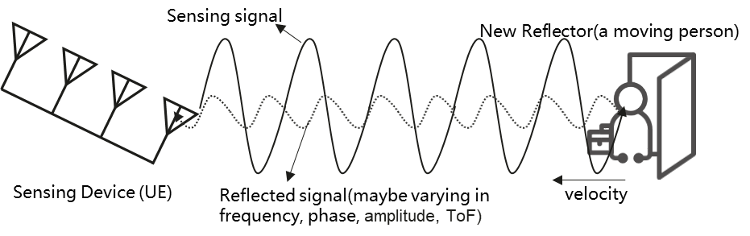

Figure 5.1.1-1 An example of sensing operation of UE

### 5.1.2 Pre-conditions

Mary and her husband Tom live in a house with little daughter Alice.

On every working day, Mary and Tom have to leave home to work, and Alice needs to go to school. Since the community where the house is located is not stable, Mary and Tom have concern on the safety of their property.

In order to address their concerns, considering protecting the personal privacy and save family cost, Mary sets up some 5G CPEs (i.e. UE) in each room at home, which support sensing functionalities.

### 5.1.3 Service Flows

Mary and all her family members travel to Hawaii in a holiday. At this time, her house is empty. Since she worries about the safety of property, she enables the sensing service on intruder detection of the 5G CPEs (i.e. UE) at home.

Mary’s CPE (i.e. UE) in the living room is activated to perform the sensing operation. While the 5G CPE transmit 5G signals to provide communication services at home, the reflected signals are also received and measured at the CPE as sensing information. The CPE reports the sensing information to 5G network or further process locally. Via the analysing the differences between the 5G signals and the received reflected signals provided by sensing service performed by 5G system, any potential intruder will not be missed.

Also, Mary’s CPE in the living room can work with other 5G UEs in other rooms. The CPE discovers that the living room has another 5G device (i.e. UE) which could assist the sensing service as secondary device via direct device connection. The connectivity used in this case is direct device connection, and CPE and this 5G device play as the role of transmitter and receiver, respectively. The receiver measures the 5G signal (e.g., number of detected transmission paths), then provides sensing information to 5G network or further process locally. Via the analysing the differences between the 5G signals and the received reflected signals provided by sensing service performed by 5G system, any potential intruder will not be missed.

An intruder breaks into Mary’s house someday. The sensing service provided by 5G network system assists detecting that the presence of an intruder based on analysing the change of collected signals is aligned with the known feature of the activities of indoor human, and the alarm of intruder is sent to Mary’s smart phone. Mary calls the police for help, and the property is protected.

### 5.1.4 Post-conditions

Thanks to the sensing service provided by 5G UE and network, an intruder is found when Mary is out of home.

### 5.1.5 Existing features partly or fully covering the use case functionality

None.

### 5.1.6 Potential New Requirements needed to support the use case

[P.R.5.1.6-1] The 5G system shall provide a mechanism for an operator to authorize a UE for sensing, e.g., based on location.

Editor's Note: Terminology of UE/base station needs to be adapted.

[PR 5.1.6-2] The 5G system shall support a UE to perform sensing measurement process based on the trusted third-party’s request.

[PR 5.1.6-3] The 5G system shall provide mechanisms for an operator to only collect or expose the sensing information requested by a trusted third-party according to agreement.

[PR 5.1.6-4] The 5G system shall support UE to perform sensing measurement process using signals received from other UE(s).

[PR 5.1.6-5] The 5G system shall support UE to perform sensing measurement process in licensed or unlicensed band.

[PR 5.1.6-6] The 5G system shall be able to provide the sensing service with following KPIs:

Table 5.1.6-1 Performance requirements of sensing results for intruder detection in smart home

|  |  |  |  |  |  |  |  |  |  |  |  |  |
| --- | --- | --- | --- | --- | --- | --- | --- | --- | --- | --- | --- | --- |
| Scenario | Sensing service area | Confidence level [%] | Accuracy of positioning estimate by sensing (for a target confidence level) | | Accuracy of velocity estimate by sensing (for a target confidence level) | | Sensing resolution | | Max sensing service latency[ms] | Refreshing rate [s] | Missed detection [%] | False alarm [%] |
| Horizontal  [m] | Vertical  [m] | Horizontal  [m/s] | Vertical  [m/s] | Range resolution  [m] | Velocity resolution (horizontal/ vertical)  [m/s x m/s] |
| Intruder detection in smart home | Indoor | 95 | ≤10 | ≤10 | N/A | N/A | N/A | N/A | <1000 | < 1 | < 5 | < 2 |
| NOTE: The terms in Table 5.1.6-1 are found in Section 3.1. | | | | | | | | | | | | |

Editor's Note: it is FFS whether other potential requirements will be identified.

NOTE: In this use case UE is acting as sensing transmitter and/or sensing receiver. This is an example and other options can also be valid.

## 5.2 Use case on pedestrian/animal intrusion detection on a highway

### 5.2.1 Description

Transportation as a basic and essential industry plays one of the important roles in a human’s life. Making transportation smarter can make life more convenient and benefit economic development. Highways are an important part of smart transportation. Due to the strong road safety demand on smart transportation, it is necessary to monitor the road situation so as to make appropriate management of road traffic, give guidance or assistance information to vehicles and/or highway traffic safety administration [2].

For example, major accidents caused by pedestrians or animals crossing highways occur frequently [3] [4]. Currently, the highway supervision systems are mainly based on traditional sensors (e.g. radars, cameras) equipped in the roadside infrastructure, but there are still many problems in road supervision system, e.g. it only has partial coverage along the roadside, and the radar may be dedicated for a single usage which requires deploying different types of transportation radars in the same place to satisfy the respective sense use cases and requirements in the area of interest.

Base stations on the roadside are already used to provide 5G coverage for communication, and the radio signals can also be used to sense the environment for object detection.

The assumption of this use case is the following:

- There is at least 10km long and 33m wide dual three-lane carriageway, which has a central reservation to separate the carriageways, six 3.75m wide lanes and two 3.00m wide shoulders to permit emergency stops [9].

- The size and typical velocity of traffic participant is described in the Table 5.2.1-1.

Table 5.2.1-1

|  |  |  |
| --- | --- | --- |
|  | Size  (Length x Width x Height) | Typical velocity |
| Pedestrian  (Adult) | 0.5m x 0.5m x 1.75m | 5km/h [9] |
| Animal  (Sheep/deer) | 1.5m x 0.5m x 1 m | 5km/h [9] |
| Vehicle | 4m x 1.75m x 1.5m | 60km/h - 120km/h |

As described in the figure 5.2.1-1, when the pedestrian/animal standing at the outermost side of the shoulder starts walking on the traffic lane, it means the highway intrusion happens. The distance that pedestrian/animal move perpendicular to the traffic lane (i.e. y direction in the figure 5.2.1-1) is more sensitive for road safety, compared to the distance parallel to the traffic lane (i.e. x direction in the figure 5.2.1-1).

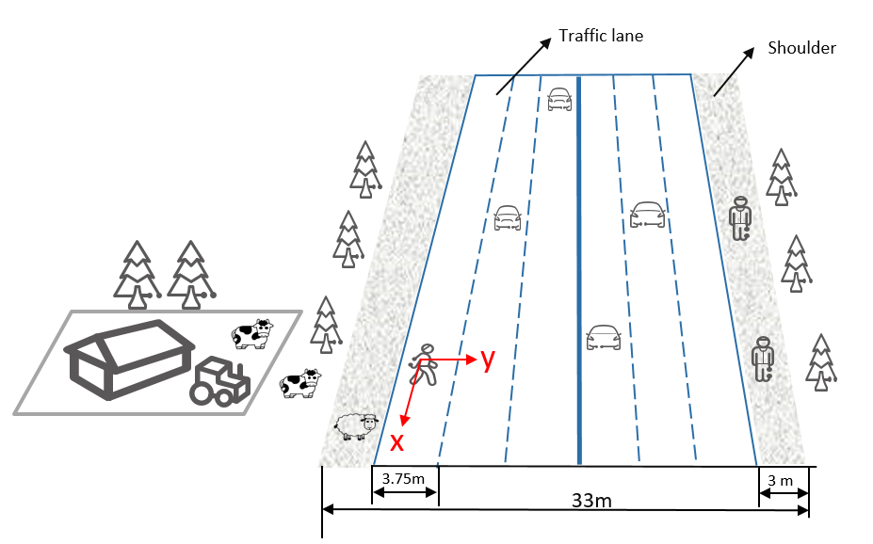

Figure 5.2.1-1: Intrusion detection on a dual three-lane carriageway

### 5.2.2 Pre-conditions

Good partnership and cooperation are established between the road supervision department and Mobile Operator#A in City#B. Requested by the supervision departments for the sensing service, the suitable base stations around/along a highway are selected, which enable Mobile Operator#A to constantly sense the road situation including moving objects (e.g. vehicles and pedestrians). The sensing signal emitted from the base station arrives at vehicles/pedestrians/objects on the road and is bounced (reflected) back to the transmitting base station.

### 5.2.3 Service Flows

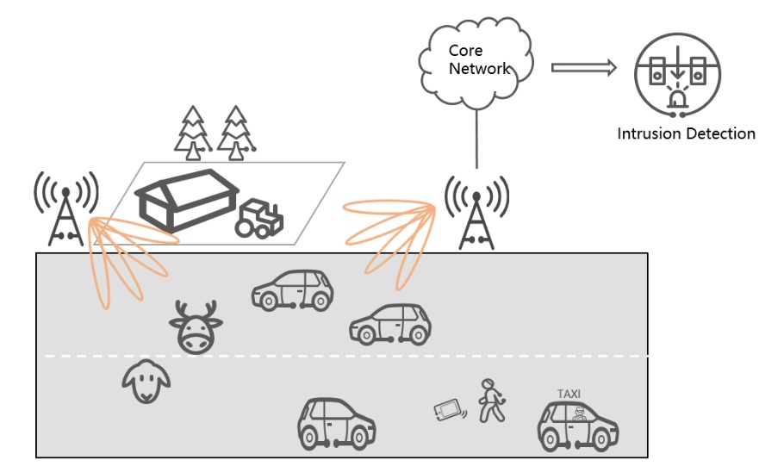

Figure 5.2.3-1: Pedestrian/animal intrusion detection

1. Fei is a tourist, who is taking a taxi to enjoy the view around the highway in City#B. The base stations around/along the highway constantly sense the road situation. While the taxi is driving on the highway, Fei rolls down the window to take some pictures. Suddenly his mobile phone falls out the window.
2. Fei tells the driver to stop and cautiously gets out of the taxi. He crosses the highway and wants to find his mobile phone. Meanwhile, some animals (e.g. sheep and deer) from a farm near the highway approach the road. More and more surrounding vehicles are passing at very high speed. The pedestrian and animals are detected and closely tracked with sufficient accuracy in the sensing area of a base station, and then the 3GPP sensing data is transferred to the core network from the RAN and further processed into the sensing results in the core network.
3. The sensing results are exposed by the Mobile Operator#A to the road supervision departments and map provider. The map provider adds the position of the vulnerable pedestrian and animals into the HD dynamic maps and transmits warning messages to the vehicles approaching them. Alternatively, RSUs are connected to the traffic control centre for management and control purposes. RSUs transmit warning messages to the vehicles approaching them. The staff working for supervision departments immediately responds to the emergency, launching temporary traffic management, and rushes to the emergency site to fetch the mobile phone for Fei and drive the animals away from the highway.
4. Finally, Fei and animals leaves the highway safely. Potential road accident(s) caused by the pedestrian/animal intrusion are avoided.

### 5.2.4 Post-conditions

Thanks to the area-coverage, long-distance sensing capability of the base station (which provides a bird’s-eye-view for monitoring the highway environment) the precision and efficiency of highway management and safety supervision is improved. The network-based sensing can provide timely, continuous, accurate, and comprehensive sensing results, which is a reliable basis for highway safety services.

### 5.2.5 Existing features partly or fully covering the use case functionality

None.

### 5.2.6 Potential New Requirements needed to support the use case

[PR 5.2.6-1] The 5G system shall be able to support a base station to perform sensing.

[PR 5.2.6-2] The 5G system shall be able to support means to select suitable base station(s) to perform sensing, e.g. based on the base station’s location, sensing capability, and the sensing service information requested by trusted third party application.

[PR 5.2.6-3] The 5G system shall be able to support means to configure the sensing operation of a base station(e.g. authorization, sensing activation and/or deactivation, sensing duration, sensing accuracy, target sensing location area).

[PR 5.2.6-4] The 5G system shall be able to support means to enable a base station to transfer 3GPP sensing data to the core network.

[PR 5.2.6-5] The 5G system shall be able to support means to enable the core network to process 3GPP sensing data for obtaining sensing results.

[PR 5.2.6-6] Based on operator’s policy, the 5G system shall expose a suitable API to a trusted third party to provide the information regarding sensing results.

[PR 5.2.6-7] The 5G system shall be able to support charging data collection for the sensing services (e.g. considering service type, sensing accuracy, target area, duration) requested by a trusted third-party application.

[PR 5.2.6-8] Subject to operator’s policy, the 5G network may provide secure means for the operator to expose information on sensing service availability (e.g., if sensing service is available and the supported KPIs) in a desired sensing service area location to a trusted third-party.

[PR 5.2.6-9] The 5G system shall be able to support the following KPIs:

Table 5.2.6-1 Performance requirements of sensing results for pedestrian/animal intrusion detection

|  |  |  |  |  |  |  |  |  |  |  |  |  |
| --- | --- | --- | --- | --- | --- | --- | --- | --- | --- | --- | --- | --- |
| Scenario | Sensing service area | Confidence level [%] | Accuracy of positioning estimate by sensing (for a target confidence level) | | Accuracy of velocity estimate by sensing (for a target confidence level) | | Sensing resolution | | Max sensing service latency[ms] | Refreshing rate [s] | Missed detection [%] | False alarm [%] |
| Horizontal  [m] | Vertical  [m] | Horizontal  [m/s] | Vertical  [m/s] | Range resolution  [m] | Velocity resolution (horizontal/ vertical)  [m/s x m/s] |
| Pedestrian/animal intrusion detection on a highway | Outdoor (Highway) | 95 | ≤1 | N/A | N/A | N/A | N/A | N/A | ≤5000 | ≤ 0.1 | ≤5 | ≤5 |
| NOTE: The terms in Table 5.2.6-1 are found in Section 3.1. | | | | | | | | | | | | |

NOTE: In this use case base station is acting as sensing transmitter and/or sensing receiver. This is an example and other options can also be valid.

## 5.3 Use case on rainfall monitoring

### 5.3.1 Description

Rainfall monitoring is a topic of great importance for several application contexts: hydraulic structure design, agriculture, weather forecasting, climate modelling, etc. At present, the most widely used measurement method is rain gauge.

Traditional rainfall monitoring use rain gauges, which are located at a particular location. Wide-area rainfall monitoring using traditional rain gauges would be costly. The base stations are deployed by the operators with radio cell planning that could cover a wider area. With base stations monitoring the rainfall, for example rain rate (mm/h), it could obtain a horizontally wider-area measurement.

Radio signals, as they propagate through the atmosphere, are reduced in intensity by constituents of the atmosphere. Oxygen and water vapor are the two major components which are responsible for the signal absorption. If it is a rainy day, an additional attenuation caused by rain further increases the propagation path loss. [7] The rain attenuation depends on the size and distribution of the water droplets, hence, by quantifying and modelling the base station signal measurements, we are able to know the rain rate.

The mmWave bands, such as 28GHz and 38GHz have been used to assess coverage, large-scale path loss, and fading and multipath effects [6]. Since the 28 GHz and 38 GHz bands are also licensed for wireless backhaul communications, these frequencies can be used for rainfall monitoring [7].

The granularity of the rainfall monitoring could be smaller than the traditional measurements.

### 5.3.2 Pre-conditions

Peter is a farmer who takes care of a big farm that grows different crops. Peter needs to monitor the rainfall of his farm to manage reasonable irrigation, drainage and fertilizer. When there is less rainfall, Peter can select reasonable irrigation plans to improve the farmland water content condition. When there is high rainfall, Peter should improve the drainage system and fertilize the crops to avoid crop losses.

### 5.3.3 Service Flows

1) Peter has a subscription for the premium service of rainfall monitoring for a more granular location.

2) Peter is at daily working routine and wants to check the timely rainfall information from the weather application on his phone.

3) The RAN obtains the NR based 3GPP sensing data every hour and the 5G system processes the 3GPP sensing data to obtain sensing results and exposes the NR based sensing results to the weather application via the core network.

4) Based on the sensing results above, the application server obtains the rainfall information (i.e. rainfall and whether it is raining) associated with location information.

5) Peter obtains timely rainfall information from weather application on his phone.

### 5.3.4 Post-conditions

Peter could check the rainfall information at any time on his phone. Based on the timely rainfall information, Peter could plan the irrigation, drainage and fertilizer for the crops in his farm.

### 5.3.5 Existing feature partly or fully covering use case functionality

None.

### 5.3.6 Potential New Requirements needed to support the use case

[PR 5.3.6-1] The 5G network shall support collection of the NR based 3GPP sensing data from the base station.

[PR 5.3.6-2] Based on operator’s policy, the 5G system shall support mechanisms to process the 3GPP sensing data to derive the sensing results.

[PR 5.3.6-3] Based on operator’s policy, the 5G system shall provide mechanisms to expose NR based sensing results with sensing contextual information, e.g. location, to a trusted third-party application via the core network.

[PR 5.3.6-4] The 5G system shall support sensing services with KPIs as given in Table 5.3.6-1.

Table 5.3.6-1 Performance requirements of sensing results for rainfall monitoring

|  |  |  |  |  |  |  |  |  |  |  |  |  |  |
| --- | --- | --- | --- | --- | --- | --- | --- | --- | --- | --- | --- | --- | --- |
| Scenario | Sensing service area | Confidence level [%] | **Rainfall estimation accuracy**  (for a target confidence level) | Accuracy of positioning estimate by sensing (for a target confidence level) | | Accuracy of velocity estimate by sensing (for a target confidence level) | | Sensing resolution | | Max sensing service latency[ms] | Refreshing rate [s] | Missed detection [%] | False alarm [%] |
| Horizontal  [m] | Vertical  [m] | Horizontal  [m/s] | Vertical  [m/s] | Range resolution  [m] | Velocity resolution (horizontal/ vertical)  [m/s x m/s] |
| Rainfall monitoring | outdoor | 95 | [1mm/h]  NOTE 2 | N/A | N/A | N/A | N/A | N/A | N/A | 1 min | 10min, application configurable | 5 | 5 |
| NOTE 1: The terms in Table 5.3.6-1 are found in Section 3.1.  NOTE 2: For rainfall rain rate >1 mm/h[39]. Rainfall estimation accuracy describes the closeness of the measured rainfall estimation to its true rainfall value. | | | | | | | | | | | | | |

NOTE: In this use case base station is acting as sensing transmitter and/or sensing receiver. This is an example and other options can also be valid.

## 5.4 Use Case on Transparent Sensing Use Case

### 5.4.1 Description

In general, a UE senses using either or combination of the non-3GPP sensors such as camera, Lidar, 3GPP-based sensing. In 3GPP 5G wireless sensing, the Sensing transmitters and Sensing receivers sense for stationary and moving Objects around them – using time-difference-of-arrival (TDoA), angle-of-arrival (AoA), angle-of-departure (AoD) measurements, RSSI etc. as shown in Figure 5.4.1-1 [14]. Transparent sensing is a use case in which 3GPP sensing data is captured by Sensing transmitter and/or Sensing receiver and communicated so that the 5GS is aware of the 3GPP sensing data, while the non-3GPP sensing data is the result of non-3GPP sensors and is transparent to 5GS. From this information, service enablers can be defined. One example of such information is location data, whose corresponding service enabler is Location Based Services.

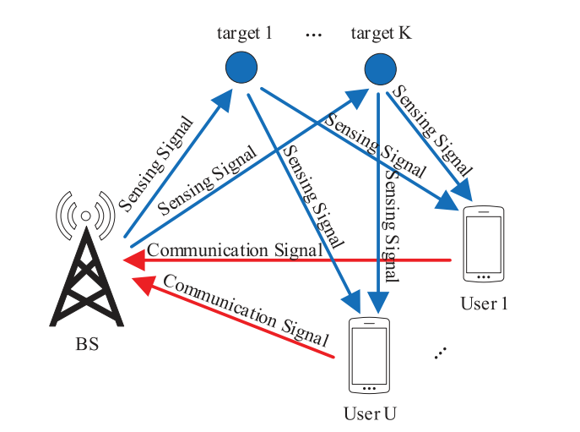

Figure 5.4.1-1: BS and UE sensing Objects

In this use case, non-3GPP sensing data is made available to the 5GS, and the requirements for this exposure are considered. The data so obtained can be used for diverse purposes. One such purpose is Localization (identifying both a three- dimensional position and orientation.) Transparent Sensing data used for Localization is described in TR 22.856 [11].

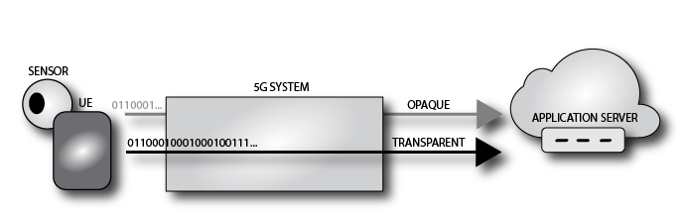

Figure 5.4.1-2: Opaque and Transparent Sensing Data

The distinguishing characteristic of this use case is that the non-3GPP sensing data is provided to the 5GS itself.

The application server receiving 'transparent non-3GPP sensing data' as shown in figure 5.4.1-2 can be operated by the MNO. This enables the MNO to provide specific processing to produce 'combined sensing results as a service,' where the sensing data is supplied by non-3GPP sensors owned and operated by third parties, subscribers, etc.

In this use case it is the 5GS that receives 3GPP and non-3GPP sensing data, not a third party.

### 5.4.2 Pre-conditions

A UE has access to one or more sensors. In this use case. the UE has access to four sensors: NR-based sensing, 3D LiDAR, an RGB Camera and a Smart Phone Camera. The sensors' physical configuration is known (e.g. the cameras are 10 cm apart). The NR-based sensing capabilities of the UE and its connected BS are used to capture information about the nearby environment by the UE.

A mobile network MN supports the acquisition of non-3GPP sensing data. We term this support by the network a 'non-3GPP sensing data consuming service'.

### 5.4.3 Service Flows

The user U activates a mechanism to enable Non-3GPP sensing data acquisition that can be collected at U's UE.

The user U provides this non-3GPP sensing data via the 5GS. This process is analogous to activating or enabling a location tracking service.

MN acquires sensing data provided by U's UE, for a period of time.

MN can also acquire 3GPP sensing data. 3GPP-RF sensing data can be processed only in 5GS to derive sensing results. The sensing results and the Non-3GPP sensing data can be combined to produce a combined sensing result.

The user U deactivates the mechanism to provide non-3GPP sensing data to the 5GS.

### 5.4.4 Post-conditions

The non-3GPP sensing data acquired by the 5GS is processed in order to enable other services. The processed information can for example provide 'Spatial Localization' information that can be exposed to authorized third parties, as discussed in 22.856 [11]. "Spatial Localization Use Case".

### 5.4.5 Existing feature partly or fully covering use case functionality

Positioning in 5G Networks been proposed in 3GPP release-16, it specifies positioning signals and measurements for the 5G NR. In release-16, 5G Positioning architecture extends 4G positioning architecture by adding Location Management Function (LMF) and Transmission reception points (TRP). 5GS provides new positioning methods based on multi-cell round-trip time measurements, multiple antenna beam measurements, to enable downlink angle of departure (DL-AoD) and uplink angle of arrival (UL-AoA) [15][16]. The Rel-17 5G system supports positioning of the device-based but not device-free – objects that do not radiate EM signals [14][15][16].

The 5GS already supports transport of non-3GPP sensor data. The table below provides indicative performance requirements for media used for sensor information communication.

|  |  |  |
| --- | --- | --- |
| **Sensor Type** | **Uplink KPI** | **Remarks** |
| 3D Lidar | 30 Mbps | An example 3D LiDAR: 16 channel, 0.3M data points, dual return mode  2 bytes distance, 1byte [13] |
| Industrial RGB Camera | 16 ~ 800 Mbps | 2,592 x 2,048 x 10bits x 2.5 Hz x 6 EA, compression ratio 2% |
| Smart Phone Camera | 4 ~ 200 Mbps | 2,160 x 2,880 x 8bits x 1 Hz x 4 EA, compression ratio 2% |

Table 5.4.5-1: Performance Requirements (already possible to fulfill with the 5GS)

### 5.4.6 Potential New Requirements needed to support the use case

[PR 5.4.6-1] Subject to user consent and national or regional regulatory requirements, based on operator policy, the 5GS shall support a mechanism to receive uplink non-3GPP sensing data from authorized non-3GPP sensors.

NOTE 1: This requirement assumes there is some functionality in the 5GS to discern and interpret the acquired 3GPP and non-3GPP sensing data.

[PR 5.4.6-2] Subject to user consent and national or regional regulatory requirements, based on operator policy, the 5GS shall support a mechanism to expose sensing results to trusted third parties.

[PR 5.4.6-3] Subject to user consent and national or regional regulatory requirements, based on operator policy, the 5GS shall support a mechanism to expose combined results to trusted third-parties.

[PR 5.4.6-4] Subject to user consent, network operator policy and national or regional regulatory requirements, the 5GS shall support a mechanism to enable Sensing transmitters and Sensing receivers to acquire 3GPP sensing data to capture information about the nearby environment and for this to be combined with Non-3GPP sensing data to produce a combined sensing result.

NOTE 2: This requirement does not imply or allow 3GPP sensing data to be exposed to third parites. This data is considered confidential.

## 5.5 Use case on sensing for flooding in smart cities

### 5.5.1 Description

Due to the climate change in recent years, a larger amount of rain sometimes falls within a short duration of time inside a small area. This result, in particular in urban areas, in inundation and flooding even in areas where these did not happen in the past. When flooding is about to happen on roads, people might enter areas getting in danger without knowing it. Once flooding really happens there, this might result in loss of human life. At places where flooding is expected to occur, monitoring of flooding is performed using cameras and other sensors. However, due to the recent climate change, it can be difficult to recognize places where flooding is expected to occur. Using radio waves, it is possible to recognize places where flooding occurs in an efficient way.

NOTE: There has been a related trend, although a mobile communication is not directly involved so far and it's monitoring of the river, not of the road as this use case deals with. In Japan, MLIT (Ministry of Land, Infrastructure, Transport and Tourism) takes care of the river administration and supervises water level observation of rivers to prevent and predict flooding. In the past, water-level gauges were only sparsely deployed along the river. Water levels at places where those gauges were not placed were estimated based on water levels observed some distance away where such gauges were placed. Detailed degree of possibility of flooding at each place was not directly understood. To improve this situation, MLIT has encouraged to develop a low-cost water-level gauge and has started placing such gauges e.g., at places that are relatively prone to flooding or show a specific water behavior due to the form of the river, or that are close to hospitals or important facilities. Disaster Information for River is now available at <https://www.river.go.jp/e/> for public.

### 5.5.2 Pre-conditions

Good partnership and cooperation are established between Mobile Operator #A and administrators of roads such as a local government in City #B. Mobile Operator #A constantly senses the surface of the road and informs results of sensing to the administrator of the road.

### 5.5.3 Service Flows

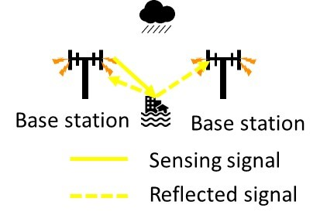

Figure 5.5.3-1: Sensing for flooding in smart cities

1. Base stations owned by Mobile Operator #A are deployed around the road. Mobile Operator #A carries out sensing of the surface of the road in City #B. This sensing is performed using radio wave. Results of sensing information, incl. whether flooding occurs on the road, are informed to the administrator of the road in City #B.
2. The administrator of the road usually monitors the state of flooding on the road using information from sensors including information from Mobile Operator #A. In addition, in the case of heavy rain, the administrator can request Mobile Operator #A to increase frequency of monitoring of situation of roads and Mobile Operator #A monitors the situation more frequently responding to this request.
3. If there is information received that flooding occurs, the administrator advises people in the areas concerned to evacuate the areas. The administrator advises via mobile networks.
4. People who received the advice evacuate the areas or do not enter such areas.
5. Now City #B trusts Mobile Operator #A and allows it to advise people about evacuation without City #B's intervention in case of flooding. Next time a similar flooding occurs, Mobile Operator #A sends advice for evacuation directly to people.

### 5.5.4 Post-conditions

Damage of the flooding has been kept at minimum.

### 5.5.5 Existing features partly or fully covering the use case functionality

None.

### 5.5.6 Potential New Requirements needed to support the use case

[PR 5.5.6-1] Subject to operator policy, the 5G system shall be able to provide sensing result indicating disasters or other emergencies (e.g., flooding) in a given geographic area to authorized third parties in a timely manner.

[PR 5.5.6-2] Subject to regional or national regulatory requirements and operator policy, the 5G system shall be able to provide its public warning system with a warning notification based on sensing result indicating disasters or other emergencies (e.g., flooding) in a given geographic area in a timely manner.

[PR 5.5.6-3] Subject to operator policy, it shall be possible for an authorized third party to configure the 5G system to initiate sensing for disasters or other emergencies (e.g., flooding) in a given geographic area.

[PR 5.5.6-4] The 5G system shall be able to support the following KPIs:

Table 5.5.6-1 Performance requirements of sensing for flooding in smart cities

|  |  |  |  |  |  |  |  |  |  |  |  |  |
| --- | --- | --- | --- | --- | --- | --- | --- | --- | --- | --- | --- | --- |
| Scenario | Sensing service area | Confidence level [%] | Accuracy of positioning estimate by sensing (for a target confidence level) | | Accuracy of velocity estimate by sensing (for a target confidence level) | | Sensing resolution | | Max sensing service latency[ms] | Refreshing rate [s] | Missed detection [%] | False alarm [%] |
| Horizontal  [m] | Vertical  [m] | Horizontal  [m/s] | Vertical  [m/s] | Range resolution  [m] | Velocity resolution (horizontal/ vertical)  [m/s x m/s] |
| sensing for flooding in smart cities | Outdoor | 95 | ≤10 | [≤0.2]  NOTE 2 | N/A | N/A | N/A | N/A | ≤ 1min  NOTE 3 | < 1min  NOTE 3 | < 0.1 | < 3 |
| NOTE 1: The terms in Table 5.5.6-1 are found in Section 3.1.  NOTE 2: This value is for the water level. Description related to NOTE in clause 5.5.1 suggests 0.01 m. [≤0.2] is derived from the water level where people feel difficulty in walking.  NOTE 3: Description related to NOTE in clause 5.5.1 suggests 2 minute-interval monitoring when the water level of the river rises quickly. | | | | | | | | | | | | |

## 5.6 Use case on intruder detection in surroundings of smart home

### 5.6.1 Description

Detection of an intruder including a person or a harmful animal into a private property is an important piece to ensure residents at home in the private property feel comfortable and secure. For the surroundings monitoring, various technologies, such as cameras, infrared cameras, and microwave radars are being used. However, these technologies require line-of-sight, and therefore locations which can be monitored may be limited.

Wireless signals make it possible to monitor locations without line-of-sight and to monitor wider areas [17]. Sensing by wireless signals can complement the afore-mentioned technologies and can improve accuracy of the detection. Sensing by wireless signals gives residents time to prepare against intruders or to drive them away.

### 5.6.2 Pre-conditions

UEs such as smart phones and consumer premise equipment are installed inside a house, in particular, near a wall or a window. Residents have a contract with a mobile operator for the UEs.

### 5.6.3 Service Flows

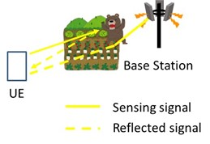

Figure 5.6.3-1: Intruder detection in surroundings of smart home

1. The UEs such as smart phones and CPE communicate with base stations in the outdoor or in the indoor and monitor 3GPP signals which are influenced by outdoor objects such as humans and animals. In addition, the UEs communicate with base stations of the mobile operator and monitor the radio wave state between the UEs and the base stations.
2. When an intruder enters the site, the radio signals are changed. The core network processes the data and yields sensing result indicating detection of the intruder.

NOTE: Cases that such an intruder or an animal is already indoor are addressed in the use case in clause 5.1.

1. The residents are informed of detection of the intruder.

### 5.6.4 Post-conditions

The residents report to the police or the security service and request them to take an appropriate action.

### 5.6.5 Existing features partly or fully covering the use case functionality

None.

### 5.6.6 Potential New Requirements needed to support the use case

[PR 5.6.6-1] Subject to operator policy, the 5G system shall be able to collect 3GPP sensing data and yield sensing result from the data for detection of outdoor objects.

[PR 5.6.6-2] The 5G system shall be able to support the following KPIs:

Table 5.6.6-1 Performance requirements of intruder detection in surroundings of smart home

|  |  |  |  |  |  |  |  |  |  |  |  |  |
| --- | --- | --- | --- | --- | --- | --- | --- | --- | --- | --- | --- | --- |
| Scenario | Sensing service area | Confidence level [%] | Accuracy of positioning estimate by sensing (for a target confidence level) | | Accuracy of velocity estimate by sensing (for a target confidence level) | | Sensing resolution | | Max sensing service latency[ms] | Refreshing rate [s] | Missed detection [%] | False alarm [%] |
| Horizontal  [m] | Vertical  [m] | Horizontal  [m/s] | Vertical  [m/s] | Range resolution  [m] | Velocity resolution (horizontal/ vertical)  [m/s x m/s] |
| intruder detection in surroundings of smart home | Outdoor | 95 | ≤2 | N/A | N/A | N/A | N/A | N/A | ≤1000 | < 1 | < 0.1 | < 5 |
| NOTE: The terms in Table 5.6.6-1 are found in Section 3.1. | | | | | | | | | | | | |

## 5.7 Use case on sensing for railway intrusion detection

### 5.7.1 Description

Extensive railway deployment and the changing wildlife habitat area due to the changing global environment has led to increase of crash of wildlife to trains. Once a crash happens, its recovery costs, takes time, and impairs convenience [18], [19]. Such a crash should be avoided, but it appears difficult to proactively predict wildlife's intrusion onto railway track. It's different from e.g., weather forecast. Passively detecting wildlife's intrusion onto railway track appears an option to take. Monitoring with cameras serves the same purpose. However, this requires LOS (i.e., line of sight) and a dense deployment of cameras, which is not necessarily efficient. Another traditional mechanism using fibre optic sensing techniques is costly and requires manual intervention, making it very difficult to meet the increasing demand for railway monitoring. Thanks to the 5G NR based sensing, the base station as transmitter and receiver along the railway can constantly sense the railway situation such as railway intrusion.

The assumption of this use case is the following:

- There is at least 300km train line as depicted in the figure 5.7.1-1[19] owned by railway operator. The safe place is a place where a person and their equipment cannot be struck by rail traffic, which is used for minimizing damage caused by possible railway accident or crash and for ensuring safe operation of railway. The danger zone is anywhere within 3m horizontally from the nearest track.

- The typical size and velocity of intruder and train in this use case are described in the Table 5.7.1-1.

**Table 5.7.1-1**

|  |  |  |
| --- | --- | --- |
|  | Size  (Length x Width x Height) | Velocity |
| Intruder | Pedestrian(Adult):  0.5m x 0.5m x 1.75m | 5km/h |
| Animal(Sheep/deer):  1.5m x 0.5m x 1 m | 5km/h |
| Trains | 24m x 3.5m x 3 m | 100km/h - 350km/h |

When the intruder standing at the outermost side of safe place starts walking on the danger zone, it means the intrusion happens. The distance that intruder move perpendicular to the railway track is more sensitive for road safety, compared to the distance parallel to the railway track.

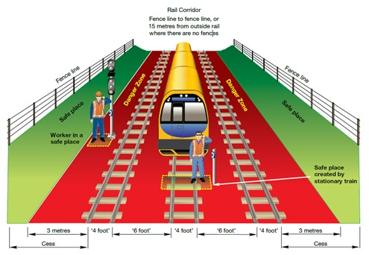

Figure 5.7.1-1

### 5.7.2 Pre-conditions

Base stations are deployed near and along a railway track which enable the mobile operator to constantly sense the railway including intruder (e.g., pedestrians and animal). For sensing, signaling transmitted by a base station is influenced or bounced by objects around the railway and then monitored by the base station and other base stations. Sensing result is being notified to a railway operator by the mobile operator. The railway operator knows locations of trains.

### 5.7.3 Service Flows

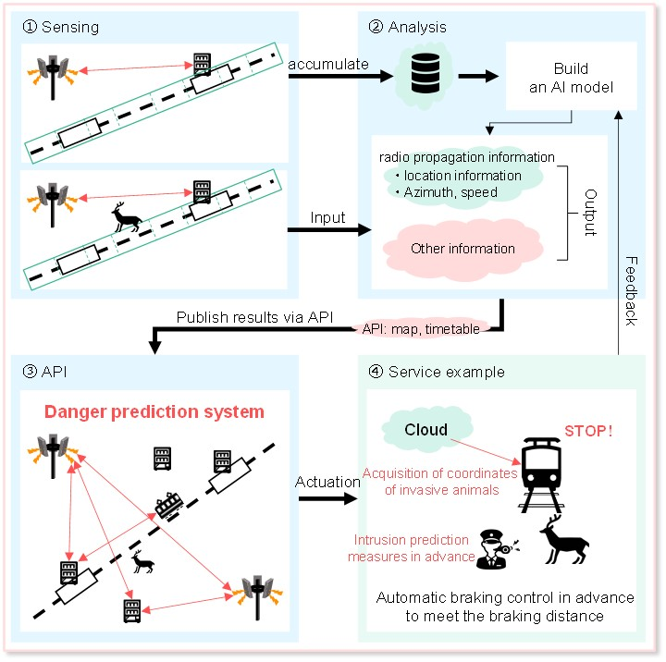

Figure 5.7.3-1 Railway intrusion detection

1. Base stations are deployed near and along a railway track. In order to acquire the sensing information of railway, railway operator requests sensing service from mobile operator. The mobile operator configures the base stations along the train line to perform sensing. Suddenly, an intruder (e.g. pedestrian or animal) is walking on the danger zone.
2. The 3GPP sensing data is reported from base stations and further processed into the sensing results by the core network. The mobile operator exposes the sensing results to the railway operator. Based on the sensing results, the location of the intruder can be estimated.

3. Trains running on the railway track measure their own location and velocity. These trains inform that information to a controller of the railway operator.

4. The controller identifies a train that is affected by an intruder based on the sensing results from mobile operator and train's location and velocity.

5. The controller orders the train to slow down or stop. In addition, the staff working for railway operator immediately responds to the emergency. The intruder leaves the danger zone safely.

### 5.7.4 Post-conditions

The controller judges the intruder is gone and safety can be ensured. The controller permits the train to start again or speed up.

### 5.7.5 Existing feature partly or fully covering use case functionality

TBD.

### 5.7.6 Potential New Requirements needed to support the use case

[PR 5.7.6-1] Subject to operator policy, the 5G system shall enable the core network to collect and aggregate 3GPP sensing data data from RAN.

[PR 5.7.6-2] Subject to operator policy, the 5G system shall enable the core network to expose a suitable API to provide the information regarding sensing results to authorized third parties.

[PR 5.7.6-3] The 5G system shall be able to support the following KPIs:

Table 5.7.6-1 Performance requirements of sensing results for railway intrusion detection

|  |  |  |  |  |  |  |  |  |  |  |  |  |
| --- | --- | --- | --- | --- | --- | --- | --- | --- | --- | --- | --- | --- |
| Scenario | Sensing service area | Confidence level [%] | Accuracy of positioning estimate by sensing (for a target confidence level) | | Accuracy of velocity estimate by sensing (for a target confidence level) | | Sensing resolution | | Max sensing service latency[ms] | Refreshing rate [s] | Missed detection [%] | False alarm [%] |
| Horizontal  [m] | Vertical  [m] | Horizontal  [m/s] | Vertical  [m/s] | Range resolution  [m] | Velocity resolution (horizontal/ vertical)  [m/s x m/s] |
| Intrusion detection on a railway | Outdoor (Along railway) | 95 | ≤1.5 | N/A | N/A | N/A | N/A | N/A | ˂1500 | ≤ 0.1 | 2 | 2 |
| NOTE: The terms in Table 5.7.6-1 are found in Section 3.1. | | | | | | | | | | | | |

NOTE: In this use case base station and UE is acting as sensing transmitter and/or sensing receiver. This is an example and other options can also be valid.

## 5.8 Use Case on Sensing Assisted Automotive Maneuvering and Navigation

### 5.8.1 Description

To support smart transportation and autonomous driving, more vehicle and devices are equipped with sensing technologies. For example, cameras, Radar, and Lidar systems are the most used sensors by the automotive industry to maintain the perception for autonomous vehicles at various levels of autonomy. Accurate sensing results are crucial to enable the safe and reliable control of the vehicles.

Due to the mounting position of the sensors (e.g., 3GPP based sensors) information collected from a single vehicle's sensors can not be sufficient or accurate enough to satisfy the advanced automotive use cases, e.g., autonomous driving, coordinated maneuver, etc. Therefore, the 5G system could coordinate sensing to get sensing data from various sources and generate sensing results which could be consumed at the vehicle and used for the vehicular control and driver assistance, e.g., feed into the Automated Driving System (ADS) in the car [21]. The 3GPP sensing data collected by the UE can be sent alongside relevant sensing information to other sensing entities (including other vehicles, roadside units, and network) for further processing (if required) before sharing with a third-party application as shown in Figure 5.8.1-1.

The network facilitated NR based sensing described above could significantly improve the sensing reliability and quality, enabling new and advanced automotive use cases.



Figure 5.8.1-1: 5G System Assisted Automotive maneuvering and navigation

### 5.8.2 Pre-conditions

In this use case, Joe and Bob’s vehicles are equipped with 3GPP-based sensing technology. Non-3GPP sensors like radar, camera and Lidar sensors could also be available in the vehicles. Additionally, the vehicles are capable of 5G communications, including direct communication with other vehicles, communication with 5G system via RAN entities.

### 5.8.3 Service Flows

**5G system assisted coordination of sensing service**

Step 1 (**Network provides configurations and policies**): When Bob’s car registers for 3GPP sensing service, the network provides policies and configurations to enable UEs take appropriate actions during sensing e.g., obtaining 3GPP sensing data from another UEs/RAN entities. For example, the policies provided by network could provide guidance for the discovery UEs/RAN entities with appropriate NR RF sensing capabilities, when to trigger requests, when to stop sending requests, messaging formats, the communication configurations (such as which 5G communication mode to use and under which conditions), the sensing configurations (such as which role i.e. transmitter/receiver, to use by a particular node for a particular sensing task, etc.. These polices and configurations could be updated frequently by the network based on e.g., network conditions, mobility pattern, etc.

Step 2 (**Bob determines his sensors are blocked**): Bob's sensor(s) is(are) blocked by Joe's vehicle, and cannot adequately detect its surroundings (e.g., detect if there is another vehicle in front). This could result in the vehicle miscalculating the needed distance to stop before a traffic light. In other cases, Joe's vehicle could also reduce the valid sensing region and result in misdetection of incoming vehicles size or shape, especially near intersections. The sensing results cannot fully satisfy the autonomous driving needs and requirement.

Step 3 (**Bob recognizes need for sensing inputs**): Due to unsatisfactory autonomous driving needs and requirements, the UE in Bob's vehicle is notified that its sensors are blocked and needs 5G System assistance for coordination of the sensing service.

Step 4 (**Bob’s vehicle discovers Joe’s vehicle**): With the policies and configurations provided by the 5G system, Bob’s vehicle can search for neighbouring UEs/RAN entities or ask the network to provide recommendations for UEs/RAN entities (e.g. considering the current network conditions in the target sensing area) and their 3GPP NR RF sensing capabilities (e.g., if UE/RAN entity supports sensing service). This information would be used to discover other vehicles and RAN entities with 3GPP NR RF sensors that can support sensing in the area. In this example, Bob's vehicle discovered Joe's vehicle could be useful in providing sensing inputs.

Step 5 (**Bob’s vehicle connects to Joe’s vehicle**): Bob's vehicle then establishes 5G communication connection with Joe's vehicle and/or RAN entities as shown in Figure 5.8.3-1. The most suitable 5G communication mode (e.g., broadcast, unicast, etc) is determined by the Bob’s vehicle based on 5G system configuration and policies.

Step 6 (**Bob's vehicle requests sensing info from Joe’s vehicle).** The request could indicate the information needed to perform sensing, e.g., the additional region to be covered, additional sensing target, synchronization info, etc.

Step 7 (**Joe sends sensing results/3GPP sensing data to Bob’s vehicle**) Based on the information provided by Bob’s vehicle; Joe sends Bob 3GPP sensing data identifying objects in its surroundings. It is important to note that when 3GPP sensing data is shared between Joe and Bob, it is expected to be performed in compliance with operator policy on the use of the operator resources (e.g., licensed/unlicensed spectrum).

Step 8a (**Bob processes 3GPP sensing data locally**) Based on the fact that Bob’s has non-3GPP sensors (e.g., camera, Lidar), Bob’s car can combine the 3GPP sensing data from Joe’s vehicle with other sensors.

Step 8b (**The 5G System expose** **sensing results to third-party application)** Additionally or alternatively Bob can share sensing results and non-3GPP sensing data from the camera and Lidar within the 5G System and then it is exposed by the 5G System to a third-party application server for combination by the third-party. It is important to note that contextual information is information forwarded alongside the sensing results which provide context to the conditions under which the sensing results were derived. This contextual information can be used in scenarios where the sensing result is to be combined with data from other sources. It should also be noted that in case contextual information is required, this information should be shared with the appropriate consent, permissions and subject to operator policy.



Figure 5.8.3-1: 5G system assisted automotive maneuvering and navigation

With the sensing information provided by Joe’s vehicle and the network, Bob’s vehicle obtains a full map of the region. The autonomous driving algorithm can make corresponding decisions reliably.

### 5.8.4 Post-conditions

Using 5G system assistance, Bob’s vehicle would be able to achieve highly reliable navigation capacity, by coordinating the operation with other vehicles to collaborate with other sensing devices to improve quality. With high-quality sensing results, advanced smart transportation use cases and autonomous driving could be achieved.

### 5.8.5 Existing features partly or fully covering the use case functionality

V2X communication supports the information exchange among the vehicles, between vehicle and infrastructure or network.

### 5.8.6 Potential New Requirements needed to support the use case

[PR 5.8.6-1] The 5G system shall be able to support mechanisms to control UEs and RAN entities for a sensing service.

NOTE 1: In the requirement above, control can include configuration such as sensing specific policies and settings (e.g., conditions for triggering sensing requests, location, etc.) coordinated amongst UE and RAN entities.

[PR 5.8.6-2] For a sensing service, the 5G system shall be able to support mechanisms for the UEs and RAN entities to provide 3GPP sensing data.

NOTE 2: This requirement can cover scenarios making use of information already available in the EPC and E-UTRA (assuming no new functionalities are required in the EPC and E-UTRA).

[PR 5.8.6-3] The 5G system shall be able to support an authorized UE in the discovery of UEs and selection of RAN entities with the required 3GPP NR RF sensing capabilities for the sensing service.

[PR 5.8.6-4] Subject to user consent and regulations, based on operator policy, the 5G system shall be able to provide means to authorize and configure a UE for sensing operation (e.g., based on location, time, etc) and for establishing the communication connection needed to assist the sensing service.

NOTE 3: The above requirement assumes that the communication connection used for assisting sensing service (e.g. for transferring 3GPP sensing data or sensing results) can include existing communication connection modes such as direct network communication, direct device connection under network coverage and indirect network connection [33].

[PR 5.8.6-5] Subject to user consent and regulations, based on operator policy, the 5G system shall be able to support exposure of sensing results and sensing contextual information (e.g. UE location), to a trusted third-party application.

[PR 5.8.6-6] The 5G system shall be able to provide means for the 5G network to activate and/or deactivate sensing service in the target sensing area based on network conditions (e.g., network-load).

## 5.9 Use case on AGV detection and tracking in factories

### 5.9.1 Description

Improving safety and work conditions in factories and industrial environments is a critical component for industry 4.0. Replacing communication cables with wireless connections has already positively changed the factory environment, by providing reliable ethernet-like communications, and enabling time-sensitive networking over the air. Nevertheless, despite automation and improvement, accidents in factories still occur, leaving room for improvement. Indeed, 5250 fatal work injuries were recorded in the US only in 2018, according to the Bureau of Labour Statistics [22], a 2% increase from 2017.

Automated Guided Vehicles (AGVs) are key components of the new smart factories, used for a variety of tasks such as heavy or hazardous materials transportation and distribution. Simultaneous presence of AGVs and human workers at the industrial side creates safety challenges and calls for stringent safety requirements [[23](https://www.sciencedirect.com/science/article/pii/S1383762120301788)]. For example, the driverless, automated guided industrial vehicles ANSI/ITSDF B56.5 [24] safety standard requires that “the AGV shall detect and avoid both static and dynamic obstacles appearing in the path of travel direction”. Reliable detection of AGV/human presence or proximity is therefore an important safety criterion.

5G system can be deployed in a factory which uses RAN entities and/or UEs to measure 3GPP sensing data, that are made available to sensing management entities in order to derive sensing results such as the detection of the presence or proximity of AGVs and humans. This use case assumes support of NR-based RF sensing.

### 5.9.2 Pre-conditions

Company #A operates multiple AGV in its factory. Each AGV is programmed to perform certain tasks, such as transporting large containers from point #B to point #C following a programmed route. AGVs can be of various sizes and operate at different speeds and locations. In a factory, workers are dispersed throughout the area, performing different tasks. Workers-AGVs interactions are a source of potential injuries, and extra care needs to be taken to avoid any harm.

The factory deploys 5G based integrated communication and sensing system with RAN entities and UEs throughout the factory floor. The RAN entities deployment is done to optimize communication, positioning, and sensing.

The RAN entities and/or UEs perform sensing operations over certain target areas throughout the factory. The deployed RAN entities (or a subset of the RAN entities) transmit sensing reference signals, which are received by a subset of RAN entities and/or selected UEs. Some UEs are authorized and configured to monitor the sensing reference signals and report 3GPP sensing data to a sensing entity in the 5G system. The sensing entity can be deployed either locally in the factory or in the cloud/edge.

In this use case it is important to note that AGVs do not actively participate in the sensing signals transmission or reception, and hence it is more applicable to AGVs which are not equipped with UEs, e.g., legacy AGVs. For those AGVs with UEs, the UEs can be helpful in sensing and tracking humans on the factory floor.

### Service Flows

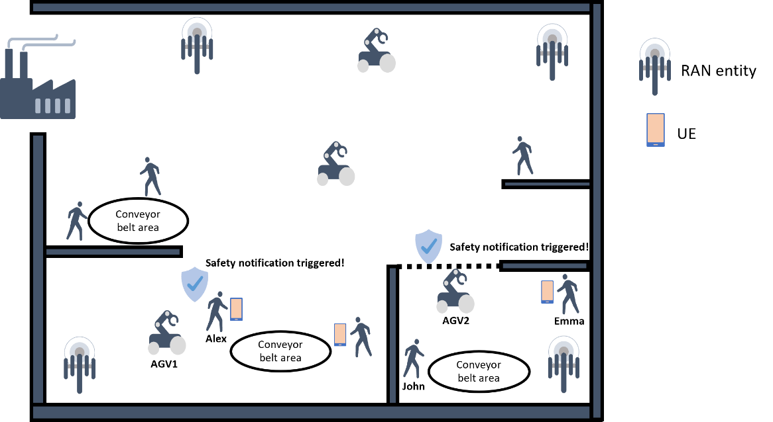

Figure 5.9.3-1: AGV presence and proximity detection

1. Alex is working in his section of the factory (shown in the lower left area in Figure 5.9.3-1), performing regular maintenance work around a conveyor belt.
2. An AGV, AGV#1, is approaching the area where Alex is working, carrying a heavy load to be placed at a designated location next to the conveyor belt.
3. Using the 3GPP sensing data from the RAN entities and the UE carried by Alex, the sensing entity processes the data to obtain sensing results and detects the proximity of the AGV1 to Alex. The sensing results are shared with a safety monitoring application of the factory, and a notification is sent to Alex to warn him of the approaching AGV.
4. Another AGV, AGV#2, enters an area (lower right area in Figure 5.9.3-1) with increased risk for workers due to higher workers presence and higher equipment and machines density. Based on the 3GPP sensing data from RAN entities, the sensing entity processes the data to obtain sensing results and detects the presence of AGV#2 and exposes the detection event to the factory safety monitoring application. The safety monitoring application triggers a warning sound to warn the workers (e.g., John and Emma) in that area of the approaching AGV.  
   Note that, in this scenario, none of the UEs was involved in the sensing session. However, the sensing entity can use 3GPP sensing data from UEs in the area (e.g., UE carried by Emma) in its sensing processing if available.
5. In another scenario, John (lower right area in Figure 5.9.3-1), working on his section, not having a UE, is being tracked using 3GPP sensing data from RAN entities and/or UEs. When John comes in proximity with an AGV, which has or does not have a UE, a warning message is sounded to alert John.

### 5.9.4 Post-conditions

Thanks to the warning messages, workers are safe and potential accidents caused by workers-AGVs interactions are avoided. By leveraging the sensing capability of the 5G based integrated communication and sensing system, the factory safety supervision is upgraded, and workers safety is enhanced.

### 5.9.5 Existing features partly or fully covering the use case functionality

None.

### 5.9.6 Potential New Requirements needed to support the use case

NOTE 1: The following requirements apply to networks managed by PLMN or NPN.

[PR 5.9.6-1] The 5G system shall be able to provide means to support NR-based sensing in a certain area or location.

[PR 5.9.6-2] Based on operator policy and location area, the 5G system shall be able to provide means to support per-UE authorization for NR-based sensing.

[PR 5.9.6-3] The 5G system shall be able to support means to enable RAN entities and UEs to transfer 3GPP sensing data to sensing processing entities in the 5G system responsible for processing and aggregation of the 3GPP sensing data.

NOTE 2: The “Sensing processing entities” in the above requirement refer to one or more entities in the 5G system responsible for aggregating and processing of 3GPP sensing data (e.g., core network).

[PR 5.9.6-4] Based on operator’s policy, the 5G system shall be able to support means to expose sensing results to a trusted third-party application.

## 5.10 Use case on UAV flight trajectory tracing

### 5.10.1 Description

With the development of UAV technologies and the increase of demands on rapid logistics, aerial photographing, environmental monitoring and public security, a variety of commercial UAV services gradually become reality.

Normally the commercial UAVs fly based on predetermined flight routes, following regulated positions, heights, speeds, and directions. E.g., a package-delivery UAV flies from the package sender to the package recipient; a task-execution (such as environmental monitoring) UAV flies from the UAV airport to the target area.

On-route flying is important for these commercial UAVs. Their flight routes are optimized and permitted by UAV service operators, UAV management department, or USS (Uncrewed Aerial System Service Supplier)/UTM (Uncrewed Aerial System Traffic Management). Usually, they have the shortest flight distance, avoid no-fly zone, and keep safe distance from obstacles (e.g., building, trees, hills) and other commercial UAVs.

Although a UAV is equipped with sensors to keep itself along the flight route, the external UAV flight trajectory tracing function is still necessary because these sensors sometimes are restricted. E.g., the camera is impacted by light situation; the UAV-borne radar is impacted by rainfall or snowfall, etc. If these events occur, UAV cannot correctly decide its own position, height or speed, and thus cannot follow the traced route.

Although there exist dedicated UAV surveillance equipment and radar, their large-scale deployment has great challenges due to lack of available sites and high installation and maintenance cost.

In comparison, using the 5G system can provide a cost-effective way to trace these UAVs, e.g., 5G network infrastructures with ubiquitous coverage can better trace the flight trajectory of each UAV.

Specifically, 5G RAN entities can rely on radio sensing to obtain the information on UAV position and motion (e.g., distance, angle) and send 3GPP sensing data to a sensing processing entity located in the 5G system.

As shown in Figure 5.10.1-1, the UEs that are connected to the 5G RAN entities can be configured to assist in the sensing operations, which can increase the sensing coverage, provide more positioning reference points, and improve sensing result accuracy and robustness. This improvement is a result of higher density of UEs compared to the base stations, which increases the probability that some UEs are located in positions that have shorter distance away from UAV than 5G RAN entities (e.g., UAV located in the middle of two 5G RAN entities while UE locates under UAV), or some UEs are located in the reflection directions that have larger radar cross section (RCS) than 5G RAN entities considering the UAV RCS variation in different reflection directions.

The 5G sensing processing entity can collect the sensing data from one or multiple network infrastructures.

The 5G network operator can provide the UAV flight trajectory tracing service to a trusted third-party application (e.g., UAV service operator, UAV management department, USS/UTM) as requested.

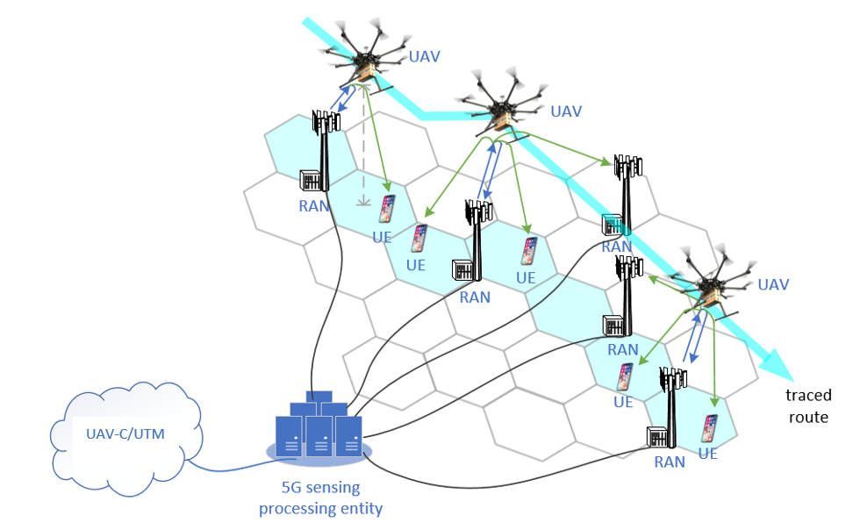

Figure 5.10.1-1: UAV flight trajectory tracing by 5G system

### 5.10.2 Pre-conditions

A UAV operator/UTM provides package delivery service in an area which is covered by 5G network. The UAV operator/UTM subscribes to the UAV flight trajectory tracing service from the 5G network operator.

The UAV operator/UTM provides the 5G network operator the characteristics of the UAV to be sensed, time and space (covering the regulated UAV flight routes and possible off-route locations) of the UAV flight trajectory tracing service.

### 5.10.3 Service Flows

When the appointed time starts, 5G network operator activates the UAV flight trajectory tracing function at the appointed space until the appointed time ends.

The UAV operator controls UAV#1 to take off from package delivery source and fly toward package delivery destination along a regulated flight route.

By radio sensing, a set of 5G base stations and UEs detect UAV#1, and then estimate the position and motion related metrics (e.g., distance, angle) as well as the target object is in coverage, resulting in 3GPP sensing data. The 5G RAN and UEs then send the 3GPP sensing data to the 5G sensing processing entity.

In certain cases, during the flying course, based on sensing and location information, if it is detected that UAV#1 has left the coverage of an old base station and entered the coverage of a new base station, the old base station could stop radio sensing and operate in a power saving mode. The new base station starts and keeps on sensing UAV#1 until it is out of coverage. Note that the determination that the UAV#1 has left the coverage of a base station or not could be determined based on the UAV positions and velocities estimated at the 5G sensing processing entity. Therefore, the network could then decide to activate and deactivate sensing in certain base stations based on this information. In other cases, the network could configure a start and stop of sensing operations for a base station based on a specified time period. In some other cases, during the flying course of the UAVs, based on location information, flying trajectory, sensing requirements, network conditions (e.g. network load) etc., if it is detected that the sensing coverage of the current base station monitoring UAV#1 has weakened and/or a new base station is available that can provide better sensing coverage to monitor UAV#1, a proactive sensing handover can be triggered. This would be useful for the sensing service continuity.

The 5G sensing processing entity collects the UAV 3GPP sensing data from one or multiple RANs and UEs, and estimates the positions and velocities, and sends in real time the sensing results (e.g., UAV positions, velocities) to the UAV operator and/or UTM.

Based on the received sensing results, the UAV operator and/or UTM traces the flight trajectory of UAV#1. Once the UAV operator and/or UTM detects an off-route event, it further steers UAV#1.

### 5.10.4 Post-conditions

UAV#1 delivers package to the destination along the traced flight route or its off-route behavior is sensed.

### 5.10.5 Existing features partly or fully covering the use case functionality

None.

### 5.10.6 Potential New Requirements needed to support the use case

[PR 5.10.6-1] Based on operator policy, request from UTM and sensing configuration (e.g. sensing area), the 5G system shall be able to support RAN entities and UEs in sensing the characteristics of an airborne object of interest (e.g., UAV), including generating 3GPP sensing data related to the object’s location and motion metrics (see examples in Table 5.10.6-1).

[PR 5.10.6-2] The 5G system shall be able to support means to authorize RAN entities and UEs in certain location area generating and reporting 3GPP sensing data (e.g., related to a UAV position, velocity) to a 5G sensing processing entity.

NOTE 1: The requirement above assumes that the 3GPP sensing data is post-processed in 5G sensing processing entity which is located within the 5G system.

[PR 5.10.6-3] The 5G system shall be able to support means to process the 3GPP sensing data and expose in real time the sensing results (e.g., related to a UAV position, velocity) from a 5G sensing processing entity to a trusted third-party application.

[PR 5.10.6-4] The 5G system shall support energy efficient sensing operations.

NOTE 2: Examples of energy efficient sensing operations can includetemporarily **disabling** sensing transmitters and receivers that are not involved in sensing and communication operations or adjusting the sensing operation parameters (e.g. sensing frequency).

[PR 5.10.6-5] Subject to operator’s policy, the 5G network may provide secure means for the operator to expose information on sensing service availability (e.g., if sensing service is available and the supported KPIs) in a desired sensing service area location to a trusted third-party.

[PR 5.10.6-6] The 5G system shall be able to provide the means for supporting sensing service continuity.

[PR 5.10.6-7] The 5G system shall support sensing services with KPIs as given in Table 5.10.6-1.

Table 5.10.6-1 Performance requirements of sensing results for UAV flight trajectory tracing

|  |  |  |  |  |  |  |  |  |  |  |  |  |
| --- | --- | --- | --- | --- | --- | --- | --- | --- | --- | --- | --- | --- |
| Scenario | Sensing service area | Confidence level [%] | Accuracy of positioning estimate by sensing (for a target confidence level) | | Accuracy of velocity estimate by sensing (for a target confidence level) | | Sensing resolution | | Max sensing service latency[ms] | Refreshing rate [s] | Missed detection [%] | False alarm [%] |
| Horizontal  [m] | Vertical  [m] | Horizontal  [m/s] | Vertical  [m/s] | Range resolution (horizontal/vertical)  [mxm] | Velocity resolution (horizontal/ vertical)  [m/s x m/s] |
| UAV flight trajectory tracing | Outdoor | N/A | 1-2 | 1-2 | 1-2 | 1-2 | 1m x 1m ~10m x 10m NOTE 2 | 1m/s x 1m/s ~ 10m/s x 10m/s NOTE 3 | 100~1000 NOTE 4 | 1Hz  NOTE 5 | 5 | 5 |
| NOTE 1: The terms in Table 5.10.6-1 are found in Section 3.1.  NOTE 2: To detect the UAV existence (e.g., for intrusion detection), the sensing resolution of distance is 10m [25]. To track the UAV flying (e.g., for collision detection and warning), the sensing resolution of distance is 1m [25].  NOTE 3: To detect the UAV existence, the sensing resolution of velocity is 10m/s [25]. To track the UAV flying, the sensing resolution of velocity is 1m/s [25].  NOTE 4: To realize 1m granularity tracking, when the velocity resolution is 1~10m/s, the maximum corresponding sensing service latency is 0.1~1s.  NOTE 5: Echodyne MESA-DAATM has approximate 1Hz scan rate [40]. | | | | | | | | | | | | |

## 5.11 Use case on sensing at crossroads with/without obstacle

### 5.11.1 Description

The various ways of transportation (e.g. vehicles, walking people, motor vehicle, non-motor vehicle) and the dense buildings make the traffic condition complicated. Typically, traffic accidents often happen at the crossroads for example the pedestrians suddenly rush to the road from the invisible place (e.g., behind the high buildings, behind the tall trees), which cause an urgent need to monitor the real-time road status for all days, thus with the collaboration of trusted third-party e.g. map service provider or ITS management platform, driving warning or assistant driving information can be provide timely to vehicles.

The road status includes vehicle moving information, VRU (Vulnerable Road User) information (e.g. VRU location, VRU moving direction, VRU moving speed, etc.), abnormal vehicle behaviour, road obstacles and road condition.

The road status information can be sensed by the cameras and radars on RSU (Road Side Unit). But considering the crossroad condition is very complicated, there are always some blind points. 5G based sensing can provide sensing information to fill these gaps.

For example, it is expected that the base station can sense the surrounding environment e.g. the road, and send the 3GPP sensing data to the core network. The core network can carry out systematic calculation and analysis of the 3GPP sensing data for outputting the sensing result. Such sensing result can be sent to a trusted third-party e.g. map service provider for combination with navigation map data, so as to make the driver aware of the congestion and traffic accidents in advance, and effectively increase the comfort and safety of driving. The base station sensing operations could improve the real-time map service with high reliability and quality.

But in some cases of above, the obstacles (e.g., high buildings or trees) block the transmission of radio signals. The availability and accuracy of the sensing service for the target objects which are located in the area will be greatly impacted.

To guarantee sensing service in this area, multiple 5G system sensing entities can work together.

### 5.11.2 Pre-conditions

Network operator “VV” has released a sensing service for road status sensing and has deployed base stations especially at multiple crossroads to continuously sense the road status.

Due to the high buildings (e.g. Building A) near the crossroads, there are some areas with obstacles for 5G base stations. Some 5G system sensing entities are further deployed by the network operator ‘VV’ to help radio signal transmission and collect 3GPP sensing data.

Network operator “VV” has a collaboration with the ITS management department that the user who has registered the Network operator “VV”’s “road status sensing service” can receive real-time road status information, driving warning or assistant driving information from ITS management platform.

Bob has registered the road status sensing service from Network operator “VV”.

Network operator “VV” can also deliver the real-time road information and the real time location/ trajectory of vehicles to a map service provider. The map service provider can provide “assisted driving service” based on this information.

Bob has a vehicle with the “assisted driving service” provided by the map service provider.

Bob drives the vehicle from home to the company in the morning of a working day.

### 5.11.3 Service Flows

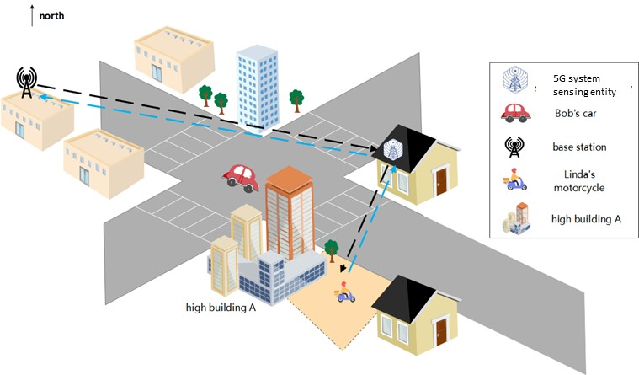

Figure 5.11.3-1. Sensing at crossroads with/without obstacle

1. The 5G base station continuously collects 3GPP sensing data of the road status and the sensing result is continuously reported to the trusted third-party (e.g. the map service provider or ITS management platform) by 5G network according to the preconfigured refresh rate (e.g. in the midnight, it uses slow refresh rate with 0.2Hz, and in the working day morning, it uses fast refresh rate with 10Hz). The refresh rate can be adjusted according to the trusted third-party demand and network operator’s policy.
2. In the working day morning, Bob has started his road status sensing service when he begins driving his vehicle to his office.
3. Bob drives his vehicle from home to his office and started assisted driving service. The map service provider sends the road sensing request to the 3GPP core network.
4. In the crossroad, there are some higher buildings. It is difficult for Bob to timely detect other vehicles and VRUs in the area. As example in figure 5.11.3-1, Bob is driving his vehicle and crossing the crossroad toward the southeast of the crossroad. Linda is driving her motorcycle on a side road toward the main road which is also the southeast of the crossroad. The line of sight between Bob and Linda is blocked by the high building A which is at a corner of the intersection.
5. Linda’s motorcycle activity is continuously sensed by the base station under the help of other 5G system sensing entities.
6. The 5G system collects and associates the multiple 3GPP sensing data from multiple base stations with the crossroad location. Considering the obstacles (e.g., high buildings or trees) in this area, it impacts the sensing quality and availability of the 3GPP sensing data from the blocked base stations. So, the 5G system needs to select suitable 3GPP sensing data to derive the sensing result to guarantee the availability of the sensing service.
7. The motorcycle sensing result which includes the motorcycles moving speed, moving direction, position etc. is periodically reported to the the map service provider and ITS management platform.
8. The other vehicles in the crossroad have been sensed and related sensing result are also reported to the map service provider and ITS management platform.
9. The map service provider fuses the sensing result with the map and then sends to the Tom’s vehicle.
10. According to the continuously received motorcycle sensing results, the ITS management platform can analyze and identify that there will be a potential collision risk between Bob and Linda. The collision warning then is sent to Bob.

### 5.11.4 Post Conditions

Bob’s vehicle receives the real-time map information which warns Bob that there is another cross-direction motorcycle driving towards his vehicle. Bob stops his vehicle before the crossroad to avoid a potential collision. With the assistance of RAN sensing, Bob arrives in the company safely and easily. Bob starts the daily work in the office.

Bob receives the warning and drives safely through the crossroads.

Linda can also ride safely to the crossroad. The potential risk of collision is avoided.

### 5.11.5 Existing features partly or fully covering the use case functionality

None.

### 5.11.6 Potential New Requirements needed to support the use case

[PR 5.11.6-1] The 5G system shall be able to support a mechanism to provide available sensing service in a target sensing service area.

[PR 5.11.6-2] The 5G RAN shall be able to collect 3GPP sensing data from requested target sensing service area according to the operator’s policy.

NOTE 1: The operator policy means to configure the target sensing service area, real time 3GPP sensing data collection or periodic collection etc.

[PR 5.11.6-3] The 5G system shall be able to report the sensing result to the trusted third-party with refresh rate which is requested by the trusted third-party e.g. a map service provider, and controllable by the operator, according to a business agreement.

NOTE 2: The sensing result can be the target object’s size, shape, position, moving direction, moving speed, etc.

[PR 5.11.6-4] The 5G system shall support means for a trusted third-party application, e.g. a map service provider to configure sensing per location.

[PR. 5.11.6-5] The 5G system shall be able to support the sensing service with given KPIs in Table 5.11.6-1.

Table 5.11.6-1 Performance requirements of sensing results for sensing at crossroads with/without obstacle

|  |  |  |  |  |  |  |  |  |  |  |  |  |
| --- | --- | --- | --- | --- | --- | --- | --- | --- | --- | --- | --- | --- |
| Scenario | Sensing service area | Confidence level [%] | Accuracy of positioning estimate by sensing (for a target confidence level) | | Accuracy of velocity estimate by sensing (for a target confidence level) | | Sensing resolution | | Max sensing service latency[ms] | Refreshing rate [s] | Missed detection [%] | False alarm [%] |
| Horizontal  [m] | Vertical  [m] | Horizontal  [m/s] | Vertical  [m/s] | Range resolution  [m] | Velocity resolution (horizontal/ vertical)  [m/s x m/s] |
| Sensing at crossroads with/without obstacle | Outdoor | 95 | ≤1 | N/A | N/A | N/A | N/A | N/A | ≤100  NOTE 2 | ≤ 0.1 | ≤5 | ≤5 |
| NOTE 1: The terms in Table 5.11.6-1 are found in Section 3.1.  NOTE 2: The value is sourced from [28]. | | | | | | | | | | | | |

NOTE: In this use case base station is acting as sensing transmitter and/or sensing receiver. This is an example and other options can also be valid.

## 5.12 Use case on Network assisted sensing to avoid UAV collision

### 5.12.1 Description

With the help of current 5G networks, the commercialization of low-altitude UAVs has entered a new stage. UAV can perform surveillance, early warning for many scenarios, and other tasks in low altitude airspace below commercial flights such as delivery. In the logistics industry, UAV delivery is developed very quickly and is estimated to become a nearly 10-billion-euro market. UAV delivery can be widely used in food distribution, retail commodity delivery, postal delivery, provision of medical aids, precision agriculture delivery, industrial delivery, etc.

While the UAV is applied in so many industries, how to avoid collision and effectively manage the UAV traffic are key challenges. In general, the UAV can provide its moving information and surrounding dynamic environment sensed by its own sensors to UTM (Uncrewed Aerial System Traffic Management), then the UTM controls the flight trajectory of the UAV accordingly. But the sensing range of a single UAV is limited and during a UAV flying, the UAV surrounding environment status will not be detected in time which will cause the UAV deviation or collision.

Using the wide coverage of 5G network, a UE on boarding UAV can be a subscriber of the 5G network and connect with UTM via the 5G network.

As shown in figure 5.12.1-1, through the communication connection between the 5G base station and the UE on boarding UAV, the UE can provide its positioning information and UE ID to 5G network. The 5G network and UTM can corelate the UE positioning information, UE ID with UAV ID. Based on it, on one hand, the 5G RAN nodes can work together to send sensing signal toward specific direction, angle, area to track the flight of the UAV. On the other hand, the UE can collect the reflection signals from its environments and send the 3GPP sensing data associated with the UE ID to 5G network via the communication connection. Some sensing information of the UAV flying environment, e.g. higher building, obstacles and other UAVs nearby, which will impact its safe flying can be collected by UE onboarding a UAV and then reported to 5G core network to be exposed to the UTM. Furthermore, continuous sensing service can be provided during UAV flight.

The UTM is using different inputs like classic radar, via systems currently used in general aviation like FLARM or ADS-B. In this sense, UTM already combines different sources of location information and could further use 5G sensing as additional source for the specific UAV to avoid it deviating from course and collision. When multiple UAVs appear in the same area, the base station also can sense them at the same time.

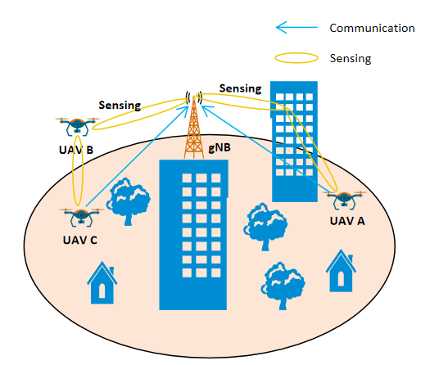

Figure 5.12.1-1 Network assisted collision avoidance for the UAVs

The following service flow gives an example of UAV delivery in retail goods delivery.

### 5.12.2 Pre-Conditions

Network Operator ‘MM’ provides a new 5G service named ‘5G Sensing Service’.

The UAV City Express ‘SS’ uses a specific UTM to assist its retail goods UAV delivery.

This UTM uses ‘5G Sensing Service’ provided by 5G network Operator ‘MM’ as additional source of information and navigate the UAVs.

Tom has ordered online daily necessities from a supermarket. Tom is living in downtown.

Jerry has also ordered online some food from a supermarket. Jerry is living in countryside.

The supermarket prepares the goods in packages and asks City Express ‘SS’ to deliver them to Tom and Jerry.

City Express ‘SS’ dispatches UAV A for Tom, and UAV B for Jerry.

UE A is on board UAV A and UE B is on board UAV B. Both UE A and UE B are subscribed to the 5G network of Operator ‘MM’.

Through the communication connections between the 5G RAN and the UE A/ UE B, the UE provides its positioning information and UE ID. The 5G network and UTM corelate the UE positioning information, UE ID with associated UAV ID.

### 5.12.3 Service Flows

The UAV A and UAV B are flying to their destinations under the guidance of UTM with the assistance of the ‘5G Sensing Service’ provided by network Operator ‘MM’.

Considering that UAV A will fly to downtown, the UTM asks network Operator ‘MM’’s ‘5G Sensing Service’ to provide sensing service for UAV A, and the required sensing result includes the flying environment along its trajectory, e.g. altitude of the buildings, obstacles and other UAVs nearby.

Considering UAV B will fly to the countryside, the UTM asks network Operator ‘MM’’s ‘5G Sensing Service’ to provide sensing service for UAV B, and the required sensing result includes the flying environment along its trajectory e.g. obstacles, and other UAVs nearby.

The UTM requests the report period about UAV A and UAV B.

Each base station continuously sends sensing signaling along the UAV A’s trajectory, and the UE A on board of the UAV A can send the 3GPP sensing data which it collects for its surrounding environment back to the RAN using the 5G communication connection. Then, the 5G network can obtain a comprehensive UAV A’s flying environment sensing result e.g. building position, altitude, other nearby moving objects e.g. other UAV’s relative position, altitude, degree of moving angle, moving speed etc. to UTM.

Same sensing operation is also for UAV B.

The 5G network reports the sensing result periodically according to UTM’s request.

The UTM adjusts and guides the UAV flying trajectories considering the received sensing result and input from other sources (e.g. FLARM, ADS-B).

Considering UAV A is flying toward downtown, both the flying environment (e.g. many buildings) and wireless environment are complex compared with UAV B and its environment in countryside, the 5G network needs to configure different sensing operation for UAV A and UAV B to guarantee required sensing service quality, for example to operate sensing with shorter period, sensing KPI, and report sensing result with higher refresh rate for UAV A.

### 5.12.4 Post-Conditions

The UAV A successfully delivers package to Tom and UAV B successfully delivers package to Jerry and return safely.

### 5.12.5 Existing features partly or fully covering the use case functionality

None.

### 5.12.6 Potential New Requirements needed to support the use case

[PR 5.12.6-1] The 5G system shall be able to provide a sensing service to track one specific target object and the environment around the target object with the sensing assistance information provided by the UE on board the specific target object or authorized third-party.

[PR 5.12.6-2] The base stations shall be able to sense multiple specific target objects and their environments at the same time.

[PR 5.12.6-3] The 5G system shall be able to provide a mechanism controllable by the operator, according to a business agreement, for a trusted third-party to request the sensing service related with a certain target object or multiple target objects of a certain location area.

[PR 5.12.6-4] Based on operator policy, the 5G system shall be able to provide a mechanism for a trusted third-party to request per location area different sensing services configuration (e.g. sensing KPI, report refresh rate etc.).

[PR 5.12.6-5] The 5G system shall be able to report sensing result of the environment around a specific target object to a trusted third-party.

NOTE 2: The sensing result of the environment for example can be its position, the size of obstacles around, and other moving objects nearby.

[PR 5.12.6-6] The 5G system shall be able to provide sensing service with follow KPIs:

Table 5.12.6-1 Performance requirements of sensing results for network assisted sensing to avoid UAV collision

|  |  |  |  |  |  |  |  |  |  |  |  |  |
| --- | --- | --- | --- | --- | --- | --- | --- | --- | --- | --- | --- | --- |
| Scenario | Sensing service area | Confidence level [%] | Accuracy of positioning estimate by sensing (for a target confidence level) | | Accuracy of velocity estimate by sensing (for a target confidence level) | | Sensing resolution | | Max sensing service latency  [ms] | Refreshing rate  [s] | Missed detection  [%] | False alarm  [%] |
| Horizontal  [m] | Vertical  [m] | Horizontal  [m/s] | Vertical  [m/s] | Range resolution  [m] | Velocity resolution (horizontal/ vertical)  [m/s x m/s] |
| Network assisted sensing to avoid UAV collision | Outdoor | 95 | 1 | 1 | 1  NOTE 2 | 1 NOTE 2 | <1  NOTE 2 | 1 | 500 | 0.5 | N/A | N/A |
| NOTE 1: The terms in Table 5.12.6-1 are found in Section 3.1.  NOTE 2: The KPI values are sourced from [25] and [40]. | | | | | | | | | | | | |

Editor's Note: Other potential new requirements are FFS.

NOTE 3: In this use case base station is acting as sensing transmitter and/or sensing receiver. This is an example and other options can also be valid.

## 5.13. Use case on sensing for UAV intrusion detection

### 5.13.1 Description

UAV industry is developing quickly around the world with the widely usages in various scenarios such as aerial photography, police force, urban management, agriculture, geology, meteorology, electric power, emergency rescue and disaster relief, etc. Especially for the smart city in future, a large number of UAVs will be used to improve the quality of our daily life including industrial inspection, public security patrol, cargo transportation, live broadcast and so on. However, this also brings big challenges on UAV supervision due to the following reasons:

1) Low-altitude UAVs have characteristics as large number, small size, wide flying zone, widely used to execute complex and diverse tasks, which makes UAV supervision very difficult if only using the traditional radar system.

2) Non-cooperative UAVs could intrude some no-fly zone (e.g. airport, military base) intentionally or unintentionally which would lead to serious consequences, e.g. exposing private information using the camera, blocking other UAV traffic on the flying route.

5G radio signals can be used to provide wireless access for communication, meanwhile the 5G radio signals can also be used to generate sensing data for object detection e.g. sense presence or proximity of UAVs illegal flying in a specific area. 5G System could provide sensing service by processing sensing data and output sensing information (e.g. relative position, altitude, distance, velocity, direction). In this case, 5G System could be used for sensing the UAV intrusion in the scenarios of UAV illegal flying in restricted area include light rail, airports, government facilities, research institutes, high-speed railway stations, temporary performance venue and other permanent or temporary restricted areas.

Furthermore, considering that the UAV entering the restricted area is illegal and the UAV itself even could be illegal, this kind of sensing operation doesn’t require the cooperation of the UAV. That means the UAV may be unaware of the sensing operation. When multiple UAVs appear in the same restricted area, the 5G system can sense presence or proximity of multiple UAVs illegal flying at the same time.

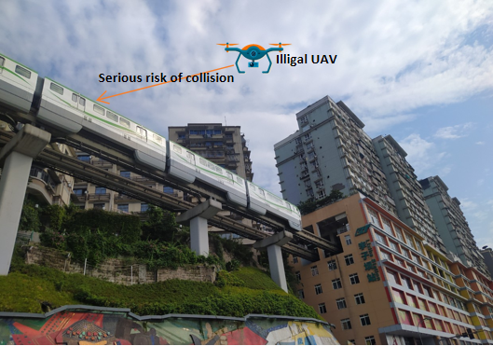

Figure 5.13.1-1 UAV collision risks at light rail (Level1)

Another example is flight route protection area intrusion detection. Compared to the wide no-fly zone (e.g. airport, military base), the flight route of a UAV is pre-allocated by UTM for given time period with restricted space vertically and horizontally, and it is generally much narrower and longer giving rise to more stringent requirements of positioning of an intruder. Such route in space shall be protected from illegal or uncollaborated UAVs for potential collision and unlawful usage. The characteristics of flight route can be virtualized in Figure 5.13.1-2 as a 3D tunnel with a 40 x 20 meter cross section which shall be monitored or sensed continuously in space and time by the 5G system to detect the presence of unauthorized usage. If illegal UAV is detected over given UAV route, 5GS will trigger intrusion alarm and UTM will take further action to warn the UAV which has been assigned for that route for potential re-routing or other necessary actions.

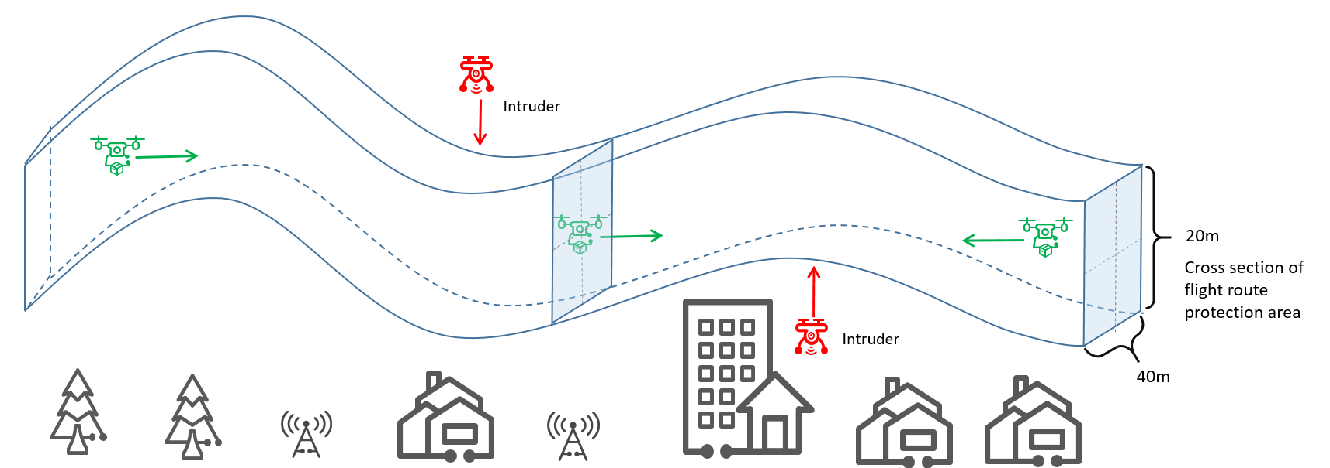

Figure 5.13.1-2 UAV collision over flight routes (Level 2)

### 5.13.2 Pre-conditions

The UAVs owned by the logistics operator ‘YY’ will take off and fly. The logistics operator ‘YY’ requests UTM to manage potential illegal intrusion into the UAV flight routes protection area. The logistics operator ‘YY’ has provided the information of flight routes protection area to the UTM.

Network operator ‘MM’ provides 5G sensing service for the park, flight routes protection area of the logistics UAV and the light rail area with its 5G network covering the park, flight routes protection area of the logistics UAV and the light rail track. ‘MM’ can make use of base stations to sense the airspace within their coverage area and report the sensing information to the USS/UTM as defined in TS 23.256 clause 3.1.

The Light rail operator ‘XX’ uses a UTM to management potential UAV illegal intrusion along the light rail tracks. ‘XX’ has provided its restricted area information to the UTM.

There is a need to hold a ceremony with high security requirement in the park temporarily, turning the park in a restricted area where UAVs are not allowed to enter. The administrator has a subscription for UAV prevention service from the USS/UTM.

The UTM uses ‘5G Sensing Service’ provided by 5G network Operator ‘MM’ to detect potential UAV illegal intrusion for above scenarios.

The UTM requests that once a UAV is detected that its distance from the border of the restricted area is less than 10m, the 5G system should report the event to the UTM.

The Network operator ‘MM’ can configure energy consumption sensing mode with different sensing period, e.g. operate sensing one time per 50 seconds, per 10 seconds, per second etc. And in emergency condition, the 5G system can provide continuously sensing service according to the UTM’s request.

The light rail works from 5:30 am to 23:00 pm every day.

### 5.13.3 Service Flows

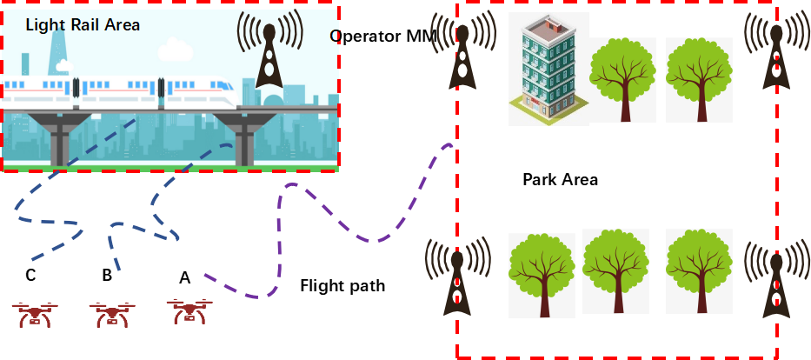

Figure 5.13.3-1: Sensing for UAV intrusion detection

The 5G system periodically senses the restricted area whether there are UAVs flying into the restricted area border for both the Park, flight routes protection area of the logistics UAV and the light rail area.

There are three UAVs (A, B, C) flying around the restricted areas.

When UAV A flying near the Park is detected and closely tracked with required accuracy in the sensing area, the 5G system reports the sensing results to the UTM in real time and begins continuously sensing. Then, the UAV A flying into the flight routes protection area of the logistics UAV is detected, and closely tracked with required accuracy in the sensing area, the 5G system reports the sensing results to the UTM in real time and continuously senses.

When UAV B and UAV C flying near the light rail are detected, and closely tracked with required accuracy in the sensing area, the 5G system reports the sensing results to the UTM in real time and continuously senses.

To reduce energy consumption, the 5G system will notify the UTM that the 5G system cannot detect any UAVs illegal flying after a time period which is requested by the UTM. After that, the 5G system stops continuously sensing and begins periodically sensing operation according to the Network Operator’s policy.

The USS/UTM could trigger to send warning messages/notices to UAV controller based on analytical results based on the sensing information from the mobile network. Alternatively, the USS/UTM will trigger UAV countermeasures to prevent the UAV from flying in the no-fly area or flight routes protection area of the logistics UAV.

When the ceremony has been finished or the logistics UAV lands, the 5G system would stop sensing operation based on the request from UTM. And when the light rail stops operation between 23:00 pm to 5:00am next morning, the 5G system stops sensing operation to save energy.

### 5.13.4 Post-conditions

The mobile network can provide sensing service for UAV intrusion detection with high quality and continuity, to improve the accuracy and efficiency of public safety supervision and management.

USS/UTM interacts with the mobile network for sensing service and perform UAV intrusion detection based on the sensing information exposed by network.

### 5.13.5 Existing features partly or fully covering the use case functionality

None.

### 5.13.6 Potential New Requirements needed to support the use case

[PR 5.13.6-1] The 5G system shall be able to provide a sensing service by using RAN to collect 3GPP sensing data.

[PR 5.13.6-2] The RAN shall be able to sense a target object by obtaining 3GPP sensing data without active involvement of the target object.

[PR 5.13.6-3] The 5G system shall provide mechanisms for an operator to transport 3GPP sensing data from RAN towards the core network.

[PR 5.13.6-4] Based on operator’s policy and subject to regulatory requirements, the 5G system shall be able to provide a mechanism for a trusted third-party to request the sensing service and based on the request, the base station shall be able to operate sensing periodically or continuously in certain location area for a certain amount of time.

[PR 5.13.6-5] Based on operator’s policy and subject to regulatory requirements, the 5G system shall be able to periodically expose sensing results to a trusted third-party application.

[PR 5.13.6-6] The 5G system shall provide a mechanism controllable by the operator, according to a business agreement, to report sensing result to a trusted third-party about a target object and multiple target objects when specific conditions are met.

NOTE: These conditions could be the target object distance from the restricted area border less than 10m or entering restricted area.

[PR 5.13.6-7] The 5G system shall be able to support the activation and deactivation of the sensing service according to operator’s policy.

[PR 5.13.6-8] The 5G system shall be able to provide a mechanism for network operator to configure and adjust sensing operation (e.g. authorization, sensing area, sensing operation period and sensing operation time window etc.) based on request from a trusted third-party.

[PR 5.13.6-9] The 5G system shall be able to provide sensing with following KPIs:

Table 5.13.6-1 Performance requirements of sensing results for UAV intrusion detection

|  |  |  |  |  |  |  |  |  |  |  |  |  |  |
| --- | --- | --- | --- | --- | --- | --- | --- | --- | --- | --- | --- | --- | --- |
| Scenario | | Sensing service area | Confidence level [%] | Accuracy of positioning estimate by sensing (for a target confidence level) | | Accuracy of velocity estimate by sensing (for a target confidence level) | | Sensing resolution | | Max sensing service latency  [ms] | Refreshing rate  [s] | Missed detection  [%] | False alarm  [%] |
| Horizontal  [m] | Vertical  [m] | Horizontal  [m/s] | Vertical  [m/s] | Range resolution  [m] | Velocity resolution (horizontal/ vertical)  [m/s x m/s] |
| UAV intrusion detection  NOTE 2 | Level 1 | Outdoor | 95 | ≤10 | ≤10 | N/A | N/A | 10 | [5] | [≤1000] | [≤1] | ≤5 | ≤5 |
| Levle2 | Outdoor | 95 | ≤5 | ≤5 | N/A | N/A | 10 | [5] | [≤1000] | [≤1] | ≤5 | ≤5 |
| NOTE 1: The terms in Table 5.13.6-1 are found in Section 3.1.  NOTE 2: Level 1 and level 2 depend on the size of the restriction area to be sensed. | | | | | | | | | | | | | |

NOTE: In this use case base station is acting as sensing transmitter and/or sensing receiver. This is an example and other options can also be valid.

## 5.14. Use case on sensing for tourist spot traffic management

### 5.14.1 Description

In order to ensure the sustainable development of tourist spots, the traffic flow management of tourist attractions should fully consider the space-carrying capacity, facility-carrying capacity, ecological-carrying capacity and other factors that may induce disasters within the area.

The scenic area controls the traffic flow through real-time monitoring, diversion of traffic and early warning and reporting. The flow control of tourist spots includes two aspects: passenger-flow management and vehicle-flow management.

Traffic data collection is an important part of traffic management. Base stations in tourist area can provide 5G communication service and also can sense the passenger and the vehicle in its coverage at gates or per unit area that are set with a finer granularity. For tourist spots with a large area, it will be convenient to use base station to have the traffic sensing data sources when it's difficult to deploy equipment like camera and other sensors.

### 5.14.2 Pre-conditions

Network Operator A provides 5G services for a famous tourist spot.

The management department of the tourist spot has subscribed the sensing service provided by 5G network Operator A, and the base stations in the tourist area can be used to sense the traffic flow and the crowd density (for both including the vehicles and passengers) constantly.

Jim is the worker of the tourist spot and responsible for traffic management.

### 5.14.3 Service Flows

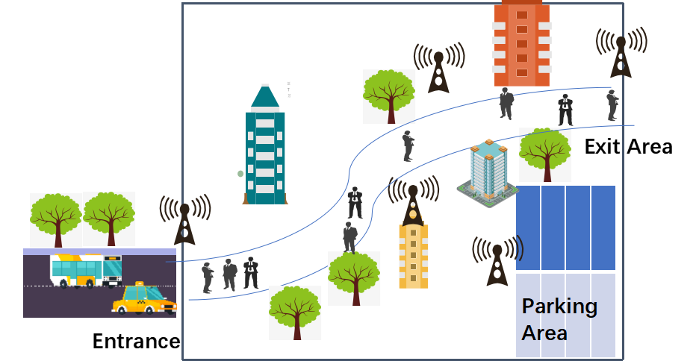

Figure 5.14.3-1: Sensing for tourist spot traffic management

1. When the scenic area begins to open, Jim will operate the scenic area traffic monitoring system to start real-time traffic control.

2. The traffic management system of the scenic spot will send a service request to the operator network to start sensing the people and vehicles in the scenic spot.

3. The base stations at the entrance and exit of the scenic spot can sense the people and vehicles that enter or leave the place, and the base stations in the scenic spot can sense the people and vehicles for certain area (e.g. walkway, parking area).

4. Operator A reports the traffic sensing information from the base stations in the scenic spot to the traffic monitoring system. Based on the sensing information, the traffic management system could analyse the traffic status and decide whether the traffic in the area is congested.

5. If the congestion exceeds the threshold, the management system would notice Jim about the detail, and Jim would trigger to limit traffic to avoid traffic overload in the scenic spot.

### 5.14.4 Post-conditions

With 5GS support to the traffic management system, the vehicles and tourists are controlled within a reasonable range, and the spot can operate normally during business hours.

### 5.14.5 Existing features partly or fully covering the use case functionality

None.

### 5.14.6 Potential New Requirements needed to support the use case

[PR 5.14.6-1] The 5G system shall be able to provide means to use base station(s) to perform sensing in certain area.

[PR 5.14.6-2] Subject to regulatory requirements and operator policy, the 5G system shall be able to expose sensing results to a trusted third-party application.

[PR 5.14.6-3] Subject to regulatory requirements and operator policy, the 5G system shall be able to support the activation and deactivation of the sensing service based on location.

[PR 5.14.6-4] The 5G system shall be able to provide sensing service with KPIs given in Table 5.14.6-1.

Table 5.14.6-1 Performance requirements of sensing results for tourist spot traffic management

|  |  |  |  |  |  |  |  |  |  |  |  |  |
| --- | --- | --- | --- | --- | --- | --- | --- | --- | --- | --- | --- | --- |
| Scenario | Sensing service area | Confidence level [%] | Accuracy of positioning estimate by sensing (for a target confidence level) | | Accuracy of velocity estimate by sensing (for a target confidence level) | | Sensing resolution | | Max sensing service latency  [ms] | Refreshing rate  [s] | Missed detection  [%] | False alarm  [%] |
| Horizontal  [m] | Vertical  [m] | Horizontal  [m/s] | Vertical  [m/s] | Range resolution  [m] | Velocity resolution (horizontal/ vertical)  [m/s x m/s] |
| Tourist spot traffic management | Outdoor | 95 | [≤2] | N/A | [1] | N/A | [1] | [1] | [≤5000] | [≤0.2] | ≤5  NOTE 2 | ≤5  NOTE 2 |
| NOTE 1: The terms in Table 5.14.6-1 are found in Section 3.1.  NOTE 2: Missed detection or false alarm describes missing to acquire a sensing result or acquiring a wrong sensing result which referring to a target object (a person or a vehicle), in this use case will be missing detect a person or a vehicle, not referring to the number of a crowd of people or vehicles. | | | | | | | | | | | | |

NOTE: In this use case base station is acting as sensing transmitter and/or sensing receiver. This is an example and other options can also be valid.

## 5.15 Use case on contactless sleep monitoring service

### 5.15.1 Description

Compared with wearable devices, contactless sensing technologies have more advantages in health status detection. 3GPP system are designed for catering people’s communication purpose, whose wireless signals are very rich and can be accessible ubiquitously. With additional processing, 3GPP system will breed new opportunities with contactless sensing technologies applied, such as smart health, smart home, smart city and even smart space.

Sleep Monitoring application describes the case that a human’s sleep situation is monitored without any wearable device [31]. Instead of utilizing capacitors as propagation medium, Sleep Monitoring application effectively reuses the current ubiquitously accessible medium, that is wireless signals to realize the sensing purpose. People’s presence, movement and even respiration will affect the wireless signal propagation, which on the receiving side will be presented as the fluctuation of waveform’s intensity, phase shift and etc.

Figure 5.15.1-1 describes how the wireless signals that are propagated via the established direct network connection (i.e. between the radio access network and 5G UE) will be affected and distorted by the target sensing object. Generally, when people are sleeping, regular chest rise and fall will cause additional vibration of the target object when detecting the doppler [37], this is defined as the **micro doppler effect** in radar [32]. By observing the micro doppler effect, people’s respiration rate per minute can be counted.

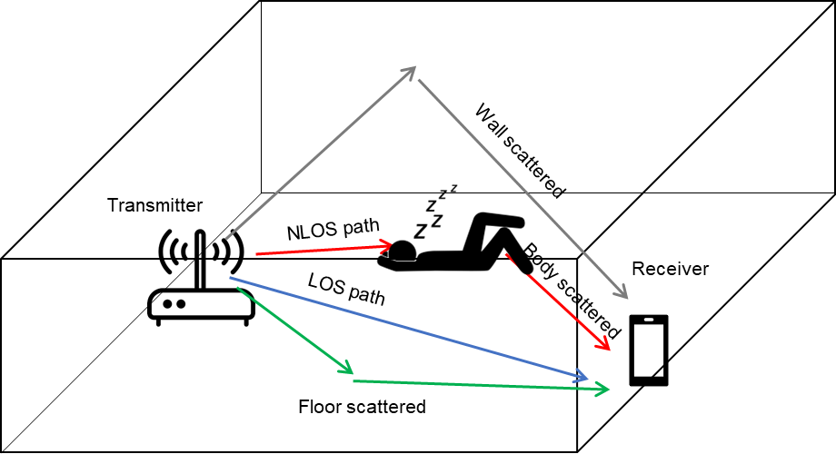

Figure 5.15.1-1: People’s respiration affected 3GPP wireless signal propagation in an indoor environment

NOTE 1: The transmitter as shown in Figure 5.15.1-1 is an indoor small base station as described in TS22.261 [33].

NOTE 2: The transmitter as shown in Figure 5.15.1-1 can also be a CPE that is used for this service.

This sleep monitoring application can help to diagnose early symptoms of some diseases, e.g. milder symptoms of sleep apnea before it develops worse [41]. Through monitoring people’s breathing, i.e. respiration rate, and the breathing stoppage duration, the application server can give instructions to the user on whether or not the user is experiencing sleep apnea, and the user in return can adjust lifestyles such as losing weight or quitting smoking to avoid worse cases.

- A person's **respiratory rate** is the number of breaths you take per minute. The normal respiration rate for an adult at rest is 12 to 20 breaths per minute. A respiration rate under 12 or over 25 breaths per minute while resting is considered abnormal [42].

- The breathing stoppage duration is the amount of time that a sleep apnea patient stops breathing, which can be from 10 seconds to two minutes or more [41]. We take breathing stoppage duration = 10 seconds for example as the trigger of the event reporting to the application server. When the user triggers this sensing service, the sensing system will monitor this special event and report it to the application server.

### 5.15.2 Pre-conditions

The device installing this sleep monitoring application is 5G UE.

There is a service agreement between MNO and sleep monitoring operator. The MNO can also be the sleep monitoring application provider.

### 5.15.3 Service Flows

1. The application user Bob triggers the sleep monitoring application on the 5G UE. When the application server receives the request, the application server contacts the 5G system to trigger the sensing service to monitor Bob’s respiration rate.

2. 5G system discovers a base station (or CPE) to start the sleep monitoring sensing service.

3. The base station (or CPE) coordinates with Bob’s phone (5G UE) to perform the sensing measurement process. The base station and the 5G UE can be transmitter and receiver or vice versa. The receiver measures the 5G wireless signals (e.g., number of detected transmission paths, micro doppler shift, etc.) and collects them as the 3GPP sensing data.

4. 3GPP sensing data is processed to derive the sensing results (e.g. respiration rate) locally or is provided to the 5G network: 5G network processes the 3GPP sensing data to derive the sensing results and exposes the sensing results to the sleep monitoring application server.

5. The 5G UE receives the sleep monitoring feedback from the application server and shows it to the application user Bob. Bob can have sleep apnea and needs the application to further monitor his breathing stoppage duration. An event with “breathing stoppages duration = 10 seconds” is triggered by Bob and received by the application server, which then contacts the 5G system to trigger this event.

6. 5G system adjusts the sensing measurement process and executes Steps 3-5. When the event report criteria are satisfied, i.e. Bob is detected to have a 10-second breathing stoppages duration, the application server will receive the notification sent by 5G system.

### 5.15.4 Post-conditions

The user experiences the sleep monitoring application enabled by the 5G network. Bob changes his lifestyle, he does more exercise, and tries to lose weight to avoid the sleep apnoea problem.

### 5.15.5 Existing feature partly or fully covering use case functionality

None.

### 5.15.6 Potential New Requirements needed to support the use case

[PR 5.15.6-1] The 5G system shall support mechanisms to discover and configure a UE and a base station to perform sensing measurement process in a certain sensing service location area.

[PR 5.15.6-2] The 5G system shall support mechanisms to derive and expose sensing results to a trusted third-party.

[PR 5.15.6-3] The 5G system shall be able to provide 5G wireless sensing service with the following KPIs:

Table 5.15.6-1 Performance requirements of sensing results for contactless sleep monitoring

|  |  |  |  |  |  |  |  |  |  |  |  |  |  |
| --- | --- | --- | --- | --- | --- | --- | --- | --- | --- | --- | --- | --- | --- |
| Scenario | Sensing service area | Confidence level [%] | Human motion rate accuracy  [Hz] | Accuracy of positioning estimate by sensing (for a target confidence level) | | Accuracy of velocity estimate by sensing (for a target confidence level) | | Sensing resolution | | Max sensing service latency[ms] | Refreshing rate [s] | Missed detection [%] | False alarm [%] |
| Horizontal  [m] | Vertical  [m] | Horizontal  [m/s] | Vertical  [m/s] | Range resolution  [m] | Velocity resolution (horizontal/ vertical)  [m/s x m/s] |
| Sleep monitoring | Outdoor (bedroom) | 95 | 0.033  NOTE 2 | N/A | N/A | N/A | N/A | N/A | N/A | 60s | 60 | 5 NOTE 3 | 5  NOTE 3 |
| NOTE 1: The terms in Table 5.15.6-1 are found in Section 3.1.  NOTE 2: Respiration rate = 18 times/min as reference, any detected value in [16,20] satisfies accuracy requirements, 0.033Hz corresponds to 2 times/min.  NOTE 3: Detect event = “breathing stoppages duration >= 10 seconds” as reference. | | | | | | | | | | | | | |

NOTE: In this use case base station and UE is acting as sensing transmitter and/or sensing receiver. This is an example and other options can also be valid.

## 5.16 Use case on Protection of Sensing Information

### 5.16.1 Description

This use case re-uses the scenario where a UE performs sensing to detect intruders in the home, as per use case 5.1 (intruder detection in smart home). The additional aspect introduced in this use case is that there is an unauthorised user that is attempting to collect sensing information from Mary's home.

### 5.16.2 Pre-conditions

Refer to use case 5.1 where 5G CPEs (i.e. UEs) are set up to detect intruders when Mary's home is vacant as her family is on holiday.

### 5.16.3 Service Flows

An unauthorised user is in the vicinity of Mary's home.

In Mary's home, the 5G CPE transmits 5G signals, and the reflected signals are used by the unauthorised user's device to collect sensing information.

As the 5G signals from the CPEs in Mary's home are protected, the unauthorised user's device fails to derive any sensing information.

### 5.16.4 Post-conditions

The privacy of sensing information in Mary's home is preserved.

The unauthorised user cannot use the 5G signals to detect that the family is not at home.

### 5.16.5 Existing features partly or fully covering the use case functionality

None

### 5.16.6 Potential New Requirements needed to support the use case

[PR 5.16.6-1] The 5G system shall provide a mechanism to protect identifiable information that can be derived from the 3GPP sensing data from eavesdropping.

## 5.17 Use case on health monitoring at home

### 5.17.1 Description

Tom is an elderly person living in his house. Since he has become weaker, he has subscribed to a wireless sensing service of his MNO so that his health state (including e.g. lack of movement, detection of falls, breathing rate) can be monitored 24/7 when he is at his home. Wireless sensing is a promising technology for health monitoring [34] [35] [36] [37] that does not require a person to wear a health monitoring device on his/her body (which people may forget, requires recharging, and can be uncomfortable to wear over long periods of time).

A single base station is not capable of covering Tom’s home with good coverage. Thus, multiple base stations capable of acting as wireless transmitters and/or receivers cooperate to ensure excellent coverage. Furthermore, the received reflected radar signal is sometimes weak, and thus, the MNO offers the possibility of using a phone with wireless sensing receiving capabilities. The usage of the phone also allows more accurate measurements of certain vital signs (e.g. breathing rate) since the phone is close to Tom. The usage of the phone also allows the MNO to offload the workload from the base station to the phone. Also other UEs in vicinity of Tom could take part in the sensing.

Fig. 5.17.1.1 shows a schematic illustration of how such system could look like, whereby the blue arrow indicates transmitted wireless sensing signals from Base Station A, and the green dashed arrows indicate reflected wireless sensing signals received by Base Station B and Tom’s phone.

Figure 5.17.1-1: Example of a distributed sensing system (incl. two base stations, a UE and a Sensing function).

### 5.17.2 Pre-conditions

1. Tom has subscribed to the sensing service offered by an MNO.

2. The MNO has deployed two RAN entities (e.g. base station A and base station B) that are capable of wireless communication and sensing. The base stations can act as wireless sensing transmitters and/or wireless sensing receivers. These two base stations are sufficiently close to Tom's house to provide good coverage in and around Tom's house in the frequency bands used for wireless sensing. Tom’s subscription includes a phone with wireless sensing capabilities for more accurate sensing.

3. Tom has a mobile phone that is capable of detecting wireless sensing signals. Tom can use it to directly and/or more accurately sense his health state.

4. The 3GPP sensing data from the RAN and UEs is collected and processed by a sensing function that can be deployed in the 5G network or provided by an external application or a combination thereof. The exact separation of functionalities between those entities is not explored further in this use case. The sensing function is assumed to be capable of extracting health state information, e.g. lack of movement, detection of falls, breathing rate from this 3GPP sensing data, determine the sensing requirements (e.g. accuracy), and determine the criteria/thresholds (e.g. lack of movement) on when to create an alert.

### 5.17.3 Service Flows

1. Based on Tom’s sensing subscription, information about a user (in this case Tom) is obtained including information about where he lives and sensing requirements that are needed (e.g. sensing of movements which can be used to detect falls or sufficient activity of Tom).

2. Base station A starts transmitting the wireless sensing signal.

3. Tom is currently located in the living room. If Tom is at this location, base station A can hardly receive the reflection of its transmitted sensing signal. However, base station B can receive a strong reflection of that sensing signal. Base station A and B coordinate with each other so that Base Station B is capable of processing the received reflected wireless sensing signal, generating 3GPP sensing data that is sent to a sensing function for further processing. In this manner, movements of Tom in and around the house can be monitored, and it can be detected if Tom falls.

4. Tom feels a bit weak today and decides to measure his health state in more detail. Tom was told that he needs to carry his phone to enable this. Tom picks up his phone and uses it as a wireless sensing receiver capable of picking up and processing the reflected wireless sensing signal transmitted by Base station A. This requires the phone to coordinate wireless sensing with Base station A, which includes for example exchanging of capabilities (since the sensing capabilities can differ per phone) and coordinating of timing/frequencies of sensing signals. Since Tom’s phone is very close to Tom, Tom can use his phone for more accurate sensing of certain vital signs, such as breathing rate and heart rate. The phone sends measurements to a sensing function for further processing. When Tom goes to sleep, he puts his phone next to him to monitor his vital signs also during the night.

5. When Tom’s health state is determined to be in danger, e.g., when Tom falls or stops moving, the family or emergency services gets alerted of such event.

### 5.17.4 Post-conditions

The sensing service/application receives accurate 3GPP sensing data about Tom and can generate alerts if an adverse event happens to Tom.

### 5.17.5 Existing features partly or fully covering the use case functionality

None.

### 5.17.6 Potential New Requirements needed to support the use case

[PR 5.17.6-1] The 5G system shall be able to coordinate wireless sensing among a set of RAN entities and UEs.

[PR 5.17.6-2] The 5G system shall support a mechanism for the 5G network to retrieve the wireless sensing capabilities from UEs and RAN entities, and for the UEs and RAN entities to exchange capabilities amongst each other.

[PR 5.17.6-3] The 5G system shall support a mechanism for two or more authorized UEs and/or RAN entities to take part in the wireless sensing of a target, whereby the authorization may be provided based on location.

[PR 5.17.6-4] The 5G system shall support a mechanism to provide wireless sensing capable UEs and RAN entities with information of which network entity to send the 3GPP sensing data to.

## 5.18 Use case on service continuity of unobtrusive health monitoring.

### 5.18.1 Description

An elderly home has installed a new 5G system capable of providing communication and sensing capabilities through the facilities as illustrated in Figure 5.18.1-1. The deployed 5G system includes multiple sensing devices, e.g., base stations, providing connectivity and sensing capabilities. These sensing devices can perform wireless sensing of a target, in this case, health monitoring (e.g. fall/activity detection [34][35][36] or wireless sensing of vital signs such as heart rate [38] or breathing rate [37] of one or more persons). Since elderly people move through the facilities, it is important to provide health monitoring independently of the base station used for sensing. The staff of the elderly home really likes this new 5G wireless sensing feature because it is unobtrusive and offers various advantages over the old system that they use with body worn sensors. For example, they don’t need to recharge or replace the batteries of body worn sensors anymore and remind people or help people to wear them after they took them off (for example to take a shower). The elderly people themselves also like it more, since the body worn sensors often made them feel uncomfortable, especially during sleep or during hot days. Installing cameras was not seen as a good alternative because of the privacy concerns.

In the provided use case, base stations cooperate with each other to ensure service continuity for sensing of a ‘target’ user. In this particular scenario, a user, Robert, is considered who moves through the facilities. Robert's health is quite frail and requires continuous monitoring of his health state *without interruption*. Robert is currently sensed by means of (indoor) base station A located near his room and is moving out of the sensing area of base station A and approaching the sensing area of base station B covering the recreation/eating area and part of the hallway. Base station A and base station B cooperate in such a way that it is ensured that base station B has started wireless sensing of Robert before base station A stops its wireless sensing of Robert. When Robert is in range of both base station A and B, both base stations can cooperate to perform simultaneous wireless sensing. Similarly, when Robert decides to go for a walk to the garden that is covered by Base Station C, the sensing of Robert is seamlessly continued by Base Station C. The 3GPP sensing data is collected and processed by the 5G network (e.g. to detect certain movement patterns) and then sensing results are exposed to a sensing application that is automatically monitoring health anomalies. If a health anomaly is detected (e.g. Robert falls down), an alarm is triggered indicating the health condition as well as the location of the monitored user.

Figure 5.18.1-1: Example of service continuity between Base stations A, B and C.

### 5.18.2 Pre-conditions

1. MNO operates a 5GS providing wireless sensing capabilities through a set of base stations installed in the elderly home and its garden, as illustrated in Figure 5.18.1-1.

2. Robert has subscribed to the wireless sensing service offered by the 5GS in cooperation with an external application provider. Robert provided some identification information, e.g. which room he resides in, the identity of his mobile phone and/or some physical characteristics (e.g. length). The application provider has no knowledge of the RAN infrastructure operated by the MNO.

### 5.18.3 Service Flows

1. Robert is currently located in his room in the elderly home. The closest nearby base station, i.e. base station A infers, based on the identification information provided by Robert, that Robert is in his room. Base station A starts wireless sensing of Robert, whereby it sends the 3GPP sensing data to the 5GC for further processing, after which the sensing results are sent to a sensing application to detect health anomalies

2. Robert starts moving toward the garden.

3. When leaving his room and entering the hallway, the wireless sensing signal conditions of base station B become better than those of base station A.

4. The 5G system coordinates the responsibility of sensing Robert from base station A to base station B. During this time, both base station A and B might sense Robert.

5. Base station B is used for sensing Robert

6. Base station A can stop sensing Robert.

7. When leaving the elderly home and entering the garden, Base Station C continues the sensing of Robert.

### 5.18.4 Post-conditions

Robert’s vital signs are monitored without interruption independently of his location.

### 5.18.5 Existing features partly or fully covering the use case functionality

None.

### 5.18.6 Potential New Requirements needed to support the use case

[PR 5.18.6.1] The 5G system shall support continuity of sensing of a target that may move across a sensing area that may be bigger than the coverage area of a single sensing transmitter.

[PR 5.18.6.2] The 5G system shall support simultaneous wireless sensing of a target by means of multiple sensing devices.

[PR 5.18.6-3] Subject to operator’s policy, the 5G network may provide secure means for the operator to expose information on sensing service availability (e.g., if sensing service is available and the supported KPIs) in a desired sensing service area location to a trusted third-party.

## 5.19 Use case on Sensor Groups

### 5.19.1 Description

Sensing has been considered in this technical report in terms of interaction between a UE and a base station. This information however is only partial, as it extends along a limited UE-base station axis. This information however can be considered a component of a scene that, when gathered with other available sensor data, can be synthesized into more comprehensive information.

Where the sensor is video, LiDAR, sonar, etc., (that is, it operates in some other way than 3GPP defined radio access technology,) it is still valuable to gather simultaneous sensor data and combine it. Only this way can sensor data capturing a *scene* (such as the front *and* back *and* sides of an object of interest, etc.) be obtained.

In the Localized Mobile Metaverse Services use case 5.1 in [11], includes the following text "His mobile device begins to collect information about his surroundings. The collected information can include information that is obtained by interacting with nearby devices (e.g. sensors and other mobile devices)."

This use case explores the implications of this function. Specifically, how can a UE identify sensors that are present that can provide information sought by the UE?

In this particular use case, on a construction site, a crane is lifting a large object near a tower. Construction worker safety, efficient pursuit of tasks and other situational awareness to prevent disasters are important tasks. Instead of merely relying on the crane operator, this use case allows the 5G system to model and track the tower, crane and payload as it is in motion.

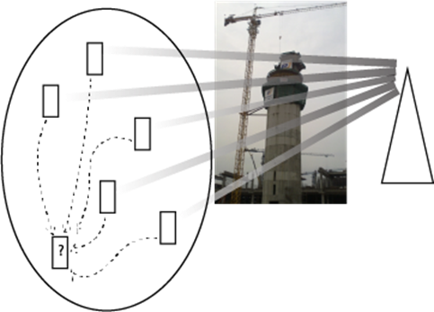

Figure 5.19.1-1: Group Sensing, to provide sensing services

In Figure 5.19.1-1, the UE is on a construction site. It seeks to identify sensors available at that site to provide sensing data potentially relevant to obtaining information for the user. These sensors - in the UE's proximity and available to provide sensor data (that is, this service is authorized,) comprise a sensor group.

Correspondence between Sensor Groups and other groups defined in stage 2 are neither implied by this use case nor excluded. There is no correspondence between Sensor Groups and other groups defined in stage 1.

The use case assumes that sensors that can form a sensor group are either UEs or communicate by means of a UE (as a kind of 'split terminal equipment (TE)' UE.)

It is essential to capture a 'synchronous' group of sensors and their movements in 3 dimensions in order to optimally combine the sensor data for the purpose of localization computations. This is particularly important when the viewer is near a large object or any non-static object must be modeled on all sides. This is an active area of research, for example in 6DoF Tracking and sensing. [44] The techniques described in this paper concern how to determine the 3D position and orientation of drones with synchronization, but it is clear that this is a fundamental requirement of a group of sensors providing input on a single physical object in (absolute or relative) motion.

The synchronous group of sensors form a logical set of devices whose data acquisition is critical for a particular task. The handling of this group is unique to this problem domain because (i) the need to synchronize the uplink transmissions of sensor measurement data of members of the group, so they can be combined in a timely way to produce a meaningful sensor measurement result of an object in motion, (ii) the dynamic nature of this group as the set of sensors that are appropriate to use can change often: the set of sensors prepared to obtain sensor measurement data of moving objects will change over time.

In this use case, a user's UE identifies a sensor group, through interaction with an AS. Part of identification of the sensors in the group is obtaining sufficient information that the user can become authorized to obtain sensor data, and the relevant service access information is obtained. The goal of the use case is to *enable* the acquisition of sensor data in a UE's proximity. The communication of the sensing data itself is out of scope of this use case.

Discovery of the kind described here can potentially be accomplished by different radio technologies, e.g. NR ProSe, UWB, IEEE 802.11, etc.

### 5.19.2 Pre-conditions

Benoît inspects various construction sites. He has a UE equipped with a set of surveillance and appraisal applications.

On construction sites he visits, there are sensors deployed. Some are UEs, e.g. using NR-based sensing. Other sensors include video cameras, LiDAR equipment and passive infrared sensors. These are not, generally, installed directly in the terminal equipment, but rather use the terminal equipment to communicate, as shown in figure 5.19.2-1.

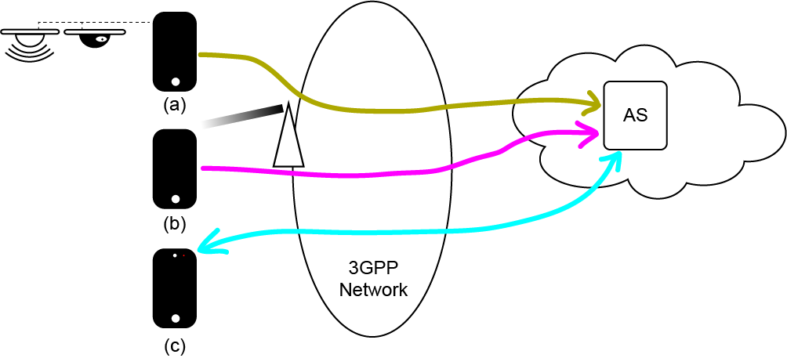

Figure 5.19.2-1: Sensors available to become a sensing group

In the scenario above, (a) is a UE that serves various sensors that are themselves not UEs. The means by which these sensors communicate with the UE is out of scope of this use case. They could be e.g. connected by means of a physical cable. (b) is a UE that is capable of 3GPP defined sensing. (c) is a UE that can operate the UE camera for sensing purposes.

As the RF measurement data contains sensitive information (e.g. location of sensing transmitter/receiver, information about objects) from the 3GPP system it is processed in the 5G network to produce sensing results. 3GPP sensing data is not shared outside of 5G network. Application enabler layer combines these results with other data like non-3GPP sensing data to produce combined sensing results.

In this example (a) and (b) are authorized and ready to send mobile originated sensing data to an AS.

The non-3GPP sensing data from UEs and sensing results from 3GPP network acquired by the AS can be combined in software in a manner that is out of scope of the 5G standard. In this use case, the combination is performed by the AS.

Benoît's UE, (c), is authorized to access the media (the sensing result output of the AS produced by taking account of the non-3GPP sensing data from (a) and (b), sensing results from 3GPP network) provided by the AS.

Benoît, using UE (c), monitors the construction site for safety and efficiency.

### 5.19.3 Service Flows

Benoît's UE (c) uses functionality provided by the 5G system to seek to determine the existence of UEs (a) and (b), referring to Figure 5.19.2-1.

UE (c) has knowledge of the AS that accumulates sensor information that could be of interest.

UE (c) requests of the AS that accumulates sensor information for a sensor group: what sensors are in the proximity?

UE (c) is able to become authorized to receive information concerning the sensor group.

The Application Server (AS) requests the 5G system obtain a sensing group.

The 5G system will identify the set of sensing group members that provide the AS with sensor information that are in the proximity of UE(c). The 5G system will strive to synchronously locate 4 or more devices, to be localized within 10cm of accuracy, with accuracy of measurement within 5 ms of synchronization.

NOTE: It is impractical for the AS to continuously track the location of each of these UEs because their location can change and this information is needed only on demand. The group needs to be captured *together, at the same time,* since the sensor data of the group needs to be interpreted by UE (c) together.

The AS provides UE (c) with sufficient information to *identify the sensing group* that are ready to provide non-3GPP sensing data and sensing results as well as *how to get sensing data from the sensing group* from the AS.

UE (c) requests to obtain combined sensing results from the AS/sensing group. The sensors must be within proximity and their locations are known with great accuracy (within 10cm in 3D), with accuracy of measurement within 5 ms of synchronization.

UE (c) is authorized to obtain combined sensing results from the AS/sensing group.

UE (a), UE (b) provide non-3GPP sensing data and the network provides sensing results. These are received by the AS and combined. This combined sensing result is provided to UE (c) by the AS.

UE (b) is mobile and its position varies. UE (c) must identify its position with sufficient accuracy to interpret the sensing result meaningfully. Since UE (b) is mobile, its position and movements must be tracked to provide accuracy up to 10 cm, with accuracy of measurement within 5 ms of synchronization.

UE (b) leaves the proximity of UE (c). UE (c) identifies that UE (b) has left the sensing group.

Later, UE (b) returns to proximity of UE (c). UE (c) identifies that UE (b) has joined the sensing group, including its position within 10 cm, with accuracy of measurement within 5 ms of synchronization.

The crane operations are monitored by sensors (a) and (b), providing different perspectives by means of non-3GPP sensing data from non-3GPP sensors and sensing results from the 3GPP network to the AS.

### 5.19.4 Post-conditions

Benoît, making use of UE (c), is able to ascertain with very high accuracy the location and movement of the entire group of UEs that can form a sensor group. The ability of UE (c) to identify the position and membership of the group continues over time, so that the *current* membership of the group is known, and that membership can change.

The AS is able to combine the non-3GPP sensing data acquired by non-3GPP sensors and sensing results acquired by 3GPP network from different perspectives and produce a useful 3D representation of the site to the site supervisor, who receives the combined sensing result by means of media delivered from the AS to the Benoît's UE (c).

### 5.19.5 Existing feature partly or fully covering use case functionality

There are requirements specified in 22.261, 6.37.2 to support ranging services that are relevant to this use case. These were developed in the FS_Ranging study. [43]

- The 5G system shall be able to support for a UE to discover other UEs supporting ranging.

- The 5G system shall be able to start ranging and stop ranging according to the application layer’s demand.

- The 5G system shall be able to provide mechanisms for a MNO, or authorized third-party, to provision and manage ranging operation and configurations.

- The 5G system shall be able to support ranging enabled UEs to determine the ranging capabilities (e.g. capabilities to perform distance and/or angle measurement) of other ranging enabled UEs.

- The 5G system shall be able to allow a ranging enable UE to determine if another ranging enabled UE is stationary or mobile, before and/or during ranging.

- The 5G system shall allow ranging service between 2 UEs triggered by and exposed to the application server.

Differences between this use case and the above ranging requirements, and ranging in general include:

- Sensing data is not acquired 'between UEs' but by means of different sensing technologies.

- It is not sufficient to discover other UEs that support sensing: these must be in the discovering UE's proximity and the discovered UE's precise location must be ascertained.

- In this use case, a 'sensing group' is formed, where in Ranging, all range information was acquired through interactions directly (or indirectly if relayed) between UEs.

### 5.19.6 Potential New Requirements needed to support the use case

[PR 5.19.6-1] Based on third-party request, the 5G system shall be able to discover a suitable sensing group where sensing transmitters and receivers are within 100m range to be localized within 10cm of accuracy, with accuracy of sensing measurement process within 5 ms of synchronization.

[PR 5.19.6-2] Based on third-party request, the 5G system shall be able to discover a sensing group in the proximity of the UE that is requesting the service from the AS.

NOTE: This requirement assumes that a UE requests an AS to discover a set of sensing group members that have sensing functions that can provide sensing service.

## 5.20 Use case of Sensing for Parking Space Determination

### 5.20.1 Description

Sensing technology can improve the user experience in parking garage via enabling the vehicle and parking garage to get more information, e.g. information whether a parking space is available or not. The indoor/underground parking garage can install multiple Sensing receivers and Sensing transmitters throughout the concrete structure for detecting the availability of the parking space. The outdoor parking garage can also exploit multiple Sensing receivers and Sensing transmitters for detecting the availability of the parking space.

Another related use case is automated parking e.g. AVP (Automated Valet Parking) and AFP (Automatic Factory Parking) [45] where cars are provided with drive-path information to do automated parking in a given parking lot facility. Connectivity is an important component in automatic parking, and the 3GPP sensing technology can serve as the way to determine available parking spaces and the best route for a car to reach it.

The coverage could be either a public network or a private network specifically for the parking garage. For the Sensing receiver(s) and Sensing transmitter(s) indoor, see figure 5.20.1-1, one deployment scenario is that Sensing receiver(s) and Sensing transmitter(s) can be ceiling-mounted and located in such a way as to provide sensor coverage for the parking bays within the structure, where the Sensing transmitter and Sensing receiver can be co-located. Another deployment method is that some Sensing receiver(s) and Sensing transmitter(s) can be ceiling-mounted and some can be mounted on the floor or wall, where the Sensing transmitter and Sensing receiver can be separately located. For the Sensing receiver(s) and Sensing transmitter(s) outdoor, see figure 5.20.1-2, Sensing receiver(s) and Sensing transmitter(s) can be deployed at a relative high place to guarantee the coverage of the parking garage.

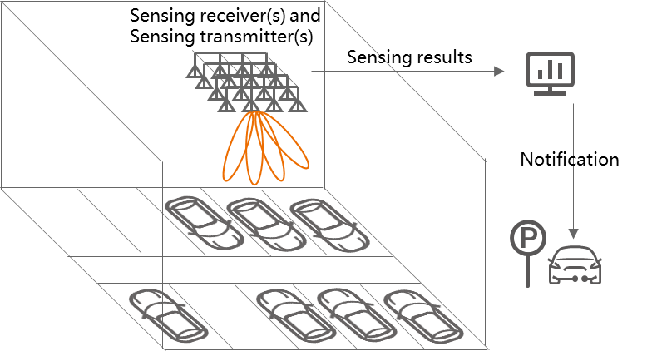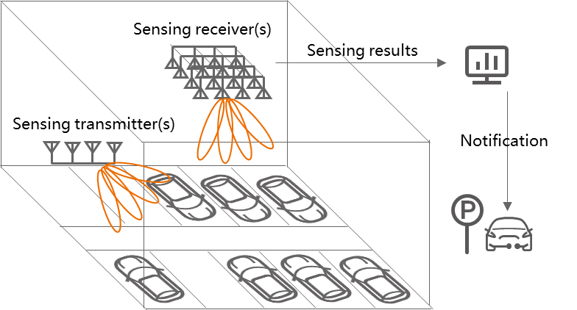

Figure 5.20.1-1: Parking space determination (indoor deployment)

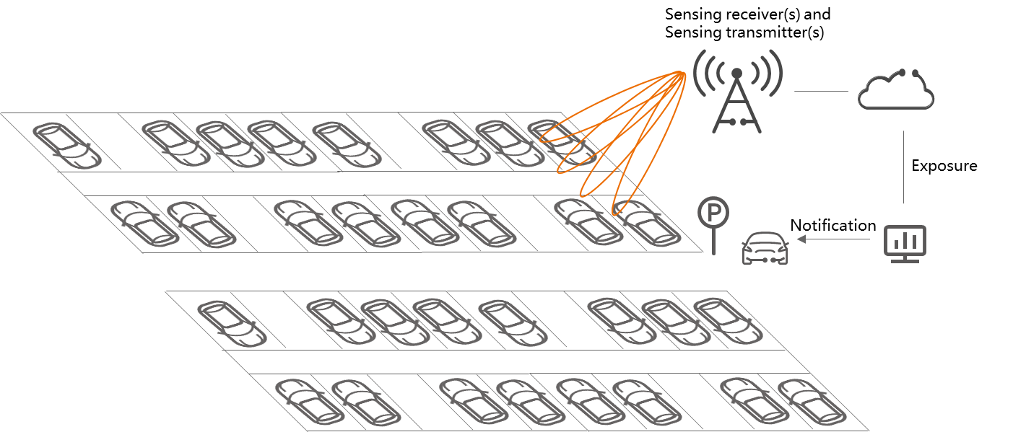

Figure 5.20.1-2: Parking space determination (outdoor deployment)

Multiple methods can be used via using the sensing signals emitted from the Sensing transmitter to detect the target object/area and the sensing signals bounced/reflected. For example, the Sensing receiver can measure the reflected signal power of the target area [8]. Since the cars are usually made of metal materials and the ground is, on the contrary, covered by cement or plastic cement, these objects can vary significantly on the reflected signal power, thus the Sensing receiver can distinguish whether a parking space is taken by simply measuring the reflected signal power difference. Another example method is that the Sensing receiver(s) and Sensing transmitter(s) can identify a parking space availability by monitoring the target movements. Comparing with the stationary objects such as ground and poles, the Sensing receiver(s) and Sensing transmitter(s) can easily distinguish a car when a car is parking or leaving, thus by measuring the distance/angle/velocity, the Sensing receiver(s) and Sensing transmitter(s) can record that a parking space is occupied when a car is parking, and that a parking space is free when a car is leaving. Or the Sensing receiver(s) and Sensing transmitter(s) can also detect a parking space availability by generating a 3-D point cloud [9], then both the stationary and moving target can be easily detected in a 3-D point cloud especially with some backend data processing skills such as machine learning/deep learning.

### 5.20.2 Pre-conditions

This use case is about a public multi-storey parking garage who has installed Sensing receiver(s) and Sensing transmitter(s) throughout the concrete structure to detect the positions of people, objects, and vehicles within the garage. The concrete structure can make coverage difficult and, especially in underground levels, coverage provided by external transmitters can be very poor. This parking garage can provide the information to the entering vehicles about the availability of the parking space.

Consider an example scenario shown in Fig. 5.20.2-1. A typical parking space is with length 5 m and width 2.5 m. So, from the horizontal dimension, the resolution requires to distinguish different parking spaces. The results can be aggregated by the parking garage operator and the parking state can be updated in seconds even when the coverage of the parking garage is poor, which helps avoid a wasting of time for the entering vehicles.

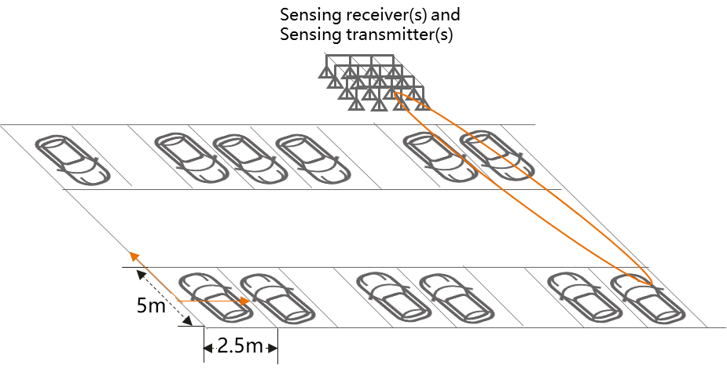

Figure 5.20.2-1: Example of sensing scenario

### 5.20.3 Service Flows

1. James wants to park his car at the public parking garage in floor #B2. His vehicle, on entering the public parking garage, queries the parking garage service for availability of a parking bay in floor #B2.
2. The parking garage operator can activate the sensing devices in floor #B2 for sensing. Sensing receiver(s) and Sensing transmitter(s) sense the parking spaces without interfering each other or with bearable interference. The sensing results can be aggregated by the parking garage operator.
3. With the aggregated sensing results, the parking garage operator can send sensing results back with an addition to the dynamic map corresponding to the floor #B2 which shows the current status of parking bays in the structure.
4. James can see the available parking bays on his in-car display and choose a suitable one.

### 5.20.4 Post-conditions

Thanks to sensing, James has found a parking space on the correct floor without issue, making his life easier during daily travel.

### 5.20.5 Existing features partly or fully covering the use case functionality

None.

### 5.20.6 Potential New Requirements needed to support the use case

[PR 5.20.6-1] The 5G system shall be able to provide sensing services in licensed and unlicensed spectrum.

[PR 5.20.6-2] The 5G system shall be able to authorize Sensing receiver(s) and Sensing transmitter(s) to participate in a sensing service.

[PR 5.20.6-3] Based on operator’s policy, the 5G system shall enable a trusted third-party to request the activation of the sensing service with specific KPI requirement, as well as deactivation of the same service.

[PR 5.20.6-4] The 5G system shall be able to support charging for the sensing services (e.g. considering service type, sensing accuracy, target area, duration).

[PR 5.20.6-5] The 5G system shall be able to provide a sensing service considering the interference to the Sensing service caused by the sensing operations between multiple Sensing transmitter(s) and Sensing receiver(s).

[PR 5.20.6-6] The 5G system shall be able to provide sensing with following KPIs.

Table 5.20.6-1 Performance requirements of sensing results for parking space determination

|  |  |  |  |  |  |  |  |  |  |  |  |  |
| --- | --- | --- | --- | --- | --- | --- | --- | --- | --- | --- | --- | --- |
| Scenario | Sensing service area | Confidence level [%] | Accuracy of positioning estimate by sensing (for a target confidence level) | | Accuracy of velocity estimate by sensing (for a target confidence level) | | Sensing resolution | | Max sensing service latency  [ms] | Refreshing rate  [s] | Missed detection  [%] | False alarm  [%] |
| Horizontal  [m] | Vertical  [m] | Horizontal  [m/s] | Vertical  [m/s] | Range resolution  [m] | Velocity resolution (horizontal/ vertical)  [m/s x m/s] |
| Parking space determination | Indoor/ outdoor | 95 | 0.5 | 0.5 | 0.1 | N/A | 2.5m perpendicular to the parking space  5m parallel to the parking space | N/A | 1000 | 1 | 1 | 5 |
| NOTE: The terms in Table 5.20.6-1 are found in Section 3.1. | | | | | | | | | | | | |

## 5.21. Use case of Seamless XR streaming

### 5.21.1 Description

Extended Reality (XR) is an important 5G use case. Split-rendering architectures, where the heavy XR video rendering computation is done at the application server based on control information received from the UE, poses strict Quality-of-Service (QoS) requirements in terms of round-trip latency and throughput for delivering the video and control info.

It is therefore crucial to always maintain a high-quality wireless link for XR. Thus, it is critical to predict and adapt fast to wireless channel changes. This is especially true in Millimeter wave bands in which the channel and propagation characteristics are very sensitive to user and environment changes such as blockages, user motion or rotation.

To adapt fast to the wireless channel changes, an understanding of the wireless channel dynamics is required. The channel dynamics depend on understanding the surrounding environment such as the transmitter and receiver locations, geometry of the buildings, moving scatterers, location and material of blockers, etc.

Interestingly, most of the XR streaming devices (e.g., 5G phones, AR/VR headsets) and third-party entities that support 5G (i.e., 3GPP sensors) also support non-3GPP sensors, such as RF sensors, Inertial Measurement Units (IMU) sensors, RGB cameras, position sensors, and others.

In light of the availability of 3GPP and non-3GPP sensors and the need of environment understanding, it is therefore natural to utilize the overall sensing information to acquire an understanding of the surrounding environment.

To this end, a “Sensing RF Map Service” can be envisioned that enables the collection of sensing information from 3GPP and non-3GPP sensors, process and provide that information to a sensing service.

* The input to this “Sensing RF Map” service could be 3GPP sensing data and non-3GPP sensing data from multiple sensors, e.g., RF sensing data, XR user position, camera images, depth maps, hand tracking, motion type, etc. Such input could be produced by a 5GS entity (e.g,, UE or RAN entities) or by a third-party (e.g., surveillance camera). It is essential to note that the collection of this sensing should be done with appropriate user consent and adherence to regional and national regulations.
* The processing of 3GPP and non-3GPP sensing data can be performed within the 5G system or outside the 5GS (for example on an application server). In this use case, we are focus on processing in the 5G system.
* The output of this service (i.e., sensing result) is some understanding of the environment and/or impact to communication performance of a service consumer, e.g., RF environment mapping, etc. When sensing result is shared outside of the 5GS, the appropriate consent and permissions for sharing this information is required.
* The consumer of this service could be a third-party application or other entities in the 5GS.

It is important to note that while this service is provided by 5GSor edge server, business model for the monetization of this service would need to consider factors such as the entities involved in sensing, the transfer of the non-3GPP sensing data and the value of sensing RF Map information produced by these entities as well as the value to the consumer of the service. These considerations are also required for scenarios involving 3GPP only sensing operations but additional considerations are indeed required for non-3GPP sensing data which is generated outside the 5G system.

### 5.21.2 Pre-conditions

Jose is playing a game inside a gaming arena using a VR headset that is connected to a RAN entity. The VR headset, RAN entity and third-party surveillance system are configured to provide “3GPP sensing data and non-3GPP sensing data” to the “Sensing RF Map Service”.

The VR headset is equipped with 3GPP sensors and non-3GPP sensors such as, IMU sensors and cameras, and it can provide sensing inputs e.g., 3GPP sensing data, headset pose and location, velocity, images of the environment and processed images (such as motion pattern and maps). Also, the VR headset can provide communication reference signal measurements or reports to the Sensing RF Map Service.

RAN entity has 3GPP NR RF capabilities and can provide 3GPP sensing data to the 5GS, which processes and provides sensing results to the sensing RF Map service.

The gaming arena also has cameras deployed by a trusted third-party surveillance camera company and can provide images of the environment and processed images (such as motion pattern and maps) to the 5GS.

### 5.21.3 Service Flows

1. Jose is playing a game using a VR headset in an arena with some obstacles and other gamers in the environment. Jose moves through the arena and approaches a communication blocker which could potentially impact the performance of the wireless communication between VR headset and the RAN entity.

2. Jose’s VR headset, RAN entity and the third-party surveillance system provide 3GPP sensing data, and non-3GPP sensing data to the Sensing RF Map Service. The Sensing RF Map Service combines the 3GPP and non-3GPP sensing data to produce a sensing result which is a comprehensive RF map of the environment surrounding the headset (e.g. information such as the location of RAN entities, reflectors, static blockers, etc. and an indication of wireless link blockage event, e.g., people walking by blocking the 5G link).

NOTE: An RF map is a spatial/geographical representation of environmental characteristics (e.g., wireless propagation and objects such as RF signal reflectors, blockers in the environment). This map enables improvements in areas such as radio resource management, beam management, mobility and user applications.

1. 5GS uses the RF map to predict that Jose’s communication link is about to be blocked if he comes close to the blocker and such prediction is sent to communication and/or the application layers of the game~~.~~ For example, the application layer adjusts the content of rendered video frames accordingly (e.g., lowers the frame rate, adds a virtual obstacle in the rendered video to prevent Jose from coming close to the blocker.)

### 5.21.4 Post-conditions

Jose enjoys seamless XR gaming application without video frame drops, i.e., no video glitches. This is because Sensing RF map Information was leveraged to assist both the communication service as well as the application.

### 5.21.5 Existing features partly or fully covering the use case functionality

None.

### 5.21.6 Potential New Requirements needed to support the use case

[PR 5.21.6-1] Subject to user consent and regulatory requirements, based on operator policy, the 5G system shall be able to support secure means for RAN entities and authorized UEs to provide 3GPP sensing data to a 5G network for processing.

[PR 5.21.6-2] Subject to user consent and regulatory requirements, based on operator policy, the 5G system shall be able to collect non-3GPP sensing data from trusted parties.

[PR 5.21.6-3] Subject to user consent and regulatory requirements, based on operator policy, the 5G system should be able to support the combination of the 3GPP sensing data and non-3GPP sensing data to derive combined sensing result.

[PR 5.21.6-4] Subject to user consent and regulatory requirements, based on operator policy, the 5G system shall be able to expose the combined sensing results to a trusted third-party service provider.

## 5.22 Use case of UAVs/vehicles/pedestrians detection near Smart Grid equipment

### 5.22.1 Description

In the future, there will be more and more autonomous driving devices, such as drones and self-driving cars. These devices have a strong ability to affect the surrounding environment, which may have an impact on the operating equipment in Smart Grid.

For example, vehicles, such as UAVs and engineering vehicles, may affect the operation safety of multiple links such as power generation, power transmission, and power transformation.

At present, multiple scenarios of power transmission and transformation in the Smart Grid industry have potential combination with integrated sensing and communication technology. Among them, there are related accidents caused by hooking or damaging transmission lines by vehicles in the power transmission process. Thus, the transmission stations need to identify and warn vehicles. In the process of power transformation, there are security risks such as candid photography and attack by drones, getting electric shock when approaching, etc. In a word, there are requirements for perimeter intrusion detection and UAV detection in substations.

### 5.22.2 Pre-conditions

There are existing 5G base stations deployed near the transmission stations and substations, which can provide constant remote sensing of the location of intruders in the coverage area including UAVs, engineering vehicles and pedestrians. Network operator A can use these 5G base stations to provide 5G sensing service for the Smart Grid operator X, including sensing the motion trail of the UAVs, vehicles and pedestrians in their working area.

The Smart Grid Operator X uses the 5G sensing service provided by 5G network Operator A to detect potential intrusion/approaching of UAVs, vehicles and pedestrians near the transmission stations and substations.

The Smart Grid operator sets the border of restricted area for the transmission stations/lines and substations in which no UAVs, vehicles or pedestrians can be access, and define a warning distance value. Once a UAV, traffic vehicle, or pedestrian is detected that its distance from the border is less than the warning distance value, the 5G system will report the event to the Smart Grid operator to send the alerting message.

The 5G base stations can sense the location of the UAV/traffic vehicle/pedestrian constantly and send these data to the 5G core network. Then the sensing node and computing node can analyse and predict the path of the UAV or pedestrian according to a large amount of data and give early warning of potential security risks.

### 5.22.3 Service Flows

1. The Smart Grid Operator X requests sensing service from network operator A to collect sensing data in the defined area (i.e., the park covering transmission stations and substations). The network operator A configures the base stations located in the defined area to perform sensing.

2. The 5G RAN constantly collects 3GPP sensing data of the location of UAVs/vehicles/pedestrians in the defined area and send the sensing data to the 5G core network with a defined frequency to obtain the sensing result (i.e., the distance between the UAV/traffic vehicle/pedestrian and the border or motion trail).

3. The 5G system will send notification to UAVs/vehicles/pedestrians with UE that they are near a restricted area. 5G system will also report the sensing results to the Smart Grid operator. The Smart Grid operator determines to send the alerting message to the intruding/approaching UAVs/vehicles/pedestrians based on the sensing results. In addition, the staffs working in the park respond to the emergency and prepare to intercept the intruding/approaching if the UAVs/vehicles/pedestrians are not away.

### 5.22.4 Post-conditions

The UAVs/vehicles/pedestrians are away from the defined area. Potential security risks are avoided. Thanks to the wide-area and constant sensing capability of the 5G base station, and the precise data processing and prediction by the 5G core network, the safety supervision of the Smart Grid is improved.

### 5.22.5 Existing features partly or fully covering the use case functionality

In TS22.261, there are existing requirements on information exposure:

In clause 6.10:

*The 5G system shall be able to:*

*- provide a third-party with secure access to APIs (e.g. triggered by an application that is visible to the 5G system), by authenticating and authorizing both the third-party and the UE using the third-party's service.*

*- provide a UE with secure access to APIs (e.g. triggered by an application that is not visible to the 5G system), by authenticating and authorizing the UE.*

*- allow the UE to provide/revoke consent for information (e.g., location, presence) to be shared with the third-party.*

*- preserve the confidentiality of the UE's external identity (e.g. MSISDN) against the third-party.*

*- provide a third-party with information to identify networks and APIs on those networks.*

### 5.22.6 Potential New Requirements needed to support the use case

[PR 5.22.6-1] Subject to operator policy, the 5G system shall enable the network to expose a suitable API to a authorized third party to provide the information regarding sensing results.

[PR 5.22.6-2] Based on operator policy, the 5G system may be able to utilize sensing assistance information exposed by a trusted third-party to derive the sensing result.

[PR 5.22.6-3] The 5G system shall be able to support the following KPIs:

Table 5.22.6-1 Performance requirements of sensing results for UAVs/vehicles/pedestrians’ detection near Smart Grid equipment

|  |  |  |  |  |  |  |  |  |  |  |  |  |
| --- | --- | --- | --- | --- | --- | --- | --- | --- | --- | --- | --- | --- |
| Scenario | Sensing service area | Confidence level [%] | Accuracy of positioning estimate by sensing (for a target confidence level) | | Accuracy of velocity estimate by sensing (for a target confidence level) | | Sensing resolution | | Max sensing service latency  [ms] | Refreshing rate  [s] | Missed detection  [%] | False alarm  [%] |
| Horizontal  [m] | Vertical  [m] | Horizontal  [m/s] | Vertical  [m/s] | Range resolution  [m] | Velocity resolution (horizontal/ vertical)  [m/s x m/s] |
| Sensing for the use case in Smart Grid NOTE 2 | Outdoor | 95 | ≤0.7 | N/A | UAV: ≤25  Pedestrian: ≤1.5  Vehicle: ≤15 | N/A | N/A | N/A | ≤5s | ≥10Hz | [≤5] | [≤5] |
| NOTE 1: The terms in Table 5.22.6-1 are found in Section 3.1.  NOTE 2: The typical size (Length x Width x Height) of UAV is 1.6m x 1.5m x 0.7m, the typical size of pedestrian is 0.5m x 0.5m x 1.75m, and the typical size of engineering vehicle is 7.5m x 2.5m x 3.5 m. The size of the park of Smart Grid depends on the real environment.  NOTE 3: The safe distance between pedestrian/vehicle and transmission station/line is 0.7m/0.95m [46]. | | | | | | | | | | | | |

## 5.23 Use case on AMR collision avoidance in smart factories

### 5.23.1 Description

Autonomous mobile robots (AMR) are currently being introduced in many logistics operations, e.g. manufacturing, warehousing, cross-docks, terminals, and hospitals. Compared to an automated guided vehicle (AGV) system in which a central unit takes control of scheduling, routing, and dispatching decisions for all AGVs, AMRs are robots built with intelligence to autonomously move and perform tasks. AGVs is expected to further be evolved into intelligent AMR to meet the demand of intelligent factory.

Compared to AGVs which move on transport paths guided by rails, magnetic markers etc. AMRs can travel automatically without derivatives or guides. AMRs don’t rely on predetermined paths, they can easily adjust routes as user demands change, so AMRs have wider mobile range and more flexibility. AMRs can not only stop on time to avoid humans and other obstacles, but also adjust its route for its destination. However, during the AMR working process, the sensing range of a single AMR is limited and the AMR surrounding environment status may be not detected in time. For example, People or other machines that suddenly appear from behind the large factory equipment can affect the driving safety of the AMR. So, it is very challenge for AMR to get accurate and continuous sensing information along its route.

5G base stations can be deployed in a factory not only to provide communication capabilities for equipments in the factory but also sense the surrounding environment e.g. obstacles or people in the trajectory of AMRs. Base stations transmit the sensing signals and receive the reflected signals to get sensing information, then reports the real-time 3GPP sensing data to the core network. The core network can process and analyze the 3GPP sensing data for outputting the sensing result. Such sensing result can be exposed to a trusted third-party e.g. automation platform of the factory to enables AMRs to know more information about the surrounding environment to improve efficiency and driving safety.

In addition, when there are obstacles (e.g., the large factory equipment) to block the transmission of radio signals or AMR trajectory is across indoor and outdoor, multiple base stations with sensing capability can work together to improve the sensing accuracy and sensing service continuity.

### 5.23.2 Pre-Conditions

5G Network operator ‘MM’ provides 5G sensing service in the factory of Company A. Its 5G system has been deployed covering the factory to provide continuous sensing service indoor and outdoor.

Company A has placed two AMRs (AMR 1 and AMR2) in its factory for moving goods from workshop A to workshop B. At the same time, there are people moving around in both workshops, and other goods or tools may be temporarily placed on the route of the AMRs. The people walking in the workshop and the goods may block the AMR route, jeopardizing production safety. In addition, the two AMRs may collide considering their flexible routes.

The AMRs of Company A uses ‘5G Sensing Service’ provided by 5G network Operator ‘MM’ during they are working. In order to ensure data security, the related sensing data is not permitted to be delivered outside Company A.

### 5.23.3 Service Flows

Figure 5.23.3-1 shows the route change of AMR1 in the process of carrying goods.

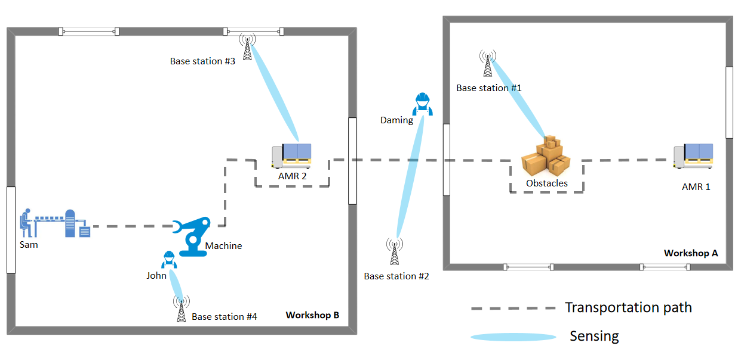

Figure 5.23.3-1: Sensing People or obstacles detection in smart factory

1. The AMR#1 is delivering the car parts from workshop A to Sam who is near the assembly line in workshop B.
2. The 3GPP sensing data collected by Base station #1/RAN, the 5G network processes the 3GPP sensing data to obtain sensing results and detects the proximity of obstacles along the trajectory of AMR#1. 5G system provides the sensing result to the AMR#1, and AMR#1 then re-route and bypass the obstacles based on the sensing result.
3. AMR#1 is leaving the Workshop A and across from indoor to outdoor.
4. The 3GPP sensing data is collected by Base station #2/RAN, the 5G network processes the 3GPP sensing data to obtain sensing results and detects the proximity of Daming who is walking across the trajectory of AMR#1. 5G system provides the sensing result to the AMR#1, then AMR#1 stops to wait for Daming to leave.
5. AMR#1 enters the Workshop B.
6. The 3GPP sensing data is collected by Base station #3/RAN, the 5G network processes the 3GPP sensing data to obtain sensing results and detects the AMR#2 near AMR#1. 5G system provides the sensing result to AMR#1, then AMR#1 re-routes and bypasses the obstacles based on the sensing result.
7. When AMR#1 enters the coverage of Base Station #4, using the 3GPP sensing data from Base station #4/RAN, the 5G network processes the data to obtain sensing results and detects the proximity of John who is behind a large machine. 5G system provides the sensing result to AMR#1, then AMR#1 stops and waits for John to leave.

AMR#1 successfully delivers the car parts to Sam in workshop B.

### 5.23.4 Post-Conditions

Based on the communication and sensing services provided by the 5G network, the AMRs in the factory operate normally and reduce safety incidents.

### 5.23.5 Existing features partly or fully covering the use case functionality

None.

### 5.23.6 Potential New Requirements needed to support the use case

[PR 5.23.6-1] The 5G system shall be able to provide the continuity of sensing service for a specific target object, across indoor and outdoor.

[PR 5.23.6-2] The 5G system shall be able to provide a secure mechanism to ensure sensing result data privacy within the sensing service area.

[PR 5.23.6-3] The 5G system shall be able to support the following sensing related KPIs:

Table 5.23.6-1 Performance requirements of sensing results for AMR collision avoidance in smart factories

|  |  |  |  |  |  |  |  |  |  |  |  |  |
| --- | --- | --- | --- | --- | --- | --- | --- | --- | --- | --- | --- | --- |
| Scenario | Sensing service area | Confidence level [%] | Accuracy of positioning estimate by sensing (for a target confidence level) | | Accuracy of velocity estimate by sensing (for a target confidence level) | | Sensing resolution | | Max sensing service latency  [ms] | Refreshing rate  [s] | Missed detection  [%] | False alarm  [%] |
| Horizontal  [m] | Vertical  [m] | Horizontal  [m/s] | Vertical  [m/s] | Range resolution  [m] | Velocity resolution (horizontal/ vertical)  [m/s x m/s] |
| AMR collision avoidance in smart factories | indoor/outdoor | 99 | ≤1 | N/A | 1 | N/A | 1 | 1.5 | ˂500 | 0.05 | N/A | 5 |
| NOTE 1: The terms in Table 5.23.6-1 are found in Section 3.1.  NOTE 2: The KPI values are sourced from [47]. | | | | | | | | | | | | |

## 5.24 Use case on roaming for sensing service of sports monitoring

### 5.24.1 Description

Sports monitoring application describes the case of a human being monitored when doing exercise via utilizing wireless signals instead of cameras, or wearable devices. With enhanced privacy preservation, wireless signals that propagated in the 5G system (e.g. between 5G UE and 5G UE, and between the radio access network and device) can be further reused and processed to retrieve the target sensing object’s characteristics [48]. In a sports monitoring situation, the target object is human and the target object’s characteristic is human body gesture. By comparing the detected body gesture with the correct body gesture when people are doing exercises like sit-ups, and push-ups, this sport monitoring application will give feedback, for example, it can count the number of the exercise e.g. sit-ups, and calculate calories.

### 5.24.2 Pre-conditions

The sports monitoring application provider has a service agreement with mobile operator A in country X and mobile operator B in country Y.

Mobile operator A in country X and Mobile operator B in country Y has roaming agreements.

Bob installs a sports monitoring application on his mobile phone and subscribes to the sensing service with mobile operator A.

### 5.24.3 Service Flows

1. Bob is a sports fan and does exercise every day. He travels to country Y and gets accommodation in hotel M, where mobile operator B’s sensing service is available. Bob triggers the application and selects his favorite sport, sit-up.

2. The sensing request is received by Mobile operator B and Mobile operator B then authorize whether the sensing request can be satisfied or allowed, e.g. by verifying the sensing system availability (infrastructure, sensing modalities), the location of the sensing service, local privacy restrictions, the roaming agreement with Bob’s home mobile operator A in country X, the identity of Bob and etc.

3. If the authorization succeeds, mobile operator B authorizes and provides such 5G sensing service to Bob with required performance targets and requirements and Bob pays for the sensing service to mobile operator B.

* Mobile operator executes sensing measurement process (e.g. micro doppler shift) with the sensing entities (e.g. RAN entities and the roaming UE, or CPE and the roaming UE) to obtain 3GPP sensing data;
* Mobile operator processes the 3GPP sensing data to derive sensing result and expose it to the application server.

4. If the authorization fails, mobile operator B does not provide such 5G sensing service to Bob and potentially, Bob or the sports monitoring application server will receive the reason of why mobile operator B cannot provide such sensing service.

5. Later, Bob left the hotel to run around the area near the hotel. When Bob runs near a restricted area where sensing service is not allowed, the Mobile operator B revokes the authorization and terminates the sensing service. Potentially, Bob or the sports monitoring application server will receive the reason of why mobile operator B cannot provide such sensing service.

### 5.24.4 Post-conditions

Bob can enjoy the sports monitoring application even when he travels in another country.

### 5.24.5 Existing features partly or fully covering the use case functionality

Roaming-related authentication and charging may refer to existing requirements as defined in Clause 9 in TS22.261:

The following set of requirements complement the requirements listed in 3GPP TS 22.115. The requirements apply for both home and roaming cases.

The 5G core network shall support collection of charging information for alternative authentication mechanisms

The 5G system shall be able to generate charging information regarding the used radio resources e.g. used frequency bands.

### 5.24.6 Potential New Requirements needed to support the use case

[PR 5.24.6-1] Based on operator policy, the 5G System shall be able to provide the 5G wireless sensing services in case of roaming.

[PR 5.24.6-2] 5G network shall provide means for mobile operator to provide / revoke authorization for the operation(s) of a 5G wireless sensing service based on location, time, specific KPI level and the origin of the request.

[PR.5.24.6-3] The 5G system shall be able to provide 5G wireless sensing service with the following KPIs:

Table 5.24.6-1 Performance requirements of sensing results for sports monitoring

|  |  |  |  |  |  |  |  |  |  |  |  |  |  |
| --- | --- | --- | --- | --- | --- | --- | --- | --- | --- | --- | --- | --- | --- |
| Scenario | Sensing service area | Confidence level [%] | Human motion rate accuracy  [Hz] | Accuracy of positioning estimate by sensing (for a target confidence level) | | Accuracy of velocity estimate by sensing (for a target confidence level) | | Sensing resolution | | Max sensing service latency[ms] | Refreshing rate [s] | Missed detection [%] | False alarm [%] |
| Horizontal  [m] | Vertical  [m] | Horizontal  [m/s] | Vertical  [m/s] | Range resolution  [m] | Velocity resolution (horizontal/ vertical)  [m/s x m/s] |
| Sports monitoring | Indoor (living room) | 95 | 0.05  NOTE 2  0.07  NOTE 3 | N/A | N/A | N/A | N/A | N/A | N/A | 60s | 1min | N/A | N/A |
| NOTE 1: The terms in Table 5.24.6-1 are found in Section 3.1.  NOTE 2: Sit-up rate = 30 times/min as reference, 0.05Hz corresponds to 3 times/min.  NOTE 3: Push-up rate = 40 times/min as reference, 0.07Hz corresponds to 4 times/min. | | | | | | | | | | | | | |

## 5.25 Use Case on immersive experience based on sensing

### 5.25.1 Description

Sensing based on the 5G signals is a technology using the difference between wireless signals and its reflective signals including the Doppler frequency shift, time of flight (ToF), amplitude variation and so on, to sense the surroundings. The information collected during sensing cannot be directly understood by human beings, providing good privacy protection. Along with 5G stepping into the home, more interesting functions can be introduced based on the sensing using 5G signals.

It will be fantastic to have an immersive audio and light experience when watching movies and listening to music in the home. The speakers can provide this kind of audio experience if they can know the position of each other and also the user. Usually, to have immersive audio experience, several speakers are needed. Ranging technology can help the speakers to determine position relative to each other and this gives a chance for speakers to provide a fantastic experience together to a listener by adjusting the audio field at a place when the listener stays at that special place.

Different from ranging service where only the UE’s position can be identified, sensing can identify the relative position of the reflector even the reflector is not a UE. If the speakers can obtain the sensing results, this will give a chance to the speakers to follow the listener and provide an immersive audio experience, even when the listener is moving around. The speakers can follow the position of the human and adjust the audio field anytime anywhere. Similar to the audio case, if the smart light can obtain the sensing results, the light can also track the user anytime anywhere to provide an immersive experience.

For the immersive experience scenario, the audio field and light adjustment should be based on the user’s position. For example, the smart screen, lights and speakers can provide immersive sound and light experience for the user who sits at the sofa area (around 2~3m2 area) and at the same time lower the sound volume and turn down the light at other places of the home avoiding the interference on others. The sensing node (e.g., smart screen, i.e., a UE) can perform sensing operations to track the user’s movement using RF signals [29] and provide the information to the speakers and lights for adjustment. Then both the lights and speakers can provide a cosy zone around the user.

In home, there is usually a mixed deployment of smart screen, lights, and speakers. We take smart screen as the sensing node as an example. Assume that the smart screen, the smart lights, and the speakers are placed in the drawing-room, and the smart screen can sense the object in the room as shown in Fig. 5.25.1-1. The smart screen (i.e., UE) can receive the reflected sensing signals transmitted by UEs in the room, or by the gNB to perform sensing operation on the user in the room.

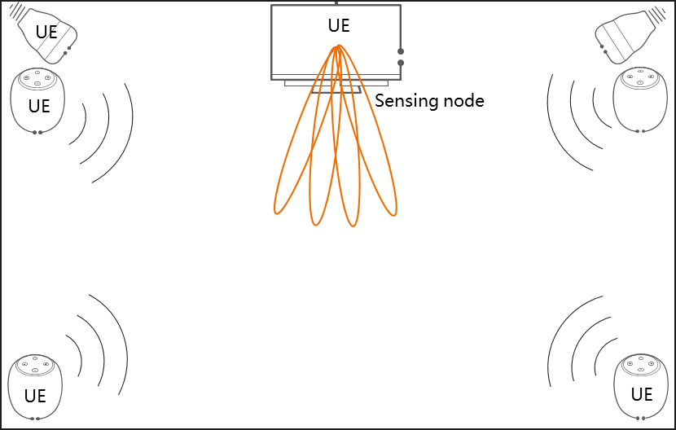

Figure 5.25.1-1: Example deployment of the smart screen, speakers and lights

The smart screen can track the user’s position via sensing operation. Each user is assumed to occupy an area 0.5m * 0.5m and move with a speed lower than 2m/s in horizontal dimension. Then the audio field and light can be adjusted based on the user position (e.g. an area 1.5m * 1.5m) to avoid the experience deterioration even when the user is walking around.

To identify multiple users in the room, in the horizontal dimension, the resolution requires to distinguish objects as large as 0.5m. With higher accuracy on distance, each user in the room can be identify with a more accurate location such as 0.2m, the light and audio can target the user better [30]. If the results are accurate but out of date due to the movement of the user, this will also degrade the experience as the cosy zone is lagging the movement of the user. Consider the audio field and lights are adjusted in an area with 1.5m * 1.5m, to avoid the experience deterioration, the service latency should smaller than 0.5m/2m/s, i.e., 250ms. To track the user’s movement, the results need to be refreshed in 250ms, i.e., 4 times per second (4 Hz).

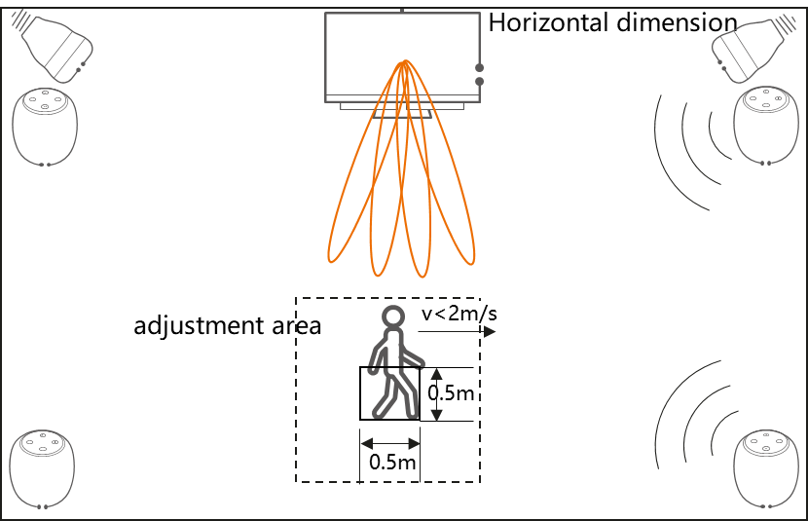

Figure 5.25.1-2: Example of accuracy required for the use case

### 5.25.2 Pre-conditions

This use case is about Tom’s home theatre plan. Tom bought a set of speakers, and placed them in his home to create an immersive audio experience. Tom also bought a set of smart lights to create an immersive light experience. Together with a smart screen in home, these smart devices compose the home theatre. According to the instruction of the speakers, and also based on the availability of audio and power wiring Tom distributed the speakers in his living room. The smart lights are installed on the ceiling of the room. After detecting the position of each distributed speakers, the home theatre system can adjust the audio field in Tom’s home. After detecting the position of smart lights, the home theatre system can control the light variation in home. This detection mechanism of the speakers and smart lights is outside the scope of this document.

There exists a sensing device in the home, which can sense Tom’s position without requiring Tom to take a UE with him. For example, the sensing node is the smart screen belonging to the home theatre system at Tom’s home. Based on the sensing results from the sensing node, the home theatre system can adjust the audio field and light based on the sensing results.

The home theatre system can be deployed by user where the smart screen, lights and speakers communicate with each other via direct device communication using unlicensed band. As an alternative, the home theatre system can be deployed with the help of operator using licensed band when the units of the home theatre system are in coverage. In this case, operator can control the performing of sensing operation based on the location of the deployment of the home theatre.

### 5.25.3 Service Flows

Tom activates his home theatre and the speaker begin to play music based on the audio on demand. The sensing device in the room (i.e., Smart screen) performs sensing operation and the sensing results begin helping adjust the audio field.

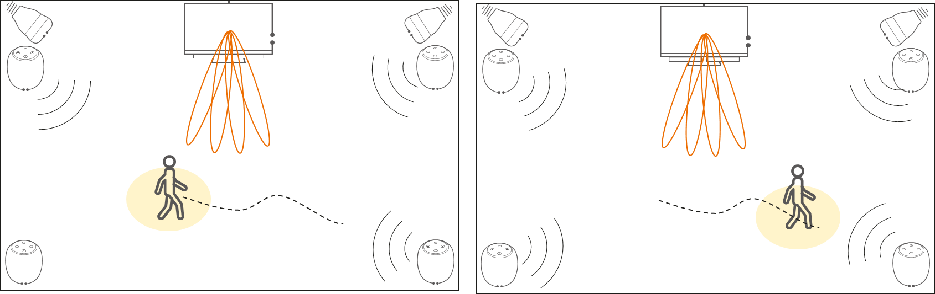

Figure 5.25.3-1 Immersive experience with tracking light and sound

Tom immerses himself in music and begins to dance. The sensing device (e.g., smart screen) tracks Tom’s position via the processing of the receiving sensing signals, the Sensing result is calculated, and the Sensing result is sent to the control unit of the home theatre system.

Based on the sensing results, the home theatre system can adjust the audio field and lights according to Tom’s movement.

Thanks for the sensing service provided by the sensing node (e.g. smart screen), no matter where Tom stands, he always experiences the best surround sound and tracking light.

### 5.25.4 Post-conditions

Thanks to the sensing service provided in the intelligent home, Tom can have an immersive experience via his home theatre.

### 5.25.5 Existing features partly or fully covering the use case functionality

None.

### 5.25.6 Potential New Requirements needed to support the use case

[PR 5.25.6-1] The 5G system shall be able to configure and authorize sensing for a Sensing device or a group of Sensing devices when using licensed spectrum based on the Sensing device’s location.

[PR 5.25.6-2] The 5G system shall be able to enable a Sensing device to perform sensing with licensed band under operator’s control based on the Sensing device’s location.

[PR 5.25.6-3] The 5G system shall be able to enable UEs without 5G coverage to use unlicensed spectrum to perform sensing.

[PR 5.25.6-4] Subject to user consent and national or regional regulation, based on operator policy, the 5G system shall be able to allow a Sensing device to provide sensing results to a trusted third party.

[PR 5.25.6-5] The 5G system shall be able to provide sensing with following KPIs:

Table 5.25.6-1 Performance requirements of sensing results for immersive experience

|  |  |  |  |  |  |  |  |  |  |  |  |  |
| --- | --- | --- | --- | --- | --- | --- | --- | --- | --- | --- | --- | --- |
| Scenario | Sensing service area | Confidence level [%] | Accuracy of positioning estimate by sensing (for a target confidence level) | | Accuracy of velocity estimate by sensing (for a target confidence level) | | Sensing resolution | | Max sensing service latency  [ms] | Refreshing rate  [s] | Missed detection  [%] | False alarm  [%] |
| Horizontal  [m] | Vertical  [m] | Horizontal  [m/s] | Vertical  [m/s] | Range resolution  [m] | Velocity resolution (horizontal/ vertical)  [m/s x m/s] |
| Immersiveexperience | Indoor | 95 | 0.5 | 0.5 | 0.1 | N/A | 0.5 | N/A | 250  (granularity of field is 1.5m x 1.5m) | 0.25 | 5 | 5 |
| NOTE: The terms in Table 5.25.6-1 are found in Section 3.1. | | | | | | | | | | | | |

## 5.26 Use case on accurate sensing for automotive manoeuvring and navigation service

### 5.26.1 Description

It is forecasted that there will be approximately 8 million autonomous or semi-autonomous vehicles on the road by 2025 [49]. NR wireless sensing will assist with automotive manoeuvring and navigation, especially in scenarios where single car-mounted sensors collecting information is not enough for making safe and reliable decisions, e.g. to avoid a collision, pedestrians, etc.

This scenario reuses the use case as defined in section 5.8, where NR wireless sensing is utilized to assist automotive manoeuvring, i.e. sensing results play an important role in making the manoeuvring decisions. However, the sensing environment when RAN entities and UEs execute the sensing measurement process may be subject to high interference (e.g. interference caused by adjacent RAN entities, radars, fake base stations) and cause the sensing information as collected to be wrong.

The sensing information provided to the Automated Driving System (ADS) server needs to be fully trustworthy: reliability, integrity, high confidence level and protection against tampering are key aspects. Users (and third parties) should not be able to fraud the ADS Server by tampering with the sensing information in order to influence the manoeuvring decision.

### 5.26.2 Pre-conditions

Refer to 5.8, where Bob’s vehicle is detected to be blocked by other vehicle and cannot do the decision for autonomous driving with sensors collected data (e.g. from lidar, radar, camera, etc). Bob recognizes the needs of 5G system assistance and requests 5G System for coordination of the sensing service.

### 5.26.3 Service Flows

1. Bob drives in downtown, and is approaching a crossroad with regulatory signs, where the sensors on Bob’s vehicle are blocked by other vehicles. Bob’s vehicle cannot see the surroundings and Bob sends the sensing request to 5G system.

2. The 5G system gives instructions about how to proceed the sensing to Bob’s vehicle and Bob’s vehicle selects Joe’s vehicle to assist the sensing service. Joe’s vehicle transfers the sensing contextual information to Bob’s ADS server.

3. Bob’s ADS server utilizes the sensing contextual information to do the decision, Bob decelerates before the traffic light.

4. Bob continues the journey and drives in a tunnel (10km length), the sensors on Bob’s vehicle are detected to be blocked by a big truck. Bob sends the sensing request to 5G system.

5. The 5G system selects RAN entities (e.g. road side units) to assist the sensing service. The 5G system transfer the sensing information collected by RAN entities to Bob’s ADS server.

6. Bob’s ADS server utilizes the sensing information to do the decision, and Bob accelerates to overtake the big truck.

7. Bob continues the journey and drives in a desert area and some sensors on Bob’s vehicle are detected to be broken (e.g. because of heat). Bob’s vehicle sends the sensing request to 5G system.

8. The 5G system selects RAN entities (sparsely deployed in desert area) to assist the sensing service. With the feedback from RAN entities, the 5G system transfer the sensing information together with the indication of confidence level as 60% to the ADS server.

9. Bob’s ADS server utilizes the indication and sensing information, and decides to return to Level 0 driving for safety.

### 5.26.4 Post-conditions

Bob’s vehicle is able to drive with high reliability by utilizing accurate 5G sensing service.

### 5.26.5 Existing features partly or fully covering the use case functionality

None.

### 5.26.6 Potential New Requirements needed to support the use case

[PR 5.26.6-1] The 5G system shall be able to determine the confidence level of the sensing results.

## 5.27 Use case public safety search and rescue or apprehend

### 5.27.1 Description

The ability to quickly locate an individual that is either missing (search and rescue) or is a suspect in an illegal activity (apprehend) is very important for public safety. Statistics show that the quicker a missing person can be found the higher the possibility they can be found in good condition. Similarly for a suspect in an illegal activity, the quicker they can be located the less likely they can hide or commit another illegal activity. These activities can be in both an outdoor environment and indoors.

Leveraging the sensing capability of a 3GPP network and integrating the feature with other 5G capabilities (e.g., metaverse, augmented reality, location, network relay, etc.) can provide a huge advantage to public safety.

In an outdoor example, an elderly person with Alzheimer’s Disease wanders off into the woods and does not know how to return. The longer it takes for public safety to locate this person the more likely they may suffer injuries or medical issues, such as dehydration, cuts, bruises, broken bones, or worse, death. Another example is an individual who robs a bank and escapes into the nearby forest and swamps. The longer it takes to track down and find the individual, the more difficult it becomes and the bigger the risk of them taking hostages, hurting others, or escaping completely.

With the density of base station deployments and with large numbers of 5G enabled UE’s, the 5G coverage includes a large amount of the territory of most countries. These base station signals and the signals of UE’s can also be used to sense the environment for object detection.

Assumptions for this use case:

* Trusted third-party applications for interpreting and presenting the data to public safety is required,
* Devices must be trusted and communicate information togethers; and
* Precision 3-axis location is needed.

An indoor example would be a firefighter entering a building with limited or no visibility using sensing integrated with firefighter heads-up displays/UEs (metaverse/AI/ML) sensing can better allow the firefighters to locate possible people trapped inside and allow them a better view of the rooms as they work through the building.

Indoor 5G coverage can be challenging but leveraging features like UE-to-UE relay, UE-to-Network Relay, UE-to-Network multi-hop relay and UE-to-UE multi-hop relay and allowing the devices to work together can provide good coverage and capability to provide indoor sensing services in this challenging environment.

Assumptions for this use case:

* The use of UE-to-Network Relay and UE-to-UE relay can provide a more reliable connectivity.
* Devices must be trusted and communicate information togethers; and
* Precision 3-axis location is needed.

### 5.27.2 Pre-conditions

1) Operator A’s network supports sensing capability with their base stations and have 3GPP sensing enabled UEs on their network.

2) Local public safety officials have a relationship with Operator A allowing them to access the networks sensing capability and service.

3) Appropriate security and privacy requirements are in place between the operator and the public safety organization.

### 5.27.3 Service Flows

1) Public safety is notified of a need to search for an individual. This could be either a search and rescue, or an apprehend scenario and could involve both indoor and outdoor environments.

2) Operator A’s network is 3GPP sensing enabled and public safety’s UEs are 3GPP sensing enabled.

3) Public safety personnel begin searching for the individual using both traditional methods, UAVs and UE’s with 3GPP sensing capabilities.

4) Depending on coverage there may be a need to leverage indirect network connections.

5) Using the 3GPP sensing data and non-3GPP sensing data public safety can quickly locate the person of interest.

6) The individual is located using the combinations of capabilities.

### 5.27.4 Post-conditions

The individual is located faster than without 3GPP sensing capability. The additional harm that might have occurred to the individual or community is avoided.

### 5.27.5 Existing features partly or fully covering the use case functionality

TBD

### 5.27.6 Potential New Requirements needed to support the use case

[PR.5.27.6-1] The 5G system shall support exposing the information of sensing result (e.g., location, relative location, velocity vectors, relative headings, etc.) to the trusted and secure mission critical applications.

[PR.5.27.6-2] The 5G system shall support mechanisms for combining 3GPP sensing data and non-3GPP sensing data (e.g., body cameras.) depending on location, availability of non-3GPP sensing data, and public safety applications.

[PR.5.27.6-3] The 5G system shall support security and protection of the 3GPP sensing data, non-3GPP sensing data, and sensing results.

[PR.5.27.6-4] The 5G system shall provide a secure sensing service for Mission Critical Services.

[PR.5.27.6-5] The 5G system shall be able to provide the sensing service with the following KPIs:

Table 5.27.6-1 Performance requirements of sensing results for public safety search and rescue or apprehend

|  |  |  |  |  |  |  |  |  |  |  |  |  |
| --- | --- | --- | --- | --- | --- | --- | --- | --- | --- | --- | --- | --- |
| Scenario | Sensing service area | Confidence level [%] | Accuracy of positioning estimate by sensing (for a target confidence level) | | Accuracy of velocity estimate by sensing (for a target confidence level) | | Sensing resolution | | Max sensing service latency  [ms] | Refreshing rate  [s] | Missed detection  [%] | False alarm  [%] |
| Horizontal  [m] | Vertical  [m] | Horizontal  [m/s] | Vertical  [m/s] | Range resolution  [m] | Velocity resolution (horizontal/ vertical)  [m/s x m/s] |
| Search and Rescue/Apprehend | Outdoor/Indoor | 99 | ≤ 0.5 | ≤ 1.0 | Pedestrian: ≤1.5 | Pedestrian: ≤1.5 | 3 | Horiz: 5  Vert: 5 | ≤1s | ≥10Hz | [≤3] | [≤3] |
| NOTE: The terms in Table 5.27.6-1 are found in Section 3.1. | | | | | | | | | | | | |

## 5.28 Use case on Vehicles Sensing for ADAS

### 5.28.1 Description

Advanced Driving Assistance System(ADAS) uses various sensors (Wireless Sensing millimeter wave radar, lidar, monocular / binocular camera and satellite navigation) installed on the vehicle to sense the surrounding environment at any time during the driving process, collect data, identify, detect and track static and dynamic objects, and carry out systematic calculation and analysis in combination with navigation map data, so as to make the driver aware of the possible dangers in advance, and effectively increase the comfort and safety of driving.

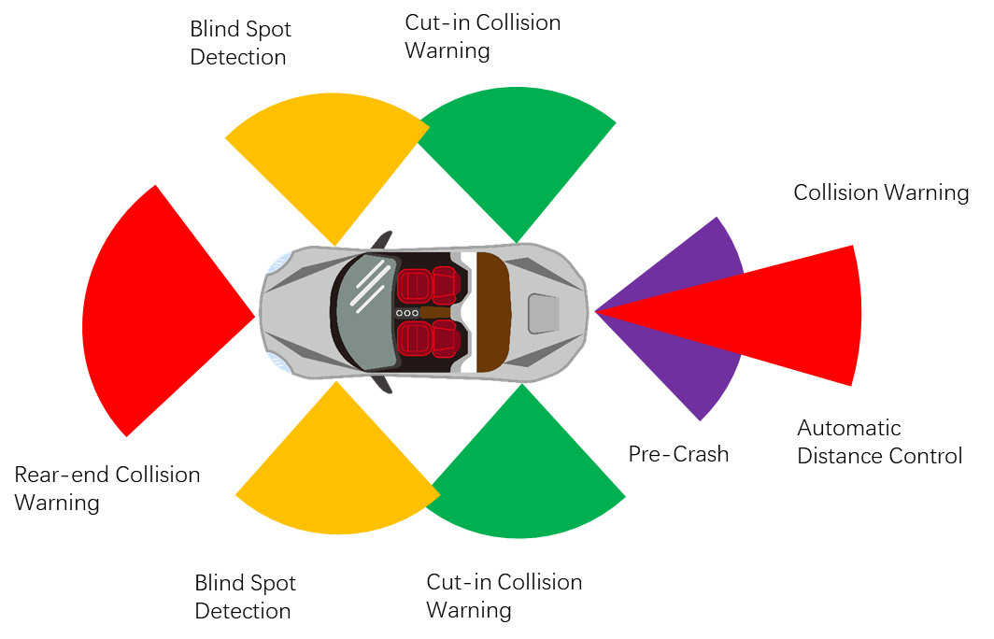

Figure 5.28.1-1 ADAS overview

There is an opportunity for 3GPP New Radio (NR) based sensing technologies to be added into ADAS. 5G based wireless sensing service could improve the ADAS reliability and quality.

The ADAS has the map information, the real time location/ trajectory of the car and can assist the car driving, e.g. stop the car for avoiding collision. The car (as 3GPP UE) is equipped with 3GPP NR based sensing technology. When the UE initially accesses the 5G network, the UE is authorized by the 5G network to participate in sensing under the operator’s control. The 3GPP sensing data is from the NR based sensor, and the sensing result is sent to the ADAS system of the car. Collaborating with other non-3GPP sensing devices/technologies, NR based sensing result as input to ADAS could improve the comfort and safety of driving.

The vehicle as a 3GPP UE based sensing sensor is important for automotive use cases, it can operate under network control & complements network-based sensing. Network based sensing alone cannot fully address the automotive use case needs, e.g.:

1. There may be a blockage from the network (base station) to the sensed target.
2. ADAS concerns more on relative positioning other than absolute position. Network based sensing introduces additional errors (due to compounding errors of two separate positions).
3. Automobiles applications may determine sensing priority/performance requirements locally (not visible to gNB).

UE based sensing resources allocations can be under the control of the network (e.g. base station). For UEs inside the coverage of enhanced network for sensing, resources can be directly controlled. Sensing results of the automobiles can be shared via 3GPP connections (Uu or PC5).

It is expected that the 3GPP NR sensing service for ADAS **should meet the requirement and level of commercial ADAS radar sensing performance.** Based on requirements for existing automotive sensors, the RF based sensing requirements for automotive applications are as the following table.

Table 5.28.1-1 RF based sensing requirements for automotive applications of existing automotive sensors

|  |  |  |
| --- | --- | --- |
| Parameter | Typical Automotive Radar KPIs | |
| Long Range Radar [10][12][20][50][51][52] | Short Range Radar [10][12][20][52][53][54] |
| Maximum range | 250-300m  (for RCS of 10dBsm with >90%detection probability) | 30-100m |
| Range resolution | 10-75cm | 5-20cm |
| Range accuracy | ±10 to ±40cm | ±2 to 10cm |
| FOV azimuth | ±9-15deg | ±60-85deg |
| Azimuth resolution | 1-3deg | 3-9deg |
| Azimuth accuracy | ±0.1-0.3deg | ±0.3-5deg |
| Update rate | 5 to 20 fps | 20 to 50 fps |
| Max one-way velocity | ±50m/s to ±70m/s | ±30m/s |
| Velocity resolution | 0.1 –0.6 m/s | 0.1 - 0.6 m/s |
| Velocity accuracy | ±0.03m/s to ±0.12 m/s | ±0.03m/s to ±0.12 m/s |

Although all vehicles on the road are expected to be equipped with NR radio, but not necessarily utilizing them for 100 percent of time. Enabling NR radio based sensing for ADAS can be a better utilization of the capability and radio resources.

### 5.28.2 Pre-conditions

The 3GPP UE in the car has 3GPP subscription and is authorized by the operator to perform sensing.

### 5.28.3 Service Flows



Figure 5.28.3-1 ADAS

1. Tom buys a new car with the latest ADAS equipped.

2. Tom wants to drive the car from home to the company in the morning of a working day. Tom drives from home to the road. The 3GPP NR based sensor in Tom’s car transmits the 3GPP NR signal to the other car(s) in the same road, and receives the reflected signal to detect the distance and speed of the other car(s) to feed to the ADAS in Tom’s car.

3. While the car is driving on the highway, suddenly a car is stopped before the Tom’s car due to an accident, fortunately it is timely detected by the NR based sensor.

4. The NR based sensors send the collision warning to the ADAS, the ADAS stops the car immediately.

5. Finally, Tom’s car avoids a collision accident and leaves the highway safely.

### 5.28.4 Post-conditions

With the safely driving experience provided by ADAS, Tom arrives in the company safely and easily. Tom starts the daily work in the office.

### 5.28.5 Existing features partly or fully covering the use case functionality

There are features of Sidelink positioning for the car moving along the LOS road (e.g., using Sidelink positioning for car ranging on the same road), which requires the participant cars are 3GPP UEs.

### 5.28.6 Potential New Requirements needed to support the use case

[PR 5.28.6-1] The 5G system shall be able to configure and authorize UEs supporting V2X applications to perform sensing.

[PR 5.28.6-2] The 5G system shall be able to c**ollect charging information** for UEs supporting V2X applications when performing sensing.

[PR 5.28.6-3] The 5G system shall be able to support the following KPIs:

Table 5.28.6-1 KPIs for Vehicles Sensing for ADAS

|  |  |  |  |  |  |  |  |  |  |  |  |  |
| --- | --- | --- | --- | --- | --- | --- | --- | --- | --- | --- | --- | --- |
| Scenario | Sensing service area | Confidence level [%] | Accuracy of positioning estimate by sensing (for a target confidence level) | | Accuracy of velocity estimate by sensing (for a target confidence level) | | Sensing resolution | | Max sensing service latency[ms] | Refreshing rate [s] | Missed detection [%] | False alarm [%] |
| Horizontal  [m] | Vertical  [m] | Horizontal  [m/s] | Vertical  [m/s] | Range resolution  [m] | Velocity resolution (horizontal/ vertical)  [m/s x m/s] |
| ADAS  [long range Radar] | Outdoor | [95] | [≤1.3]  NOTE 2 | ≤0.5 | [≤ 0.12]  NOTE 4 | N/A | [0.4]  NOTE 5 | [≤ 0.6]  NOTE 4 | [50] | [≤ 0.2] | [≤ 10] | [<1] |
| ADAS  [Short range Radar] | Indoor (parking space)/Outdoor | [95] | [≤2.6]  NOTE 3 | ≤0.5 | [≤ 0.12]  NOTE 4 | N/A | [0.4]  NOTE 5 | [≤ 0.6]  NOTE 4 | [20] | [≤ 0.05] | [≤ 10] | [<1] |
| NOTE 1: The terms in Table 5.28.6-1 are found in Section 3.1.  NOTE 2: Assuming typical max range of 250m, range accuracy of 10cm, azimuth accuracy of ±0.3deg. Positioning accuracy as (Min-Max) within field of view.  NOTE 3: Assuming typical max range of 30m, range accuracy of 2cm, azimuth accuracy of ±5deg.Positioning accuracy as (Min-Max) within field of view.  NOTE 4: Velocity accuracy and resolution is typically reported for the radial velocity (not absolute H/V velocity).  NOTE 5: Range resolution typically reported as 3D ranging distance accuracy. | | | | | | | | | | | | |

## 5.29 Use case on Gesture Recognition for Application Navigation and Immersive Interaction

### 5.29.1 Description

As a new way of human-device interface, gesture recognition enables a more intuitive interaction between humans and machines, compared to the conventional text or GUI-based interfaces. Common applications of gesture recognition include touchless control of mobile devices, such as smartphones, laptops, and smart watches. Compared to other use cases, such as sports monitoring or sleep monitoring, gesture recognition requires higher resolution, higher update rate, and lower latency, which makes it more challenging in terms of resource utilization and processing complexity.

Gesture recognition identifies motions and postures of human body parts, such as head, hands, and fingers. As shown in Figure 5.29.1-1, gesture recognition can be applied to various applications such as human motion recognition, keystroke detection, sign language recognition and touchless control.

|  |  |
| --- | --- |
|  | Gesture/motion/posture recognition   * Human motion recognition * Keystroke detection * Touchless control * Sign language recognition |

Figure 5.29.1-1 Gesture Recognition

In this use case, we focus on application of gesture recognition for touchless control and immersive (i.e. XR) application.

For touchless control, the identified gestures are then interpreted to specific behaviours or operations of the device, including locking/unlocking a screen, increasing/decreasing volume, and navigating forward/backward web pages.

For XR application, the position tracking and mapping of the human body is a basic requirement that permeates XR application to provide the immersive experience [55]. Hereby a variety of sensors are integrated in the XR devices to measure the movement of the human body (e.g., head, eye, hand, arm, etc) in order to simulate normal human mimicry. Besides, the hand tracking goes beyond the simulation and enables a natural and intuitive way of the interaction between the human and the machine compared with the use of the physical controller. The gesture recognition and hand tracking becomes a vital function in XR applications, especially when the human and the controlled object stay in physical and virtual world separately.

For both touchless control and XR application, NR-based RF sensing is suitable for gesture recognition because certain RF signals can detect small body movements and the RF signals are not susceptible to the ambient illumination condition and occlusions in the environment. In addition, NR-based RF sensing allows for finger and hand tracking in a lower-complexity and economic manner.

### 5.29.2 Pre-conditions

There are two roommates, Jose and Bob, both of whom subscribed to MNO A, which has deployed RAN entity (e.g., an indoor base station) supporting NR-based sensing.

Jose subscribes to the touchless user interface service and his mobile device has NR sensing capability.

Bob subscribes to the immersive interaction service, provided by both MNO A and XR application (e.g. game, sports training) provider AppX on the access rights of the interaction information relevant to Bob’s hands. Bob’s UEs (e.g. smartphone, XR device such as headset) are capable of NR-based sensing and Bob’s XR device also have other sensors (e.g. IMU) embedded on the device.

### 5.29.3 Service Flows

**Social Media Navigation service with Gesture Recognition**

**Step 1**: Sitting in this room, Jose is reading through social media posts using his smartphone, to navigate to either the previous or next posts. Jose waves his hand in the air from left to right or from right to left.

**Step 2**: Jose’s smartphone detects the hand gesture using 5G wireless sensing using the RAN entity, UE or both. The smartphone and RAN entity can send sensing data (with extracted gesture features such as range and Doppler of the detected gesture) to the 5G network.

**Step 3**: 5G network then aggregates and processes the information collected from the UE and RAN entity to detect Jose’s gesture and provides the sensing results to Jose’s smartphone which is shared with the social media application and used for the navigation of the post.

**Immersive interaction service with Gesture Recognition**

**Step 1**: Bob launches the XR application in his room, at which moment one avatar is generated to represent him in the virtual world of the XR application, and the immersive interaction service is activated as shown in Fig 5.29.3-1.

**Step 2:** When Bob sees a basketball flying toward him, he bends the fingers to catch the ball and throws it back. The characteristics of the gesture (e.g. range, doppler shift) are detected using NR sensing signals of UEs, the RAN entity or both.

**Step 3:** 5G network (e.g. 5GC) collects the 3GPP sensing data from UEs, RAN entity or both, process the data and exposes the sensing result (e.g. 3D position, velocity) to XR application. In parallel, the non-3GPP sensing data obtained from the XR device is transmitted to the application platform transparently through UE to 5GC.

**Step 4:** The gesture and hand movement are recognized and the basketball bounces to another direction as a sensing result. The entire course will be presented on Bob’s headset as that the basketball is caught by one hand of Bob’s avatar and thrown back.

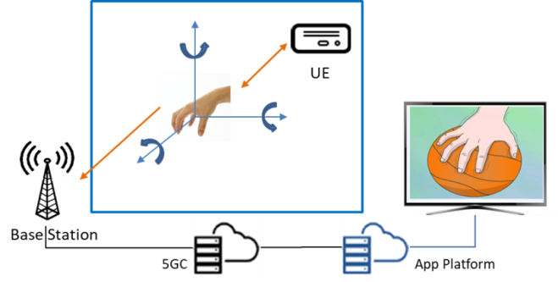

Figure 5.29.3-1 Hand Tracking in XR applications

### 5.29.4 Post-conditions

Due to the RF sensing capability in Jose’s mobile device and a nearby RAN entity, Jose’s gestures are detected and used to navigate the social media posts on his phone.

Similarly, due to the RF sensing capability in Bob’s smartphone, XR device and a nearby RAN entity, Bob’s gesture and the motion of his fingers and hands will be recognized and tracked correctly. The avatar in XR application will show the correct gesture and execute the correct action triggered by the gesture.

### 5.29.5 Existing features partly or fully covering the use case functionality

None.

### 5.29.6 Potential New Requirements needed to support the use case

Editor’s note: Functional requirements are FFS.

[PR 5.29.6-1] The 5G system shall be able to provide sensing with the following KPIs:

Table 5.29.6-1 Performance requirements of sensing results for gesture recognition

|  |  |  |  |  |  |  |  |  |  |  |  |  |  |
| --- | --- | --- | --- | --- | --- | --- | --- | --- | --- | --- | --- | --- | --- |
| Scenario | Sensing service area | Confidence level [%] | Motion rate accuracy | Accuracy of positioning estimate by sensing (for a target confidence level) | | Accuracy of velocity estimate by sensing (for a target confidence level) | | Sensing resolution | | Max sensing service latency[ms] | Refreshing rate [s] | Missed detection [%] | False alarm [%] |
| Horizontal  [m] | Vertical  [m] | Horizontal  [m/s] | Vertical  [m/s] | Range resolution  [m] | Velocity resolution (horizontal/ vertical)  [m/s x m/s] |
| Gesture recognition | Indoor | N/A | N/A | FFS | FFS | 0.1 | 0.1 | FFS | [0.3] | FFS | ≤0.1 | FFS | FFS |
| NOTE 1: The terms in Table 5.29.6-1 are found in Section 3.1.  NOTE 2: KPIs provided in table are derived from [56] and with the use of the pre-defined gestures to be identified some of the KPIs e.g. positioning accuracy and range resolution could be relaxed. | | | | | | | | | | | | | |

## 5.30 Use case on sensing for automotive manoeuvring and navigation service when not served by RAN

### 5.30.1 Description

Consider the scenario defined in section 5.8, where NR wireless sensing is utilized to assist automotive manoeuvring, i.e. sensing results play an important role in making the manoeuvring decisions. However, in this section the vehicles are not served by RAN when the Sensing activity is expected to occur, where UE is not served by RAN and therefore RAN entities are unable to be involved. UEs performing the sensing measurement process in this scenario have to be able to operate when UE is not served by RAN.

### 5.30.2 Pre-conditions

Refer to 5.8, where Bob’s vehicle determines the need for sensing service. Bob’s vehicle integrates a UE supporting V2X application i.e., Bob’s vehicle supports V2X. Sensing can be performed by 5G Wireless sensing. Unlike in section 5.8, the vehicles are not served by RAN and perform 5G Wireless sensing without help of the network entities. Bob’s vehicle has been provisioned by his home operator to be able to perform 5G Wireless sensing when not served by RAN. There may be other vehicles or RSU (road side unit) helping the 5G Wireless sensing of the Bob’s vehicle.

### 5.30.3 Service Flows

1. Bob is driving from urban to rural countryside. As his vehicle is operational, in motion, and attempting to assist his driving using ADS, Bob’s vehicle is performing sensing using 5G Wireless sensing.

2.Bob drives his vehicle outside the coverage area of its mobile network. The 5G Wireless sensing continues providing assistance to Bob’s driving.

3. Bob’s vehicle approaches Joe’s vehicle.

4. Bob’s vehicle becomes aware of Joe’s vehicle by Bob’s onboard Sensing receiver(s) receiving 5G Wireless sensing reflected by Joe’s vehicle.

5. Bob’s vehicle applies this new object information to the local ADS function to ensure a safe, collision-free, drive.

### 5.30.4 Post-conditions

Bob’s vehicle is able to drive with high reliability by utilizing 5G sensing service when not served by RAN.

### 5.30.5 Existing features partly or fully covering the use case functionality

None.

### 5.30.6 Potential New Requirements needed to support the use case

[PR 5.30.6-1] The 5G system shall be able to provide mechanisms for an MNO to configure UEs supporting V2X application for 5G Wireless sensing operation when not served by RAN.

[PR 5.30.6-2] Subject to regulation, the 5G system shall enable UEs supporting V2X application to perform 5G Wireless sensing when not served by RAN using the allowed ITS spectrum and unlicensed spectrum.

## 5.31 Use case on blind spot detection

### 5.31.1 Description

Blind spot detection reduces the risk of accidents during lane changes by monitoring the dangerous blind spot area [26]. The blind spot area is a typically a moving target area that changes when car moves if we take the road infrastructure as reference point. Currently, the blind spot detection system operates via a variety of external sensors located on a car’s bumpers and wing mirrors, which can detect if a person or vehicle enters your blind spot, notifying you via an audible or visual cue - typically, a warning light located in the car’s wing mirror.

Figure 5.31.1-1: blind spot detection system, a moving target area.

Wireless sensing technology can be utilized to detect obstacles that presents in car’s blind spot area:

* Case I: Base stations on the roadside are already used to provide 5G coverage for communication, and the radio signals that are reflected can be used to sense the blind spot area of a car.
* Case II: Base stations on the roadside are already used to provide 5G coverage for communication, and the radio signals that are received by the UE (i.e. the car is a 3GPP UE, or there is a 3GPP UE such as smartphone on the car) can be used to sense the blind spot area of the car.

Any obstacle that presents in the car’s blind spot area, no matter the obstacle is moving (e.g. car, motorcycle, walking human, animal etc) or static (building, tree), will affect the reflected/received signals. By deriving the characteristics of the affected signals, obstacle can be detected, and danger can be avoided. It is convenient to utilize current deployed 5G network system to achieve this blind spot detection.

This use case is to reuse 5.8 to describe the blind spot detection aspects.

### 5.31.2 Pre-conditions

MNO provides blind spot detection sensing service to different kinds of subscribers:

- Bob’s car is a 5G UE and subscribes to this sensing service. His car has NR-based sensing technology and capabilities such as NR-based sensing capabilities, sensing processing capabilities are also provided to the MNO.

- Juan’s car is not a 5G UE, but his 5G UE (smartphone) subscribes to this sensing service, where an application is installed on the 5G UE.

- Alex’s car is not a 5G UE, an application installed on his car subscribes to this sensing service.

Laura has no subscription to the blind spot detection sensing service.

### 5.31.3 Service Flows

Step 1: Bob, Juan, Alex and Laura are friends and driving together to Alps skiing resort. At 8:00am, Bob starts from Street A, Juan and Alex start from Street B and Laura start cars from Street C. Bob, Juan and Alex trigger the blind spot detection sensing service separately.

Step 2: When received the service request, 5G system discovers and configures sensing transmitter(s) and sensing receiver(s) to track and monitor the moving car’s blind spot area (from sensing transmitter’s perspective), e.g.:

* Bob’s car is a 5G UE and has NR-based sensing capabilities, 5G system configures base station(s) as sensing transmitter and Bob’s car as the sensing receiver. The moving blind spot area is tracked by Bob’s 5G UE.
* Juan’s car and Alex’s car are not 5G UE. 5G system configures base station(s) as sensing transmitter and sensing receiver. Juan’s car’s moving blind spot area and Alex’s car’s moving blind spot area are separately tracked by 5G base station.

Step 3: 3GPP sensing data is collected by sensing receiver and transferred to the network sensing processing entity to derive the sensing result, which is then exposed to the service consumer to fetch out whether there is obstacle presence in the blind spot area, e.g.

* Bob’s car is a 5G V2X UE and has processing capabilities, 5G system authorizes 5G UE as sensing processing entity.
* Juan’s car is not a 5G V2X UE, but Juan has his smartphone (5G UE) carried in car, 5G system authorizes 5G UE as sensing processing entity.
* Alex has no 5G UE on board, 5G network processes the 3GPP sensing data to derive sensing result.

Step 4: A car is moving very fast from Street A to Street B to Street C and presents sequentially in Bob’s, Juan’s Alex’s and Laura’s blind spot area.

* Bob is changing lane, the moving car is detected and Bob safely changed lane.
* Juan and Alex turning left, the moving car is detected and they safely turned right.
* Laura is overtaking a truck, the moving car suddenly presents in the blind spot area, Laura forgets the over-shoulder view and hits the moving car.

### 5.31.4 Post-conditions

Bob, Juan and Alex drive safely to the Alps skiing resort and enjoy their holiday thanks to the blind spot detection sensing service.

Laura is in hospital.

### 5.31.5 Existing features partly or fully covering the use case functionality

None.

### 5.31.6 Potential New Requirements needed to support the use case

[PR 5.31.6-1] The 5G System shall be able to provide sensing service to track a moving target sensing service area.

## 5.32 Use case of integrated sensing and positioning in factory hall

### 5.32.1 Description

Autonomous Mobile Robots (AMR)s and automated guided vehicle (AGV) are enabling solutions for a smart factory environment, in which a diversity of logistic tasks are done with an autonomous and efficient implementation, with minimal direct human engagement. In order to achieve a safe and efficient operation to serve a desired goal (e.g., transfer of construction materials with minimal risk, delay and energy consumption), a command center may take over the task of collecting the information of the involved facilities and performing a coordinated planning of the device operations. Nevertheless, a safe and efficient operation of the mobile devices may be only achieved on the condition of an accurate awareness of the environment (e.g., obstacles, humans) and the device positioning/tracking information (e.g., AGV/AMR position and velocity).

In view of the above, the 5G system shall serve the implementation of a smart factory by means of a reliable data connectivity (e.g., the low-latency and reliable AGV/AMR to command center connection) and positioning of the involved AGV/AMR UE devices. Furthermore, the 5G system sensing services can be utilized to augment the environment awareness by means of detecting and locating the non-connected objects (e.g., obstacles such as trash box, or safety-sensitive objects such as human, etc.).

In addition to the detection of the non-connected objects, the 5G system sensing enables a higher positioning and tracking accuracy of a target UE at the 5G system, by means of augmenting the positioning and sensing capabilities [27]. In case of an AMR/AGV, the positioning measurement of a device can be augmented at the 5G system with the 3GPP sensing data obtained from the reflections of the sensing signal from the AMR/AGV physical body, in the interest of a higher environment awareness and positioning accuracy, as well as the additional information obtained via sensing of the AMR/AGVs (e.g., orientation of an AMR). In particular, when both 5G system sensing and positioning services are activated, the same 5G system nodes (e.g., sensing Tx nodes) and 5G system signals (e.g., positioning or sensing signals) can be reused to efficiently generate and process the desired sensing and positioning measurements, see Figure 5.32.1-1 as an example of a joint sensing and positioning of a UE.

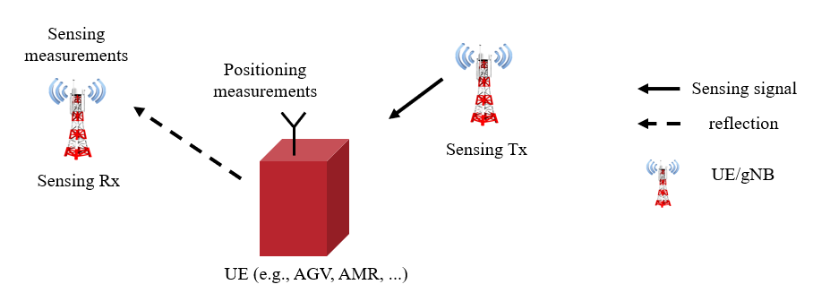

Figure 5.32.1-1 The 5G system obtains position estimate of a UE, utilizing 3GPP sensing data of the UE obtained from the 5G wireless sensing service, in combination with the positioning measurement of the UE

The obtained higher positioning accuracy of an AGV/AMR is particularly valuable for coordination of multiple AGVs and AMR with indeterministic movement paths, wherein the situations involving sudden break and/or velocity change may lead to a high delay, damage risk, and interruption energy loss.

5.32.2 Pre-conditions

Multiple AMR/AGVs are deployed in a factory hall belonging to the company **X**. The AMR/AGVs are coordinated by a command center to perform a collaborative construction task. The command center coordinates the AMR/AGVs’ movements to improve safety and to avoid energy loss (due to an AMR/AGV break) and delay as much as possible.

To facilitate this, the factory hall is equipped with the 5G system sensing services provided by the Mobile Network Operator (MNO) **A**. Moreover, the AMR/AGVs are equipped with the 5G system communication and positioning modules.

The company **X** has provided the MNO with the physical type/characteristics of the deployed AMR/AGVs, as well as the installed camera data of the factory hall to assist detection and positioning of the AMR/AGVs via sensing.

### 5.32.3 Service Flows

**Step 1:** [AMR/AGV is deployed to deliver goods]

AMR/AGV **Y** is assigned with a task for delivering needed material to a construction site within the factory hall. The AMR/AGV is loaded with the materials and departs from its initial location.

**Step 2:** [AMR position is obtained via 5G system positioning]

AMR/AGV moves from its initial position towards the construction site. The position information of the AMR/AGV is obtained by the MNO **A** via the 5G system positioning module of the AMR/AGV and reported to the command center.

The command center determines that the provided positioning accuracy of the MNO **A** is sufficient since the AMR/AGV currently moves in the low-traffic area of the factory hall. Based on the received positioning information of the AMR/AGV, the command center recommends that AMR/AGV keeps its velocity towards the construction site.

**Step 3:** [AMR/AGV position is obtained via a joint 5G system sensing and positioning]

As the AMR/AGV moves towards the construction site, more objects (other AMR/AGVs, humans, tools) appear in the vicinity. The command center identifies that the AMR/AGV is now in a high-traffic area and a higher positioning accuracy is desired.

The command center requests the MNO **A** to activate 5G system sensing service during the 5G system positioning service for positioning of the AMR/AGV UEs.

MNO **A** activates sensing of the desiredAMR/AGV areas to enhance positioning of the AMR/AGV devices. MNO **A** identifies UE and/or gNBs capable of sensing in the vicinity of the AMR/AGV and starts sensing measurement process jointly with the 5G positioning measurements of the AMR/AGVs. The 5G network obtains 3GPP sensing data of the identified nodes and generates a high accuracy position estimate and/or additional sensing information of the AMR/AGVs, based on the collected 3GPP sensing data in addition to the AMR/AGV’s positioning measurements. The obtained positioning estimate of the AMR/AGV is reported to the command center.

Based on the obtained high-accuracy positioning information of the AMR/AGVs the command center adjusts the velocity of the AMR/AGVs.

**Step 4:** [AMR reaches the construction site]

The AMR/AGV reaches the construction site and offloads the goods.

### 5.32.4 Post-conditions

Thanks to the 5G system based sensing service enabling an enhanced AMR/AGV positioning and sensing of the environment, the involved AMR/AGVs are coordinated to arrive at their destination with minimal risk and interruption loss.

### 5.32.5 Existing feature partly or fully covering use case functionality

A UE equipped with 5G positioning module may obtain positioning information of the UE based on the 5G positioning services. Moreover, the 5G system sensing services shall support detection and positioning of an object. Nevertheless, interpretation of an object’s position as a UE’s position (e.g., among multiple detected objects), as well as a joint positioning and sensing of a UE device as a physical object by the 5G system (when both 5G system services are available to the UE) has not been enabled by the current requirements.

### 5.32.6 Potential New Requirements needed to support the use case

[PR 5.32.6-1] Based on operator’s policy, the 5G system may provide a mechanism for a trusted third party to provide sensing assistance information about a sensing target.

[PR 5.32.6-2] The 5G system shall be able to provide sensing results with the following KPIs:

Table 5.32.6-1 Performance requirements of the sensing results exposed to the third party

|  |  |  |  |  |  |  |  |  |  |  |  |  |
| --- | --- | --- | --- | --- | --- | --- | --- | --- | --- | --- | --- | --- |
| Scenario | Sensing service area | Confidence level [%] | Accuracy of positioning estimate by sensing (for a target confidence level) | | Accuracy of velocity estimate by sensing (for a target confidence level) | | Sensing resolution | | Max sensing service latency  [ms] | Refreshing rate  [s] | Missed detection  [%] | False alarm  [%] |
| Horizontal  [m] | Vertical  [m] | Horizontal  [m/s] | Vertical  [m/s] | Range resolution  [m] | Velocity resolution (horizontal/ vertical)  [m/s x m/s] |
| Indoor Factory | 100 m2 | 99 | [≤0.5] | N/A | 0.5 | N/A | [0.5] | [0.5] | ≤100 | 0.1 | N/A | N/A |
| NOTE: The terms in Table 5.32.6-1 are found in Section 3.1. | | | | | | | | | | | | |

# 6 Considerations

## 6.1 Considerations on confidentiality, integrity and privacy

### 6.1.1 General

When introducing sensing technology, new aspects on confidentiality, integrity, and privacy need to be considered, to ensure that these aspects are considered already when proposing service requirements.

For instance, with sensing technology by-standers can be affected in a completely new way, previously only UEs have been able to be tracked but now sensing capabilities may enable tracing and potentially identification of anything in the environment, including humans that do not carry a UE, or any objects. This has implications for privacy. Obviously humans should have a right to privacy.

For privately owned areas, respective permission is required for sensing operation from such as the homeowner for in-home sensing or the building management for the in-building sensing.

For public areas, such as a public road, park and airport, it is required to obtain the permission of the respective public area management.

It is important to have the user consent before the network uses UEs in providing sensing service. If the sensing results and user ID are brought together for further processing, user consent is also needed.

Of course, factors such as resolution, updating frequency, and type of application influence the security implications.

Requirements to minimize the risk of unwanted usage and awareness of the usage needs to be considered in stage 1. These are captured in the next chapter.

### 6.1.2 Potential New Requirements

A set of general new requirements can be identified:

[PR 6.1.2-1] The 5G system shall limit sending the sensing results only to third party authorized to receive that sensing results.

[PR 6.1.2-2] The 5G system shall support encryption and integrity protection of the sensing result, to protect the data inside the 5G system and when used.

[PR 6.1.2-3] The 5G system shall support appropriate level of sensing for both situations where consent can be obtained from the sensing targets, and where it cannot.

[PR 6.1.2-4] Subject to regulation, the 5G system shall obtain user consent when sensing results and user identification are brought together for further processing.

## 6.2 Considerations on Regulatory, Mission Critical and other priority services

### 6.2.1 General

The sensing operation in Operator’s network can support commercial services (e.g. use case described in section 5.8 on sensing assisted automotive manoeuvring and navigation). There could be areas where the network resources are limited and prioritization (according to operator’s decision) would be needed among the resources used for sensing service and resources used for other services (e.g. communication service).

In addition, sensing operation could also be used to support services such as MCS (e.g. public safety, Utilities, Railways) and MPS with requirements for priority treatment. The 5G system can provide flexible means for priority treatment to the users of sensing services subject to regional/national regulatory rules and operator policy.

### 6.2.2 Potential New Requirements

[PR 6.2.2-1] Subject to regulation and operator’s policy, 5G system shall provide prioritization among sensing services.

# 7 Consolidated potential requirements and KPIs

## 7.1 Consolidated functional requirements

Table a – Sensing configuration and authorization Consolidated Requirements

| CPR # | Consolidated Potential Requirement | Original PR # | Comment |
| --- | --- | --- | --- |
|  | The 5G system shall be able to provide mechanisms for an MNO to configure UEs supporting V2X application for 5G Wireless sensing service when not served by RAN. | PR 5.30.6-1 |  |
|  |  |  |  |

Table b – 5G Wireless sensing service Consolidated Requirements

| CPR # | Consolidated Potential Requirement | Original PR # | Comment |
| --- | --- | --- | --- |
|  | The 5G system shall be able to provide 5G wireless sensing service in a sensing service area location using sensing transmitters and sensing receivers. | PR 5.2.6-1  PR 5.9.6-1  PR 5.11.6-1  P.R 5.14.6-1  PR 5.1.6-2 |  |
|  | Subject to regulation and operator policy, the 5G network shall be able to activate, configure, and deactivate 5G wireless sensing based on parameters such as location and network conditions (e.g. network load). | P.R 5.14.6-3  P.R 5.13.6-7  PR 5.8.6-6 |  |
|  | Subject to user consent, regulation, and operator’s policy, the 5G system shall be able to collect non-3GPP sensing data from authorized non-3GPP sensors and securely provide it to 5G network for processing. | PR.5.4.6-1  PR 5.21.6-2 |  |
|  | The 5G system shall support continuity for 5G wireless sensing service (e.g. for sensing a moving object). | PR 5.23.6 -1  PR 5.18.6.1 |  |
|  | Subject to operator’s policy, the 5G System shall be able to provide the 5G wireless sensing service in case of roaming. | PR 5.24.6-1 |  |
|  | Subject to user consent, regulation, and operator’s policy, the 5G system should support the combination of the 3GPP sensing data and non-3GPP sensing data to derive a combined sensing result. | PR 5.21.6-3  PR 5.4.6-4  PR 5.27.6-2 |  |
|  | Subject to regulation and operator’s policy, 5G network shall provide prioritization among 5G wireless sensing services (e.g. prioritizing between communication and sensing services). | PR 6.2.2-1 |  |
|  | The 5G system shall be able to enable UEs without 5G coverage to use unlicensed spectrum to provide 5G wireless sensing service. | PR 5.25.6-3  PR 5.1.6-5  PR 5.25.6-2 |  |
|  | Subject to regulation, the 5G system shall enable UEs supporting V2X application to perform 5G Wireless sensing when not served by RAN using the allowed ITS spectrum and unlicensed spectrum. | PR 5.30.6-2 |  |
|  |  |  |  |

Table c – Network exposure Consolidated Requirements

| CPR # | Consolidated Potential Requirement | Original PR # | Comment |
| --- | --- | --- | --- |
|  | Subject to operator’s policy, the 5G network shall be able to provide secure means to report sensing result to a trusted third-party requesting information about a target object when specific requested conditions are met.  NOTE: These conditions could be e.g. the target object distance from the restricted area border or entering restricted area. | PR 5.13.6-6 |  |
|  | Subject to operator’s policy, the 5G network shall be able to provide secure means to enable trusted third-party to request discovering a sensing group in the proximity of the UE that is requesting a service from application server. | PR 5.19.6-2 |  |
|  | The 5G network shall provide secure means for a trusted third-party to request 5G wireless sensing service based on specific parameters (e.g. refresh rate, period of time, sensing KPIs, geographical location) and to receive the respective corresponding sensing results. | PR 5.11.6-3  PR 5.13.6-4  PR 5.12.6-3  PR 5.12.6-5  PR 5.12.6-4  PR 5.5.6-1  PR 5.5.6-2 |  |
|  | Subject to operator’s policy, the 5G system shall be able to provide secure means for a trusted third-party application to receive sensing results with contextual information. | PR 5.8.6-5 |  |
|  |  |  |  |

Table d – Security Consolidated Requirements

| CPR # | Consolidated Potential Requirement | Original PR # | Comment |
| --- | --- | --- | --- |
|  | The 5G system shall provide a mechanism to protect identifiable information that can be derived from the 3GPP sensing data from eavesdropping. | PR 5.16.6-1 |  |
|  | The 5G system shall limit the exposure of the sensing results only to third party authorized to receive that sensing results. | PR 6.1.2-1 |  |
|  | The 5G system shall support encryption, integrity protection, privacy of the 3GPP sensing data, non-3GPP sensing data and sensing results, to protect the data inside the 5G system. | PR 5.27.6-4  PR 5.27.6-3  PR 5.23.6 -2  PR 6.1.2-2 |  |
|  | The 5G system shall support appropriate sensing KPIs of 5G wireless sensing for both situations where consent can be obtained from the sensing targets, and where it cannot. | PR 6.1.2-3 |  |
|  |  |  |  |

Table e – Charging Consolidated Requirements

| CPR # | Consolidated Potential Requirement | Original PR # | Comment |
| --- | --- | --- | --- |
|  | The 5G system shall be able to support charging for the 5G wireless sensing service (e.g. considering sensing KPIs, duration). | PR 5.20.6-4 |  |

## 7.2 Consolidated potential KPIs of sensing results

|  |  |  |  |  |  |  |  |  |  |  |  |  |  |  |
| --- | --- | --- | --- | --- | --- | --- | --- | --- | --- | --- | --- | --- | --- | --- |
| Scenario | Sensing service level | Sensing service area | Confidence level [%] | Accuracy of positioning estimate by sensing (for a target confidence level) | | Accuracy of velocity estimate by sensing (for a target confidence level) | | Sensing resolution | | Max sensing service latency  [ms] | Refreshing rate  [s] | Missed detection  [%] | False alarm  [%] | Example Services |
| Horizontal  [m] | Vertical  [m] | Horizontal  [m/s] | Vertical  [m/s] | Range resolution  [m] | Velocity resolution (horizontal/ vertical)  [m/s x m/s] |
| Object detection and tracking | 1 (use cases 5.1; 5.13 – level1) | Object to be detected indoor: Human, object to be detected outdoor: UAV | 95 | ≤10 | ≤10 | N/A | N/A | 10  NOTE 2 | 10  NOTE 3 | <1000 | < 1 | < 5 | < 2 | intruder detection in smart home,  UAV intrusion detection |
| 2 (use cases 5.13 – level2, 5.6) | Object to be detected outdoor:  Human, UAV | 95 | ≤5 | ≤5 | N/A | N/A | 10  NOTE 2 | 10  NOTE 3 | [≤1000] | [≤1] | ≤5 | ≤5 | UAV flight route intrusion detection,  intruder detection in surroundings of smart home |
| 3 (use cases 5.2, 5.7, 5.10, 5.11, 5.12, 5.23) | Factory (100m2), crossroad, highway, railway [air]  NOTE 4  Object to be detected: Animal, Human, UAV, Vehicle | 95 | ≤1 | N/A | 1  NOTE 5 | N/A | <1  NOTE 5  NOTE 8 | 1 x 1 NOTE 9 | ≤100 ≤1000  NOTE 6  NOTE 10 | [≥0.05 ÷ ≤ 0.1 ≤ 1]  NOTE 11 | ≤2 | ≤2 | pedestrian/animal intrusion detection on a highway/railway,  sensing at crossroads with/without obstacle,  UAV flight trajectory tracing  UAV collision avoidance,  AMR collision avoidance in smart factories |
| 4 (use cases 5.20, 5.22, 5.25, 5.27, 5.32) | Public area safety, factory  NOTE 7  Object to be detected: Animal, Human, UAV, AGV/AMR, Vehicle | 95 | 0.5 | 0.5 | 0.1  Pedestrian: ≤1.5  Vehicle: ≤15 | N/A  Pedestrian: ≤1.5 | 0.5m | 5 x 5  for factories 0.5 may be needed | 250 | 0.25 ≤ 1 | 1 | 5 | Parking Space Determination,  UAVs/vehicles/pedestrians detection near Smart Grid equipment,  immersive experience based on sensing,  public safety search and rescue or apprehend,  integrated sensing and positioning in factory hall |
| 5 (use cases 5.28) | ADAS -TBD  Object to be detected: Vehicle | [95] | ~ [0.1]-[1.3] ; for short range radar ~[0.02]-[2.6] | TBD | [±0.03] -[±0.12] m/s | N/A | [0.4] | [0.1] – [0.6] | [50] | [0.05] -[0.2] | [1-10] % | [<1] % | ADAS |
| Environment monitoring | 1 (use case 5.14) | Object to be detected outdoor:  Human | 95 | [≤2] | N/A | N/A | N/A | [1] | [1] | 1000 NOTE 10 | [≤0.2] | 5 | 5 | traffic management |
| 2 (use cases 5.3 and 5.5.) | Rainfall monitoring and flooding  NOTE 14  Object to be detected: Rain | 95 | ≤10 | [≤0.2]  NOTE 15 | N/A | N/A | N/A | N/A | 1 min | 1<10min, application configurable | < 0.1 | < 3 | rainfall monitoring,  flooding monitoring |
| Motion monitoring | 1 (use cases 5.15, 5.24, 5.29) | Indoor human motion -sleep monitoring NOTE 12, sports monitoring NOTE 13, gesture recognition  Motion on human, gesture | 95 | N/A | N/A | 0.1 valid for gesture recognition | 0.1 valid for gesture recognition | N/A | N/A | 60s | 60, ≤0.1 for gesture recognition | 5 | 5 | sleep monitoring,  sports monitoring,  gesture recognition |
| NOTE 1: The terms in Table 7.2-1 are found in Section 3.1.  NOTE 2: To detect the UAV existance (e.g., for intrusion detection), the sensing resolution of distance is 10m [25].  NOTE 3: To detect the UAV existence, the sensing resolution of velocity is 10m/s [25].  NOTE 4: The typical size (Length x Width x Height) of UAV is 1.6m x 1.5m x 0.7m, the typical size of pedestrian is 0.5m x 0.5m x 1.75m, and the typical size of engineering vehicle is 7.5m x 2.5m x 3.5 m.  NOTE 5: The KPI values for UAVs are sourced from [25] and [40] and for factories are sourced from [47].  NOTE 6: The value 100 ms is sourced from [28] and is valid for sensing at crossroads.  NOTE 7: The safe distance between pedestrian/vehicle and transmission station/line is 0.7m/0.95m [46]. The size of the park of Smart Grid depends on the real environment.  NOTE 8: To track the UAV flying (e.g., for collision detection and warning), the sensing resolution of distance is 1m [25].  NOTE 9: To track the UAV flying, the sensing resolution of velocity is 1m/s [25].  NOTE 10: To realize 1m granularity tracking, when the velocity resolution is 1 m/s, the maximum corresponding sensing service latency is 1s.  NOTE 11: Echodyne MESA-DAATM has approximate 1Hz scan rate [40].  NOTE 12: Additional KPI on motion rate accuracy of 2 times/min (0.033 Hz).  NOTE 13: Additional KPI on motion rate accuracy of 3 times/min (0.05Hz) and 4 times/min (0.07 Hz)  NOTE 14: Rainfall estimation accuracy is1 mm/h[39] and describes the closeness of the measured rainfall estimation to its true rainfall value.  NOTE 15: This value is for the water level. Description related to NOTE in clause 5.5.1 suggests 0.01 m. [≤0.2] is derived from the water level where people feel difficulty in walking. | | | | | | | | | | | | | | |

Editor’s note: The values in brackets are FFS

Editor’s note: Different service level of the KPIs is FFS

# 8 Conclusion and recommendations

# 

Annex A (informative):  
Change history

|  |  |  |  |  |  |  |  |
| --- | --- | --- | --- | --- | --- | --- | --- |
| **Change history** | | | | | | | |
| **Date** | **Meeting** | **Tdoc** | **CR** | **Rev** | **Cat** | **Subject/Comment** | **New version** |
| 5.2022 | SA1#98e | S1-221249 | - | - | - | Initial Skeleton | 0.0.0 |
| 5.2022 | SA1#98e |  | - | - | - | Output of approved pCRs from SA1 #98e  Includes: S1-221250; S1-221251; S1-221252 | 0.1.0 |
| 9.2022 | SA1#99e |  | - | - | - | Output of approved pCRs from SA1 #99e.  Includes S1-222300; S1-222301; S1-222302; S1-222303; S1-222304; S1-222305; S1-222306; S1-222307; S1-222308; S1-222309; S1-222310; S1-222311; S1-222312; S1-222313; S1-222314; S1-222315; S1-222316; S1-222317; S1-222318; S1-222319; S1-222320; S1-222321; S1-222322 | 0.2.0 |
| 11.2022 | SA1#100 |  | - | - | - | Output of approved pCRs from SA1#100.  Includes: S1-223333; S1-223484; S1-223485; S1-223061; S1-223716; S1-223577; S1-223494; S1-223495; S1-223496; S1-223578; S1-223498; S1-223579; S1-223580; S1-223701; S1-223690; S1-223730; S1-223731; S1-223590; S1-223592; S1-223488; S1-223604; S1-223606; S1-223607 | 0.3.0 |
| 03.2023 | SA1#101 |  | - | - | - | Output of approved pCRs from SA1#101.  Includes: S1-230600; S1-230601; S1-230549; S1-230692; S1-230693; S1-230808; S1-230798; S1-230639; S1-230696; S1-230558; S1-230539; S1-230697; S1-230647; S1-230648; S1-230538; S1-230121; S1-230177; S1-230547; S1-230649; S1-230541; S1-230626; S1-230698; S1-230754; S1-230755; S1-230653 | 0.4.0 |
| 03/2023 | SA#99 | SP-230219 | - | - | - | Clean-up by MCC for presentation to SA | 1.0.0 |
| 05/2023 | SA1#102 |  | - | - | - | Output of approved pCRs from SA1#102.  Includes: S1-231421; S1-231306; S1-231759; S1-231742; S1-231478; S1-231481; S1-231482; S1-231428; S1-231483; S1-231135; S1-231681; S1-231432; S1-231307; S1-231237; S1-231375; S1-231449; S1-231274; S1-231450; S1-231437; S1-231793; S1-231811; S1-231794 | 1.1.0 |
| 06/2023 | SA#100 | SP-230506 | - | - | - | Clean-up by MCC for approval by SA | 2.0.0 |
| 06/2023 | SA#100 | SP-230506 | - | - | - | Raised to v.19.0.0 by MCC following approval by SA | 19.0.0 |